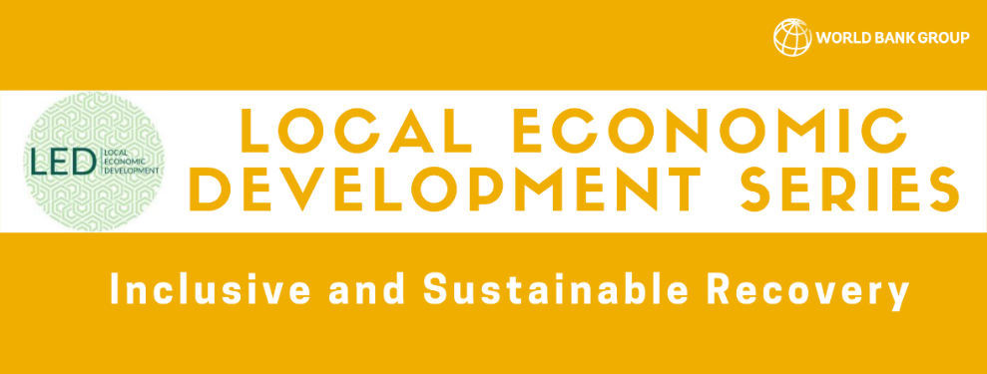
LED Session #4: The Power of Savings Groups: An Underutilized Platform for Local Economic Development in Africa
Key Takeaways
Opening Remarks:
Sybil Chidiac, Senior Program Officer, Gender Equality, The Gates Foundation: Welcome to the World Bank’s LED series! Savings groups (SGs) have transformed marginalized communities across Africa and can rebuild social networks, trust and local economies. Today we will hear from experts working in this field.
Helene Carlsson Rex, Practice Manager, Social Sustainability and Inclusion, World Bank: Welcome to the LED series. Today, we will explore the untapped potential of savings groups in Africa. There are 20-30 million active members of SGs in Africa that are delivering results, even during the current crisis. Most group members are women, and they benefit from increased food security, resilience and labor force participation. Today, we hope to learn how different organizations are working with SGs in Africa and how the World Bank can utilize such platforms to promote LED and inclusive recovery.
David Panetta, Program Director, Savings Groups, The SEEP Network: Over the past 25 years, thousands of NGOs have supported 20 million individuals in SGs across 75 countries. 85% of these are in Africa and 80% of members are women. Furthermore, SGs have shown a consistent positive impact on savings, access to credit, investment, food security, self-confidence and social support networks. However, work with SGs has been undertaken by many different organizations in a fragmented manner. Also, engagement with these groups tends to be very short-term. Groups could be better engaged deliberately as community development platform. Today’s speakers are doing just that.
Our speakers include:
- Aisha Rahamatali, Senior Advisor, Economic Justice and Rights Action Coalition, CARE International​
- Japheth Muli, Chief Operations Officer, East Africa, Hand in Hand International​
- Angeline Munzara, Senior Advisor, External Engagement & Savings Groups, World Vision International​
- Brian Ssebunya, Senior Technical Advisor, Enterprise Development and Employment, International Rescue Committee​
- Edwin Ocharo, Senior Projects Officer, Kenya Post Office Savings Bank ​

Fireside Chat
Sybil: What is CARE’s strategy with SGs and what has your work with SGs during COVID revealed?
Aisha: CARE has supported 10.2 million people across 54 countries to form Village Savings and Loan Associations (VSLAs). These support women’s economic, social and political empowerment while improving health and food security and reducing GBV. Under COVID, CARE found that women are adapting by supporting businesses and the vulnerable. CARE has engaged with African governments for the public adoption of the VSLA model to expand financial inclusion and social protection.
Sybil: How has Hand in Hand also helped members sustain their businesses during the pandemic?
Japheth: Hand in Hand follows a 4-pillar model: setting up SGs, providing training, providing credit, and linking members to larger markets. Over the last 10 years in Kenya, more than 305,000 members have begun enterprises. All SGs still meet 9 months after training, 95% continue applying learned skills and 95% of members had savings to sustain them during the most challenging times of the pandemic. Hand in Hand provided soap and facemasks to members during its initial COVID response. Businesses were also trained remotely on how to adapt to new restrictions. Governments should provide coordination among NGOs in different thematic and geographic areas and SGs should have a greater stake in decision making.
Sybil: SGs can expand access to funds via cash transfers. What is World Vision’s experience in this area?
Angeline: SGs can support farmer producer groups, facilitate cash transfers and access to microfinance. World Vision has placed Women’s economic empowerment at the center of its approach to SGs. Teenage pregnancy has reduced while girl’s education increased. A rapid assessment of SGs in Uganda showed that 47% of groups lost income and 88% face increased food prices during the pandemic. However, SGs provide a safety net in the absence of government. Livelihoods of the most vulnerable can also be enhanced through SGs, which merit being scaled within national poverty alleviation plans.
Sybil: How does IRC engage with SGs in a humanitarian setting?
Brian: IRC supports women in SGs by enhancing financial literacy, business skills and gender discussion. In FY19, IRC supported 41,700 members (78% female) who saved over $2.2m. IRC’s cash-first strategy for emergency response distributed $29.5M to 160,000 HHs in FY19. During COVID, SGs have been key to supporting public health, food security and public information dissemination. In Cote D’Ivoire, SGs have purchased PPE for members. In Sierra Leone, SGs began group farming and subsistence gardening. Other groups have shared information on health, and markets. It is clear that SGs increase resilience of members by providing funds during a crisis. SGs also help combat harmful social and gender norms and provide community leadership and engagement during crisis.
Sybil: Edwin, Kenya Post Bank (KPB) has developed many products for SGs. Private sector players such as yours are demonstrating the value of SGs. What is Kenya Post Bank’s vision?
Edwin: KPB seeks to inculcate a savings culture and then provide the means to save. SGs offer considerable market potential since 11% of Kenyan citizens are excluded from formal financial services. KPB created a new business line through digital technology in 2016. Key results show that over 4 years, 59,202 new accounts have formed in previously unserved markets mobilizing $6.2m. Clients invest in housing, livelihoods and agriculture. Savings have enabled access to improved healthcare, education and water management. Partnerships have been critical; with NGOs, local governments, MNOs and technology providers. Furthermore, clients are very sensitive to pricing; requiring small margins and high scale. Also, users are not highly literate, which requires simple technology.
Sybil: Our speakers have shared approaches to reducing gender gaps and enhancing LED. Let’s hear more about partnerships that enable replication of work and integration into national agendas. Angeline, how has World Vision partnered with the public sector?
Angeline: Most governments where we work don’t have social protection programs. NGOs can fill these gaps or align with existing social protection platforms where they exist. We provide guidance for child support mechanisms. PPPs are essential to reach impact and scale. We facilitate dialogue between citizens and government to improve quantity and quality of social support. Governments have a key role for creating an enabling environment for smooth delivery of cash transfers and the establishment of SGs. For example, the Government of Kenya waived fees from mobile cash transfers during the crisis.
Sybil: How can we replicate models that foster leadership in chaotic times with the public sector per IRCs experience?
Brian: While government leadership is essential in the response to COVID, wider stakeholder engagement is key. Local governments, faith groups and NGOs have transmitted public health messages, distributed PPE and provided basic needs. Trusted local authorities are a vital means of support and leadership in emergencies. Public entities can leverage local groups to reach the vulnerable. SGs and women are a source of leadership capable of supporting broader community needs.
Sybil: Japheth, how do you envision the expansion of entrepreneurship as governments look locally?
Japheth: Provision of business training and an enabling environment for savings will be vital. Governments can focus on policy issues such as taxation of agricultural inputs, which drains savings quickly. Also, supporting social development services such as formal registration can support groups. We encourage strengthening financial inclusion to help incubate enterprises. Also, governments should seek to empower NGOs to provide entrepreneurship support to SGs so that they use savings profitably. We used groups during COVID to spread information for business adaptation, health and PPE use.
Sybil: How is Kenya Post Bank able to drive these results? What about its enabling environment is most important and how can results scale across Kenya?
Edwin: Partnering with many organizations has been vital. They have identified which SGs are ready for linkage to a formal financial service provider and tell KPB where groups are located. The enabling environment in Kenya entails a robust mobile money network that enables accessibility for clients. To expand financial inclusion will require improved infrastructure to reach remote locations. We are looking at other technologies that can enable serving remote areas that lack formal financial services.
Sybil: How has public sector-driven scale happened and created results?
Aisha: Government national frameworks are needed to drive local level response. For example, many countries are committing to supporting SGs. Tanzania and Ethiopia have invested in SG formation and support. These promote economic skills, credit access, asset transfer and mentoring. In Uganda, the government, CARE and the Gates Foundation are identifying points to support women locally. Ugandan policies and regulations request that SGs register in order to gain access to finance. The government supports SGs formation, networking, women’s entrepreneurship and credit access.
Audience Q&A
Sybil: Angeline, what is the concept of the Finance for Recovery Program? How does the lending portion work? Is the concept similar to the SG methodology? Is the support just for COVID, or is it ongoing?
Angeline: Finance for Transformation is part of the microfinance arm of World Vision to support group members affected by COVID. Many of them are selling off their assets. Repayment periods are being extended. The loan is not more than 50% of the member’s total share so that groups can still get interest from their loans. Groups must undergo a readiness checklist. This applies to recovery lending and business as usual. Group linkage loans are being promoted at the moment.
Sybil: Edwin, tell us more about KPBs technology product and any insight into how the client’s gender affects product uptake. Is internet required?
Edwin: The technology doesn’t need internet. It only requires an SD card. Customers can then withdraw or transfer cash. Our portfolio shows that 98% of customers are women. Between ages 18 and 35, women are able to quickly learn how to use the technology while older users face a steeper learning curve. This model has been very profitable for KPB. There is a high initial cost, but once consumers trust the product, it becomes widely spread and adopted.
Sybil: Japheth, how can other institutions apply the strategy you’ve described to improve emergency response for women? What is the roadmap for governments?
Japheth: Its important to emphasize business diversification in production so that they have access to food and entrepreneurship. Policies that encourage savings and the accumulation of interest is vital. Also, helping communities prepare for crisis by saving is important, which SGs accomplish.
Sybil: Are there any databases of SGs across Africa? Are they registered anywhere?
Aisha: We need to look at counting groups both within organizations, and from a government perspective. Across practitioners, Savex is a platform to count members globally. Some governments like Rwanda and Tanzania use registrations for all practitioners implementing the SG model. The most advanced model is from Rwanda which tracks members and the amount of money saved.
Sybil: In Nigeria and Uganda, the Gates Foundation is mapping women’s groups. Results should be published by the end of 2021. This could serve as a framework for other countries to map their groups. Angeline and Japheth, what is your perspective on the work that women are doing in order to drive their livelihood? How can we decrease the burdens that women face in order to lead more productive lives?
Angeline: In our SGs, we integrate gender education from the onset to overcome cultural norms that impact women ownership of livelihood assets. This promotes local political participation and leadership.
Japheth: Its important to bring awareness to youth, women, men and boys. Everyone should understand their roles and how they compliment each other. Women also should receive trainings that do not disrupt their existing livelihoods. Gender analysis and sensitivity training is essential at the start of programs.
Closing Remarks:
Shobha Shetty, Practice Manager, Agriculture and Food Global Practice, World Bank: It is clear that partnerships are powerful. Governments play a key role. As in Uganda, the government can create an enabling environment for different organizations to work together. Also, SGs can be used as a base from which to build economic empowerment, financial inclusion, child protection and cash transfer components. This process takes time. Many countries in Africa are also prone to fragility and conflict, which should inform our approach to SGs and VSLAs. Training, financial literacy and partnering with the private sector has also been effective. Technology is becoming crucial, such as Mpesa in Kenya, to converge agricultural producers and SGs. Thank you to our panelists for your wonderful presentations!

