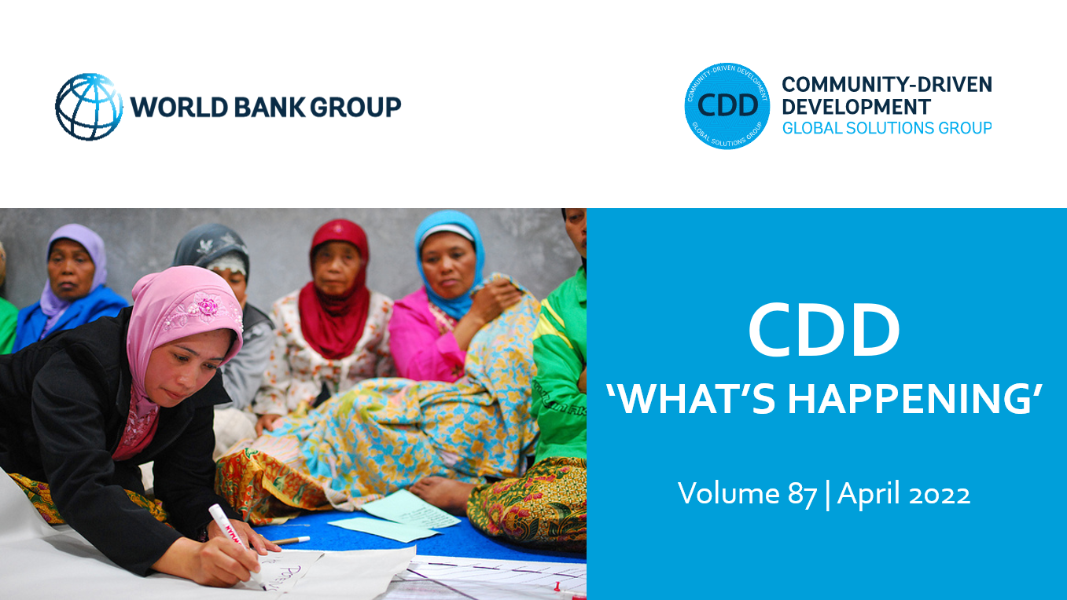
Dear CDD Community of Practice Members,

We hope this finds you all well. This month, we’re excited to share with you resources from the launch of the first three papers in the Forced Displacement and Social Cohesion series. In case you missed the event, the recording is now available online. In a blog, authors Louise Cord, Audrey Sacks, and Stephen Winkler share some of the emerging findings on the social and eocnomic benefits of refugee arrivals.

We’re also pleased to announce that the CDD Transformative Grassroots Leadership Training Manual, a resource to build the leadership capacities and soft skills of community institutions and women leaders, is now available in French. This newsletter also highlights new papers on the role of competition in reducing conflict and how self-help groups have helped women mitigate the impacts of the pandemic.

As always, we are eager to hear from you! Please share any relevant information and materials that you feel would benefit our community and stay in touch.

With best wishes,

Susan, Nik, Stephen, Helen, Camila and Anastasiia

BLOGS AND FEATURE STORIES

The social and economic benefits of refugee arrivals
In this blog, authors Louise Cord, Audrey Sacks and Stephen Winkler highlight findings from the World Bank, UNHCR, and UK FCDO’s work to understand how to prevent conflict and promote cohesion among communities experiencing forced displacement. Drawing from a series of commissioned papers that span diverse settings from Uganda and Peru to an analysis of refugee camps across Africa, the authors share emerging lessons on how forced displacement can bring about social and economic prosperity if managed effectively with inclusive policies and development investments.

Scaling up Impact for Recovery and Resilience in Yemen
This feature story highlights the work of the Yemen Emergency Crisis Response Project (ECRP). Amid heighted conflict, ECRP is supporting labor-intensive works and community services that help people regain access to services, earn wages, and support micro and small businesses to generate income. Working across 321 of Yemen’s 333 districts, the program has provided wage employment and skills training to nearly 443,000 people, benefitting youth, women and internally displaced persons/returnees.

RESOURCES AND REPORTS

CDD Transformative Grassroots Leadership Training Manual
Now Available in French
The CDD Transformative Grassroots Leadership Training Manual is a tool to 1) strengthen the capabilities and soft skills of community institutions to promote the inclusion of marginalized groups and advance women’s empowerment, and 2) build the leadership skills and self-confidence of women leaders.

The training manual, which consists of modules that are customizable to specific contexts and can be delivered as a whole or as stand-alone sections based on project needs, is now available in both French and English.

If you are interested in learning more, please contact Susan Wong and Helen Liu.
Can Competition Reduce Conflict?
A working paper from authors Teevrat Garg, Caterina Gennaioli, Stefania Lovo, and Gregor Singer studies the role of competition as a potential conflict reduction policy device in the context of Indonesia’s CDD program – the Kecamantan Development Program (KDP). They find that higher competition between villages reduces conflict, but only up to moderate levels of competition. The conflict-reducing effects of competition are largest in the most ethnically fractionalized and segregated villages and exist regardless of the eventual outcome of the competition. They find no evidence that competition increases inter-group violence.

Women’s groups and COVID-19: An evidence review on savings groups in Africa
This paper presents emerging evidence from studies in diverse contexts in sub-Saharan Africa —with a deep dive into Nigeria and Uganda—on how COVID-19 has affected women’s groups, especially savings groups, and how these groups have helped mitigate the gendered effects of the pandemic’s and the associated policy responses’ consequences up until April 2021. The synthesis presents evidence that savings groups found ways to continue operating, provided leadership opportunities for women during the pandemic, and mitigated some of the negative economic consequences of COVID-19 on individual savings group members.
RECENT EVENTS

The Social and Economic Benefits of Refugee Arrivals
March 31, 2022
The World Bank, together with UNHCR and FCDO, is working to build evidence on how policy measures and development investments can help reduce inequalities, alleviate social tensions, and promote social cohesion between and within displaced populations and host communities. Check out the recording of our launch of three papers in the Forced Displacement and Social Cohesion series. The event explored how the arrival of refugees often bring social and economic benefits to hosting communities.

Supporting Locally Led Adaptation Action: A MENA Climate Week Side Event
March 30, 2022
Last month, the World Resources Institute held a virtual side event at Middle East and North Africa Climate Week 2022 which explored the Principles for Locally Led Adaptation and shared lessons learned from the Middle East and North Africa (MENA) region and globally.
PROJECT APPROVALS

Response – Recovery – Resilience for Affected Communities in Ethiopia Project (P177233)
This project was approved on April 12, 2022 for $300 million and aims to (i) rebuild and improve access to basic services and climate-resilient community infrastructure and (ii) improve access to multi-sectoral response services for Gender-Based Violence (GBV) survivors; in selected conflict-affected communities in Ethiopia.

Additional Financing for Second Rwanda Urban Development Project (P177247)
This additional financing was approved on April 4, 2022 for $10.2 million and will support the comprehensive upgrading of four unplanned settlements, reduce flood risks at hotspots, pilot an integrated approach to sustainable wetland management, and deliver technical assistance in Kigali. In six secondary cities, the project will support basic infrastructure activities and the functioning of the newly established City Management Offices.

Gulf of Guinea Northern Regions Social Cohesion Project (P175043)
This regional project was approved on March 31, 2022 for $450 million and will operate in Benin, Cote d’Ivoire, Ghana, and Togo. The program aims to improve regional collaboration and the socioeconomic and climate resilience of border-zone communities in the target northern regions of the Gulf of Guinea countries exposed to conflict and climate risks.
JOIN OUR COMMUNITY

The Community-Driven Development CoP and GSG connects peers, thought leaders, and practitioners across governments, agencies, and academia, to share ideas and experiences on CDD approaches. This CoP/GSG is facilitated by the Global Programs Unit of the Social Sustainability and Inclusion Global Practice at the World Bank, with inputs from around the world.
To share papers, project news, interesting blogs, or upcoming events on CDD and other relevant themes with the CDD CoP, please email the CDD email and we'll incorporate these in the next "What's happening in CDD" newsletter.

To sign up for CDD CoP membership and receive our monthly newsletter, please click here
Please visit and bookmark our sites!
CDD Global Solutions Group (WB internal):
https://worldbankgroup.sharepoint.com/sites/gsg/CDD/Pages/Home.aspx
CDD Collaboration4Development (C4D) (external):
https://collaboration.worldbank.org/content/sites/collaboration-for-development/en/groups/community-driven-development-global-solutions-group.html

GLOBAL PROGRAMS UNIT - SSIGL | THE WORLD BANK
Email: cddgsg@worldbank.org

