EaP Country Fiche - Armenia
Tuesday, May 16, 2017
5:06 PM

EU EaP Transport Connectivity Agenda
Country Fiche Armenia
Last Update: 30/05/2016
Version: 4.00
Background | Introduction | The Republic of Armenia is situated in the south-western part of Asia at the junction with south-eastern part of Europe. This landlocked country occupies the North-Eastern part of the Armenian plateau, between Caucasus and Western Asia. It borders in the North and East with Georgia and Azerbaijan, and in the West and South with Turkey and Iran.  Road, rail and air routes are main transport modes in the Republic of Armenia. The most accessible ports are those of Georgia, Poti and Batumi, situated on the Black Sea some 650 km from Yerevan. The route to the Iranian ports is much longer (2000km from Yerevan) and is more expensive. As Armenia's main trade partners are Europe, Russia and China, cargo is usually transited on rail ferry services from Georgian Ports. A land connection with Russia exists through the Verkhny Lars crossing points. (Source: LOGMOS)  Yerevan, the capital city, accounted for about two-thirds of the domestic freight by roads. Roads account for most of passenger traffic, while air transport accounts for less than 1 % (in passenger-km). (Source: ADB)
 | Transport infrastructure bottlenecks | Key problems identified in the field of transport are:  - Road transport: there are lack of roads in good technical conditions, and the sub-standard road parameters are rife. This makes the roads unsuitable for cargo transportation and a great deal of modernisation will be required to make them reliable for heavy commercial truck fleets. (Source: LOGMOS). The reasons why many segments of the road network are in poor condition include insufficient financing for maintenance; outdated road design, maintenance standards, and technical specifications; and lack of qualified workers, contractors, and consulting companies with the necessary knowledge and skills. (Source: ADB)  - Road design and maintenance standards as well as technical specifications need to be modernized, collection of road and traffic data should be improved, and cost-effective technical solutions need to be developed for low-volume roads. (Source: ADB)  - There is also the need of updating the vehicle fleet, free market formation and creation of logistics centres.  - Road safety is a critical issue for the country. The number of recorded traffic accidents was 3.156 in 2014 and 3.399 in 2015 and the number of people killed or injured in traffic accidents for the same years was 4.479 and 4.738, respectively. The traffic accident fatality rate is much higher in Armenia than in European countries. (Source: ADB)  - Rail transport: there is only one key railway line connection, which is now under development. However, there is still an urgent need to rehabilitate and reconstruct some of its sections and structures and to modernize the rolling stock.  - Key challenges and opportunities for the railway include network development for faster transit across Armenia and to Georgia, establishment of intermodal terminals, and development of container transport. (Source: ADB)  - A major problem in Armenia's transport sector is that multimodal transport and logistics services are underdeveloped. (Source: ADB)  - Armenia is a land-locked country and does not possess any maritime access, the most accessible ports are those of Georgia, Poti and Batumi. Given this situation, the accessibility to Georgian Ports and the Black Sea maritime links is vital for Armenia's economy. (Source: LOGMOS)
Flagship transport projects |  | The North-South Road Corridor investment program is the most important intervention in the sector and relates to the 556 km highway connecting Georgia (North) and Iran (South) along Meghri - Yerevan - Bavra. The design of the Northern part of the corridor is progressing and Tranche 1 (31 km Yerevan-Artashat and Yerevan-Ashtarak) has been opened for traffic in December 2015. The feasibility study for the Southern part of the corridor has been completed and preliminary design is currently on going. For this part of the corridor the Armenian government is exploring the opportunity of PPP and additional cofinancing by IFI's.  Another priority is the rehabilitation and improvement of M6 Vanadzor-Alaverdi-Georgian border interstate road. The project relates to 90 km interstate road which presents poor pavement conditions and lacks of adequate sight distance. The intervention will be cofounded by EIB and ADB.  Both the North-South investment program and the rehabilitation of the M6 Vanadzor-Alaverdi-Georgian border are included in the priorities set in the "Armenia Transport Sector Development Strategy 2020" of 2009.  Other priorities are the rehabilitation and improvement of M3, M4 and M8 interstate roads. The rehabilitation is planned to last 3 years if funded only by the government and 1 year in case of additional IFI's funds.  Future plans in the sector regard the rehabilitation of additional 300 km of interstate roads in order to improve road safety which is a serious issue for the country. The improvement of the road network (built over 50 years ago and never improved/maintained due to financial constraints) for rural communities is one of the Government's key objectives. These roads are called "lifeline" roads and they cover about 40% of Armenia's rural roads. As part of its anti-crisis policy aimed at creating temporary employment through investment in public works, the Government has embarked on a program to make significant investments in the improvement of the "lifeline" road network.
Institutional and legal framework | Road sector | The Ministry of Transport and Communications (MOTC) is the principal government agency in charge of the transport sector. It administers all interstate roads and of republican roads.  MOTC delegates its road administration functions (including collection of road and traffic data and maintenance of roads) to the Armenian Road Directorate SNCO (ARD), a state-owned non commercial organization, through annual contracts.  Regional administrations (marzes) and local communities manage all local roads. Private companies provide road maintenance services under 5-year contracts with ARD, marzes, and local communities. (Source: ADB).  Most public bus services in Yerevan and secondary towns as well as intercity routes have been franchised to private operators on a route-by-route basis. (Source: ADB).  Currently there are no tolled roads in the country but there are some plans to introduce them in the future on the southern part of the North-South corridor.  The private sector provides most road transport services (including international and urban transport services), and competition in the market for the seservices is fairly robust. (Source: ADB).  There are no subsidies for operators.
 | Railways sector | The relevant authority in the railway sector is the Ministry of Transport and Communication (MOTC) who is in charge of planning the development of the sector.  Armenian Railways was established in 1991 as a closed joint-stock company. Prior to independence, it was part of the Trans-Caucasus Railway, headquartered in Tbilisi, Georgia, which also included the Azerbaijani and Georgian networks. Most of Armenia Railways was built during the Soviet era. (Source: ADB)  In 2008, the government signed a concession agreement allowing Armenian Railways to be run by a 100% subsidiary of Russian Railways, and to operate as the South Caucasus Railway (SCR) for 30-year concession management with a right to prolong the management term for other 10 years. (Source: ADB)  SCR received property owned by Armenian Railways consisting of 2.000 freight wagons, 58 passenger coaches, 85 locomotives and 30 electric trains.
 | Aviation sector | To enforce the liberalization policy ("Open sky" policy, adopted by Government of RA on October 2013) the Ministry of Economy together with the GDCA are currently renegotiating Air Services Agreements with our partner States and initiating new partnerships. Series of very productive negotiations have been held with already 26 countries. High degree of liberalization has been agreed upon in the agreements with some of the partner states reciprocally granting 5th freedom traffic rights.  Discussions on a possible EU-Armenia Common Aviation Area Agreement have been held and the Commission has recently requested negotiating mandate. This will allow Armenia to liberalize aviation market with all EU member states.  To ensure successful implementation of the Aviation Reform three main directions have been defined:  - Revision of the legal and regulatory framework in the field of aviation with an emphasis on the optimization of the governance structure.  - Revision of existing Air Services Agreements to reflect changes in the aviation policy and legal framework.  - Negotiations with airlines with the purpose to promote awareness regarding liberalization and to bolster competition.  With the Government's firm determination to fully and effectively implement the reform, new Aviation Law consistent with McKinsey recommendations was enforced, effective August 1, 2015. The new law established the institutional framework, where:  - The Ministry of Economy, henceforth, is responsible for Aviation policy formulation, implementation, and regulatory control. It is commissioned to negotiate bilateral air services agreements with partner states and authorize foreign carriers to operate both regular/charter flights to/from Armenia. Also it is authorized to license and designate local carriers.  - The General Department of Civil Aviation remains the technical regulatory authority responsible for aviation safety and security.  - An independent accident investigation body will be established by the Government.
National transport policy and plan |  | The governmental body in charge of regulation and defining the axes of development and the national transport policy is the Ministry of Transport and Communication of the Republic of Armenia (MoTC). It is composed of the transport department, which comprises the transport policy and the technical policy sections, the Railway department and the Road Construction Department. (Source: ADB)  Improving transport infrastructure and services is among the government's top priorities. Its transport sector strategy is set forth in several documents, such as the Armenia Development Strategy 2025 (ADS, approved with the Government decree N442-N of March 27, 2014) and the latest Government Program (2014). The ADS calls for an increase in, and more efficient use of, public resources allocated to maintenance and rehabilitation of roads. The transport sector priorities identified in the ADS include reconstruction of the north-south road and of at least one road connecting each settlement with the rest of the country; strengthening of road subsector management; improvement of public transport services; and development of eco-friendly transport. (Source: ADB)  The Republic of Armenia Government Program (2014) also calls for an increase in public funds allocated to maintenance and rehabilitation of roads, and for more efficient use of these funds. The program identifies the following medium-term priorities for the government in the transport sector:  - reconstruction of the North-South road;  - construction of bypass roads for Yerevan;  - accelerated implementation of road projects in the secondary towns;  - strengthening of management of urban and intercity transport;  - modernization of public transport;  - improvement of rural roads;  - expansion of bilateral cooperation with other countries in air transport;  - improvement of the quality of air transport services;  - and diversification of transport links with the rest of the world. (Source: ADB)  Also, the Midterm Expenditure Framework 2016-2018 (MTEF) paper prepared by the Ministry of Finance puts forward that the main goal for the transport and communication sector continue to be: "maintaining reliable transportation and communication, also construction of the North-South road corridor and development of communication systems."  Today, the national transport policy of Armenia is defined in the following main documents:  - Armenia Transport Sector Development Strategy 2020 (developed by ADBand approved in 2009) which pursues improved management, enhanced infrastructure and technology to maximise the transport sector's performance until 2020. It also envisages long-term prosperity through the establishment of efficient, cost-effective and environmentally and socially sustainable transport infrastructure and services.  - National Road Safety Strategy for Armenia (a five years action plan approved in 2009 whose implementation is under the National Road Safety Council of Armenia) that aims to reduce the number of road fatalities by 10%.  - Road Sector Financing Strategy 2015-2025 (Decree N° 873-N of June 25th 2015)  - National Strategy of the Republic of Armenia for Ensuring Transport Security 2009-2013  - Air Transport Development Strategy (prompted in June2013 after the bankruptcy of Armavia), which envisions gradual liberalization of the market for air transport services. (Source: ADB)  - TRACECA program road safety project
Investments decision making process |  | Investments on transport infrastructure in Armenia are under the responsibility of:  - Ministry of Transport and communication  - Armenian Road Directorate ARD  Priorities in transport investments are jointly decided by the Road Council and the Ministry of Transport. They also jointly decide the interventions that can be funded by the national government and those that require IFI's contribution. Representatives of the Ministry of Finance are also involved in the Road Council. The Road Council establishes the priorities on the basis of data on road status.  The project cycle is structured along the following phases:  - Concept phase (under the responsibility of MoTC and ARD)  - Feasibility study  - Design phases  - Financing and funding  - Implementation  - Monitoring
Financing and Funding |  | Infrastructures in Armenia are financed through general taxation and donor sources. There are no tolls and the fees collected at borders are redirected to the national budget and not to the sector. The MoTC is not responsible for the introduction of taxes in the sector.  Currently the government is exploring the possibility to finance the southern part of the North-South corridor through PPP and to introduce tolls on this section given that certain conditions are respected i.e.  - the availability of alternative non tolled roads for those unwilling to pay;  - the reduced length of the new road that will become attractive enough to justify the payment of a toll.  The Government is pursuing a policy of extensive use of public-privatepartnerships (PPPs) in the transport sector. (Source: ADB)  The legislative framework for introducing PPP and concessions system in Armenia is not yet sufficiently developed, but the government is currently reviewing international practices in order to implement new legislation and/or agreements.  Although MOTC has introduced a growing number of private sector participation and PPP projects in recent years, it mainly secures the financing of investment projects from government budget and donor sources. (Source: ADB)  State budget expenditures on road network operation and maintenance in 2007‐2012 are presented in the table below.  2007 2008 2009 2010 2011 2012  mln. AMD 44.243 41.901 57.792 32.540 24.647 29.474  Share of GDP 1.40% 1.17% 1.84% 0.93% 0.64% 0.73%  Source: Armenia Development Strategy for 2014‐2025  According to the Armenia Development Strategy for 2014‐2025, the public expenditure policy in the transport sector will focus on increasing the volumes of public resources allocated to the current maintenance and capital repair of motorways, and enhancing the effectiveness of the use of those resources.  In 2014 contributions from consolidated budget comprise around 1.5% of GDP compared to the baseline 2012 level of 0.49%, and decreasing further to reach 1.0% in 2025. 85% of this budget will be aimed at road network, and the remaining 15% at other programs.  The primary target of the investment policy will be to repair segments of at least one traffic road connecting each settlement to the corresponding regional center, North‐South road corridor construction, as well as roads and segments of roads with high economic effectiveness.  In order to put spending on the road infrastructure on solid basis, a road financing study was carried out. Based on the recommendations of the study the RA Government issued Decree N° 873-N of June 25th 2015 on approving the Road Sector Financing Strategy 2015-2025. (Source: WB)  Since December 31 2015 the road asset management system has been introduced to make management of road assets more efficient and helping in decision-making on road infrastructure financing. (Source: WB)  Based on advanced international experience, a uniform bidding package and performance based contracting for the procurement of road rehabilitation and maintenance works will be developed and piloted. (Source: WB)
Donors coordination |  | Donor coordination in infrastructure sectors in Armenia is very limited. A group called the Infrastructure Coordination Group (ICG) was established by the World Bank (WB) and Asian Development Bank (ADB) in 2014. The group is chaired at the moment by ADB. Current members of ICG include:  - Asian Development Bank (ADB)  - Eurasian Development Bank (EADB)  - European Bank for Reconstruction and Development (EBRD)  - European Investment Bank (EIB)  - European Union (EU)  - Initiatives for Development of Armenia (IDeA Foundation)  - International Monetary Fund (IMF)  - KfW  - United Nations Development Program (UNDP)  - World Bank  There is no participation from the Government although a recent initiative to request the presence of governmental official has been launched.  The meetings are organised on an ad hoc basis (3-4 times a year) and the topics discussed depend on donors' proposal. There are no formal minutes of the meetings and very little follow up on common topics/issues discussed.  The EU has launched a technical assistance to improve the coordination and decision making across all infrastructure sector projects. This exercise is being carried out jointly with the Ministry of International Economic Integration and Reforms (MIEIR).
Transport Indicators | General | Mode Indicator Year Unit of measurement Value  Road Total length 2015 Km 7.570  Paved network 2015 Km 5.953  Total motor vehicles 2010 per 1.000 people 92,3  Cars 2010 per 1.000 people 80,1  Freight 2015 million tons∙km 479  Passengers¹ 2015 million pass∙km 2.396  Road accidents 2015 Accidents 3.399  Fatalities 2015 People 346  Serious injuries 2015 People 4.733  Railway Total length (broad gauge) 2015 Km 703  Electrified network 2015 Km 703  Freight 2015 million tons∙km 640  Passengers 2015 million pass∙km 44  Air Airports 2013 Units 11  Freight 2014 million tons∙km 2  Passengers 2014 million pass 2  Pipelines Total length 2015 Km 1.594  Source: National Statistical Service of the Republic of Armenia (2016), C.I.A. (The World Factbook), The World Bank, Noravank Scientific Educational Foundation.  ¹ By motor vehicles and taxi
 | LPI (Logistics Performance Index) | Year 2007 2010 2012 2014  LPI Rank 131 111 100 92  LPI Score 2.14 2.52 2.56 2.67  Customs 2.10 2.10 2.27 2.63  Infrastructure 1.78 2.32 2.38 2.38  International Shipments 2.00 2.43 2.65 2.75  Logistics Competence 2.11 2.59 2.40 2.75  Tracking and Tracing 2.22 2.26 2.57 2.50  Timeliness 2.63 3.40 3.07 3.00  Source: WB  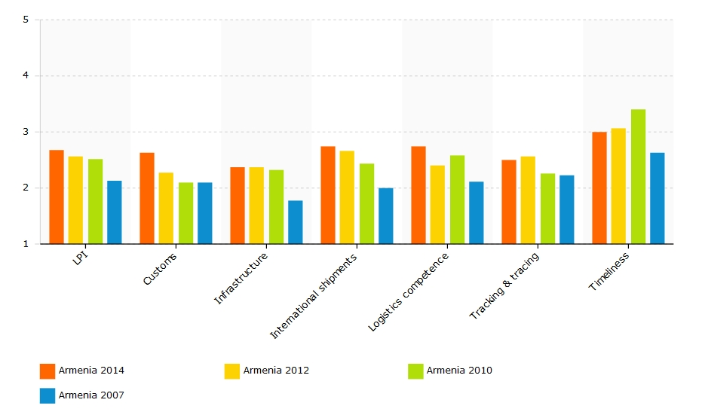  Source: WB  The Logistics Performance Index is an interactive benchmarking tool created to help countries identify the challenges and opportunities they face in their performance on trade logistics and what they can do to improve their performance. The LPI is based on a worldwide survey of operators on the ground (global freight forwarders and express carriers), providing feedback on the logistics "friendliness" of the countries in which they operate and those with which they trade.
 | EaP Road Network Indicators | Total length: 707 km  - Motorway with separated lanes (4 lanes in both directions): 34 km  - Single carriageway road (2 lanes in both directions): 654 km  - Single carriageway road (4 lanes in both directions): 19 km  Network indicators (km)  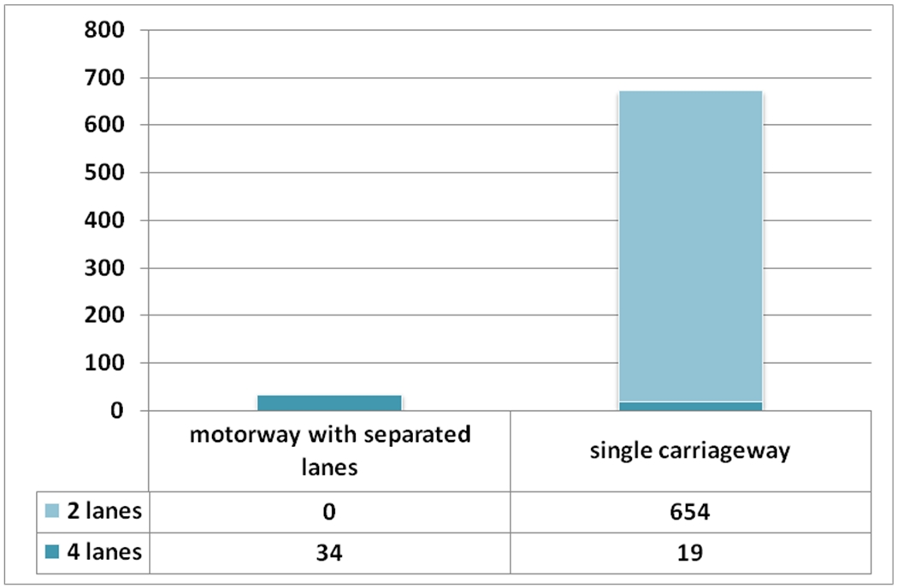  Design speed (km)  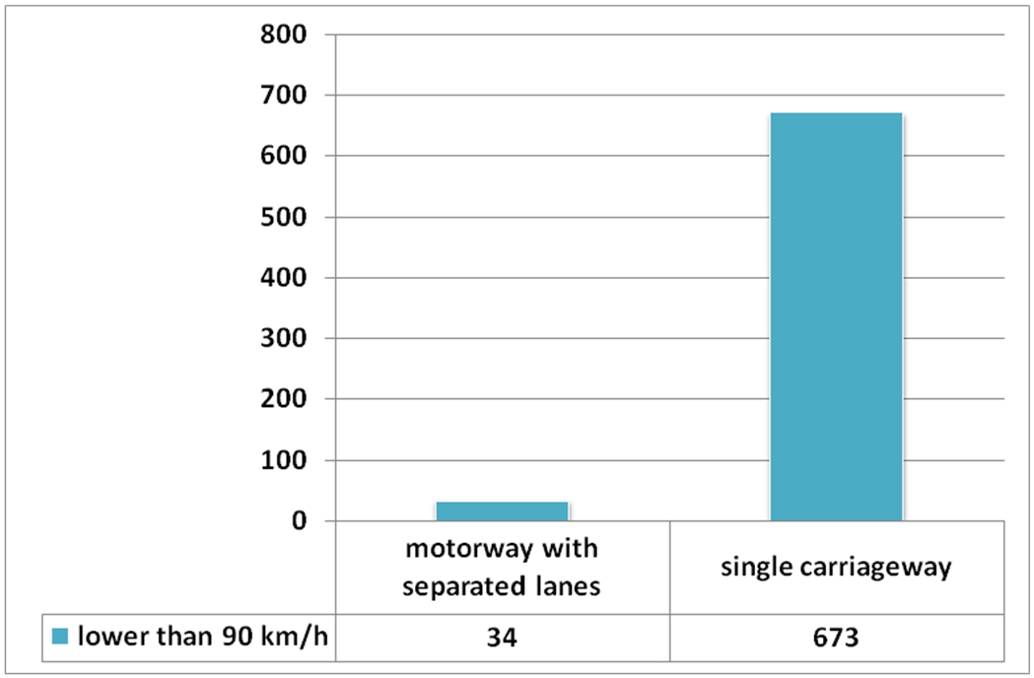  Road conditions (km)  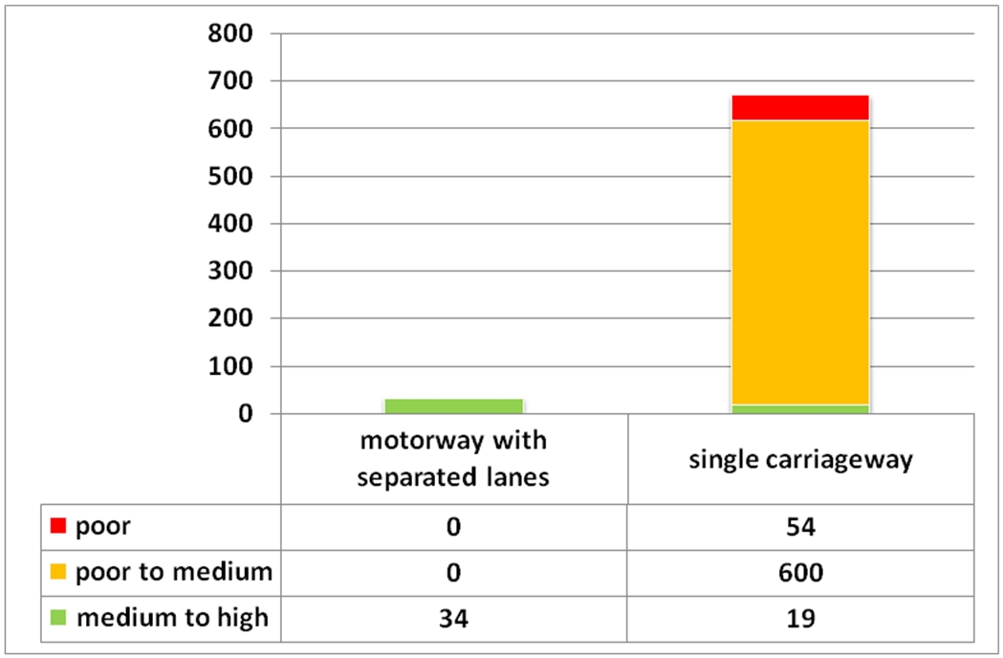  The survey on road quality performed on the context of the EaP regional transport study shows that 93% of the EaP strategic network in Armenia is characterized by poor (54 km) and poor to medium (600 km) road conditions.  LEVEL OF SERVICE ON EaP ROAD NETWORK  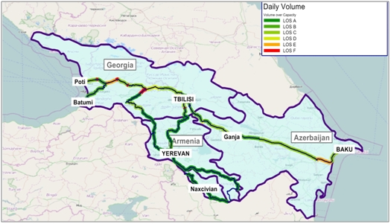  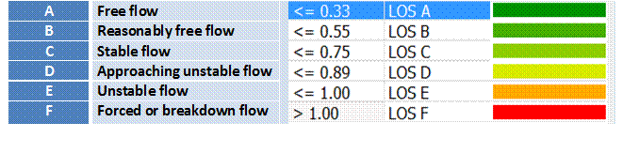
 | EaP Rail Network Indicators | The total length of the railway tracks in Armenia is 1,328.6 km (including 780 km of express tracks) but only 845 km is operated (single track, electrified at 3000 V DC). These are Russian-gauge (1520 mm) rail tracks. Almost all the rail tracks are single, electrified and equipped with semi-automated blocking and modern communication systems. Double tracks constitute 2.56% of the network.  Traction  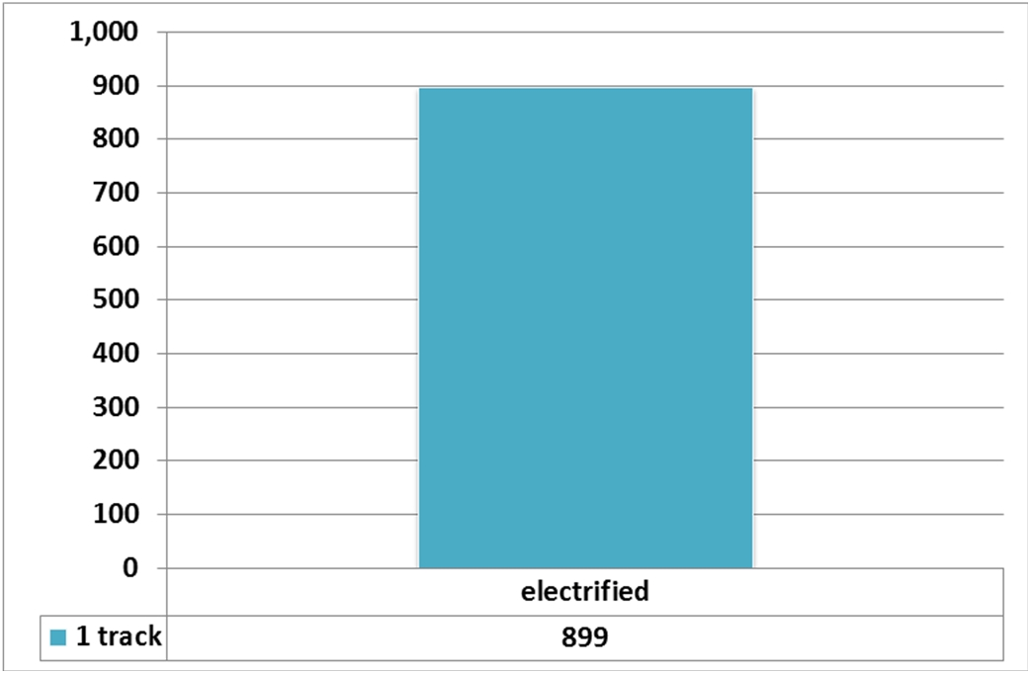
Projects included in the EaP Database |  | Title of project Sector Total cost IFI funding  North-South road corridor: section in the northern part of the corridor Yerevan - Bavra Road All costs are given net of taxes  1. Yerevan - Ashtarak 21mln USD ADB  2. Ashtarak - Talin 170mln USD ADB  3. Talin - Lanjik 100 mln USD ADB  4. Lanjik - Gyumri 72mlnEUR EIB  Rehabilitation and improvement of the M6 Vanadzor - Alaverdi - Georgian border interstate road Road 102 mln EUR EIB ADB NIF  Armenia Northern corridor modernisation project: upgrade of Bagratashen, Bavra and Gogavan border crossing points Road 62,3 mln EUR EBRD EIB (NIF) (UNDP)  International Logistics Centre (ILC) at Zvarnots international airport Intermodal 24,4 mln EUR n.a.  Lifeline Road Network Improvement Project Road 85 mln USD WB  North-South road corridor: section in the southern part of the corridor Road All costs are given net of taxes  1.Yerevan - Artashat 39mln USD ADB  2. Artashat - Qajaran 170 mlnUSD (preliminary agreement) + n.a. ADB  3. Qajaran- Agarak 150mln USD (for 20 km from Agarak) + n.a. EADB  4. Gyumri - Bavra 132 mln EUR (preliminary agreement) EIB(NIF)  Improvement of the M3 Turkish border - Margara - Vanadzor-Tashir- Georgian border road Road 70,5 mln EUR n.a.  Improvement of the M4 Yerevan - Sevan - Ijevan - Azerbaijan border road Road 98,5 mln EUR n.a.  Improvement of the M8 Vanadzor - Dilijan road Road 23,3 mln EUR n.a.  Improvement of the M16 M4-Voskepar - Noyemberyan - M6 road Road 43,6 mln EUR n.a.  ADB Asian Development Bank  EIB European Investment Bank  EDB Eurasian Development Bank  NIFNeighbourhood Investment Facility  UNDP United Nations Development Programme  WB World Bank  () Envisaged IFI
Macro-financial context |  | BASIC ECONOMIC INDICATORS  Indicator Unit of measurement 2010 2011 2012 2013 2014  GDP¹ million Euro 4.750 4.973 5.331 5.507 5.705  GDP per capita¹ Euro/capita 1.560 1.642 1.763 1.822 1.893  GDP growth % 2,2 4,7 7,2 3,3 3,6  Inflation² % 8,2 7,7 2,6 5,8 3,0  Unemployment % 19,0 18,4 17,3 16,2 17,1  Agriculture % of GDP 19,2 22,8 21,6 20,7 20,4  Industry % of GDP 37,0 33,8 33,2 30,0 28,5  Services % of GDP 43,8 43,4 45,2 49,3 51,1  Trade % of GDP 66,1 71,1 76,0 76,6 75,4  Public debt % of GDP 34,7 36,4 37,7 30,4 32,8  External debt % of GDP 68,1 73,0 71,9 78,0 73,4  Total loans % of GDP 48,8 49,8 47,3 44,0 n. a.  Import million Euro 2.824 2.977 3.315 3.302 3.333  Export million Euro 784 958 1.074 1.113 1.166  Balance million Euro -2.040 -2.019 -2.241 -2.189 -2.167  Real interest rate % 10,6 12,9 11,3 12,2 13,3  Source: National Statistic Service of the Republic ofArmenia (2016), The World Bank (2014), EC (2014), Central Bank of Armenia (2014).  ¹ Constant prices 2005  ² Consumer annual price  Explanatory Note: The external debt, at any given time, is the unresolved amount of current, and not contingent, liabilities that require payment of an interest by a debtor at some point in the future and that are owed to non-residents by residents of an economy.  The non-resident creditors that owns the external debt are disseminated by many economies. Official creditors are public bilateral bodies and multilateral organizations. Public bilateral creditors are lenders in individual countries (e.g., central governments and central banks), multilateral organisations are international institutions (e.g., the International Monetary Fund, the World Bank and regional development banks). The total loans supplied to the economy of a country characterise the borrowing capacity of that country, with respect to external financing.  Source: IMF (2014), External Debt Statistics Guide for Compilers And Users; The World Bank (2016), Joint External Debt Hub.  BASIC SOCIAL INDICATORS  Indicator Unit of measurement 2010 2011 2012 2013 2014  Total population Inhabitants 3.055.236 3.034.499 3.021.376 3.026.879 3.017.079  Urban population % 63,5 63,4 63,3 63,3 63,4  Rural population % 36,5 36,6 36,7 36,7 36,6  Gini Index adimensional 36,2 37,1 37,2 37,2 37,3  Life expectancy years 74,1 74,2 74,3 74,8 75,0  Poverty rate % 35,8 35,0 32,4 32,0 30,0  Source: Statistic Service of the Republic of Armenia (2016).  BASIC ENERGY AND ENVIRONMETAL INDICATORS  Indicator Unit of measurement 2010 2011 2012 2013 2014  Energy use Kg of oil eq./capita 838,0 915,1 997,4 n. a. n. a.  Electric power cons. kWh/capita 1.676,1 1.752,4 1.832,2 n. a. n. a.  CO₂ emissions metric tons/capita 1,4 1,7 n. a. n. a. n. a.  Source: The World Bank (2014).  STRUCTURE OF THE ECONOMY  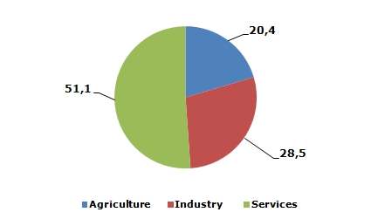  Source: Statistic Service of the Republic of Armenia (2016).  IMPORT AND EXPORT BY MAIN PRODUCTS AND LEAD MARKETS  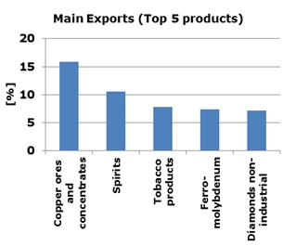  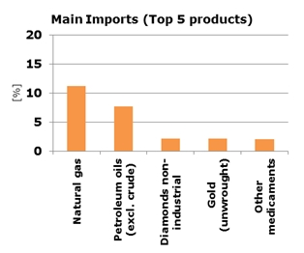  Source: The World Bank (2014)  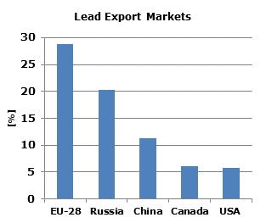  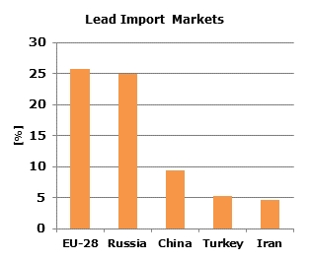  Source: The World Bank (2014)
References |  | http://www.traceca-org.org/fileadmin/fm-dam/TAREP/65ta/Master_Plan/MPA9.1AM.pdf  http://www.traceca-org.org/fileadmin/fm-dam/TAREP/65ta/Country_Profiles/CP_chapters/AR_CP_en.pdf  http://ec.europa.eu/transport/themes/international/studies/doc/2015-06-eastern-partnership-regional-transport-study.pdf  http://www.armstat.am/file/doc/99493663.pdf  https://www.cia.gov/library/publications/the-world-factbook/geos/am.html  http://www.noravank.am/upload/pdf/Transportation%20Modes%20in%20Armenia.pdf  http://www.who.int/violence_injury_prevention/road_safety_status/2013/country_profiles/armenia.pdf  http://everything.explained.today/List_of_countries_by_rail_transport_network_size/  http://databank.worldbank.org/data/reports.aspx?source=world-development-indicators  http://www.tradingeconomics.com/armenia/government-debt-to-gdp  http://trade.ec.europa.eu/doclib/docs/2006/september/tradoc_113345.pdf  http://wits.worldbank.org/CountryProfile/en/Country/ARM/Year/2014/Summary  http://www.adb.org/sites/default/files/institutional-document/153661/cps-arm-2014-2018.pdf  http://www.adb.org/sites/default/files/linked-documents/cps-arm-2014-2018-ssa-01.pdf  http://www.worldbank.org/content/dam/Worldbank/document/Armenia-Snapshot.pdf  http://faolex.fao.org/docs/pdf/arm151333.pdf  http://www.adb.org/sites/default/files/publication/28298/armenia-transport-outlook.pdf  http://databank.worldbank.org/data/reports.aspx?source=joint-external-debt-hub  http://www.jedh.org/jedh_home.html
This document has been prepared by the IDEA II project.
The content of this document does not reflect the official opinion of the European Union.
Responsibility for the information and views here expressed lies entirely with the author(s).

Inserted from <http://trt.serverlet.com/EaP/country_fiche.php?id=2>

