EaP Country Fiche - Belarus
Tuesday, May 16, 2017
5:10 PM

EU EaP Transport Connectivity Agenda
Country Fiche Belarus
Last Update: 24/06/2016
Version: 2.00
Background | Introduction | Belarus is a landlocked country in north-east of Europe bordered by Russia to the northeast, Ukraine to the south, Poland to the west, and Lithuania and Latvia to the northwest. Export and import are carried out through the sea port facilities of Lithuania, Latvia, Estonia, Ukraine and the Russian Federation (Source: UNECE 2013).  The following major transport axes pass through Belarus:  - Two Pan-European transport corridors: Corridor II Berlin-Warsaw-Minsk-Moscow-Nizhny Novgorod and Corridor IX, which crosses Belarusian territory from north to the south. (Source: UNECE 2013, UNECE Pan corridors).  - Two transport corridors of the Organization for Cooperation of Railways (OSJD) - № 1 and № 9. OSJD corridor 1 coincides with the Trans-Siberian railway corridor on the territory of the Russian Federation. (Source: UNECE 2013)  - Inland waterways of Belarus, including the Dnieper- Bug Canal, are part of the main international waterway E- 40 from Gdansk through Pinsk to Kherson. (Source: UNECE 2013).  Belarusian road infrastructure is an extensive network of roads, which provide a continuous communication with almost all populated areas. More than 70% of all goods are transported by road. The analysis of road conditions shows that only 32,5% of national roads correspond to the required standards; 30%, of road is in poor condition or 21% presents big pavement defects. (Source: UNECE 2013).  Belarusian railways is a modern, well developed transportation system with a length of 5.491 km, in which the length of electrified lines is 1.128 km (21%), non-electrified- 4.363 km (79%); 3.856 km (70%) of the network has a single-track, the remaining 1.634 km (30%) is the two tracks and more.  Inland waterway transport organizations carry out goods transportation along the rivers of the Republic of Belarus (10 river ports are engaged in transport and handling of cargo) and in international traffic on the Dniepr River in the Black Sea ports. The fleet work from March to November. (Source: UNECE 2013).
 | Transport infrastructure bottlenecks | Key problems identified in the field of transport are:  Road transport  - Limited number of repair work due to lack of funding;  - Seasonal restriction of traffic in spring and summer is applied in order to ensure the safety of roads;  - Insufficient number of gas and service stations located along the public roads.  Rail transport  - Renewal of rolling stock of the Belarusian Railways is needed;  - Electrification of rail tracks is needed (Source: UNECE 2013).  Inland waterway transport  - Restoration of waterways between river Muhovets and river Visla is needed. This will lead to increased flow of goods from the ports of the Black Sea along the Dnieper and Pripyat, as well as Dnieper- Bug Canal with further access to the Vistula-Oder waterway system and the Baltic Sea (Source: UNECE 2013).  Intermodal system  - Extension of complexness of services in the logistics centres in the territory of Belarus;  - Poor transit efficiency of Belarus regarding the control of movement of the goods across the customs border, complicated procedures for customs clearance of goods  (Source: UNECE 2013).
Flagship transport projects |  | Three main transport infrastructure projects cover the highest priority in the country:  - Upgrade of road between Minsk and Vilnius  - Construction of a brige across the river Zapadny Bug (Western Bug) at the road checkpoint Domachevo (Slovatichi) (Source: MTK-BY)  - Electrification of Molodechno-GudaGai-State border.
Institutional and legal framework | Road sector | Motorways of general purpose in the Republic of Belarus are state property. They are divided into national and local motorways.  The Ministry of Transport and Communications is responsible for maintenance and motorway services in the field of road transport.  Road maintenance is provided by state owned firms. Some road organization, including the management and operation of roads, have been transformed into joint-stock companies.  Road construction is conducted by private road-building organizations.  Belarus currently has 1.512 km of toll roads and the government plans to reach 2,000 km by 2020. In 2013, the government introduced an electronic system called BelToll for charging road tolls, which replaced the older system of manual collection. In Belarus the toll is charged for cars registered outside the Eurasian Economic Union and cars weighing over 3,5 tonnes.  Urban transport services are decentralised. The Ministry of Transport and Communications carries out State regulation in the sphere of transportation of passengers and goods. Operators are legally separated but not fully corporatized. Private operators are active in urban and intercity transport, mainly with minibuses. Urban transport organizations provide services at fixed rates with local budgets grant socially meaningful traffic.  Tariff policies are heavily influenced by the state and are not cost reflective. In 2011 the authorities of the City of Minsk abolished the price control over the fixed-route mini-bus operators, allowing them to set prices at their own discretion, but with certain profitability margin restrictions. There are no formal contractual arrangements between municipal operators and municipalities, whereas private companies operate on the basis of simple licenses.  Freight transportation is carried out mostly by public companies. Privatization of state-owned companies is not promoted. The existing regulations on the import of heavy trucks are unfavourable for private companies which enforces them to suspend their activity. (Source: Case Study Transport in Minsk)
 | Railways sector | The Ministry of Transport and Communications of the Republic of Belarus determines the state policy in the field of railway transport. The state association "Belarusian Railroad" is a commercial organization submitted to the Ministry of Transport and Communications which exercises control of transportation process on public railway transport and the management of organizations activity.  The infrastructure of public railway transport is in state ownership. Transportations of passengers, freights, baggage and cargo baggage are carried out by national carriers -"Belarusian Railroad" and its organizations. Other actors who are not legal entities of Republic of Belarus and citizens of Republic of Belarus registered as individual entrepreneurs can transport passengers, freights, baggage and cargo baggage on infrastructure if the possibility of providing to such carriers the access to services of infrastructure is provided by international treaties of Republic of Belarus, and according to the contracts terms.  The main act regulating activity of railway transport in the Republic of Belarus is the Law "On Railway Transport" which last edition works since July 11, 2015.
 | Maritime sector | n.a.
 | Aviation sector | Powers of national aviation administration are carried out by the Department on aircraft of the Ministry of Transport and Communications of Republic of Belarus.  Most companies, such as the airports, are fully state-owned entities; therefore the Ministry is directly responsible for the management of the Belarus airports, such as Minsk, Brest, Gomel, Grodno, Mogilev, Vitebsk. Furthermore, the Ministry controls the air companies "Belavia", BELAERONAVIGATSIA, the JSC "Transaviaexport", an aviation college and two recreational centres.  The competitive advantage of Belavia in comparison to competitors still lies in the fact that, because of low wage levels in Belarus the operating costs are lower, and therefore lower ticket and transport fares could be offered on the market. Furthermore, Belarus has a direct access to the fuel refineries, where aviation fuel has been produced. Thus, Belarus has one of the lowest fuel prices in Europe. (Source: Grodno Airport)
 | Inland waterway sector | The Ministry of Transport and Communications of the Republic of Belarus is in charge of public regulation and governance in the sphere of sea and inland water, which is duly dedicated to actions of legal entities and individual entrepreneurs performing:  - carriage and forwarding;  - work (services) related to provision of services to cargo, transport vehicles, repair of transport vehicles and technological equipment;  - diagnostics, design, construction, reconstruction, repair, maintenance of domestic inland waterways, navigable hydrotechnical objects and ports;  - scientific researches;  - staff training;  - information support;  - other work in this area. (Source: BELARUSIAN TRANSPORT AND LOGISTICS CONGRESS)
National transport policy and plan |  | The National Strategy for Sustainable Socio-Economic Development of Belarus until 2020 (NSSD 2020) is the principal development policy document for the country. The Strategy established development priorities. In the field of transport the strategic document is the "Strategy of innovative development of a transport complex of the Republic of Belarus till 2030" approved by the Ministry of Transport in 2015.  Subprogrammes are a part of the state program:  "Development of railway transport of the Republic of Belarus";  "Development of motor, city electric transport and subway of the Republic of Belarus";  "Development of inland water and sea transport of the Republic of Belarus";  "Development of civil aviation of the Republic of Belarus".  Development and modernization of a road network in the republic is carried out within the "State program on development and the maintenance of highways in the Republic of Belarus for 2015-2019".  Challenges in logistics facing Belarus today include:  - attracting investors in the transport and logistics sector;  - acceleration of logistics development through the use of foreign experience and adoption of the relevant technologies and guidance methods;  - ensuring legal conditions for the development of logistics services market;  - promoting competition in the logistics market;  - providing the comprehensive and simultaneous development of logistics infrastructure facilities;  - ensuring the coordination of the various elements of the logistics market;  - simplification of taxation and workflow for logistics operators;  - liberalization of customs legislation in the field of transit of goods. (Source: Ministry of Foreign Affairs 2015)  The analysis of the legislation of the Republic of Belarus in the sphere of international transport of freights shows the focus on restriction of monopoly in this area, development of both the public, and private sectors, strengthening of safety on transport, prevention of discrimination, providing equal conditions for activity and effective control in this area.
Investments decision making process |  | The order of the organization of development, approval and consideration of business plans of investment projects, carrying out examination of investment projects, except for cases when other order of carrying out examination is established by acts and (or) resolutions of the Council of Ministers of the Republic of Belarus, is defined by the Provision on an order of the organization of development, the statement and consideration of business plans of investment projects, and also carrying out examination of investment projects approved by the resolution of the Council of ministers of the Republic of Belarus dd. 26.05.2014 No. 506.
Financing and Funding |  | Road sector  Financing of road economy of the Republic of Belarus in 1991-2008 was carried out according to the Law of the Republic of Belarus dd. December 23, 1991 No. 1339-XII "On road funds in the Republic of Belarus". This law regulated sources of formation and use of means of these funds for contents and development of a network of public roads.  The main sources of funds were:  - tax on users of roads;  - tax on fuel sales;  - charge for transition of vehicles of the foreign states on roads of the republic;  - a fare on paid highways;  - TKTS fare.  Since 2009 the Law of Republic of Belarus "On road funds in the Republic of Belarus" was suspended and financing of republican roads was carried out at the expense of the republican budget.  For prevention of an aggravation of symptoms of a road network, development of transit capacity of the country taking into account staying in a common economic space, ensuring stable and rhythmical financing of road economy and in the next years of significant improvement of a road network in the Republic of Belarus since 2014 the road fund is restored.  Sources of formation of republican road fund are:  - charge for transition of vehicles of the foreign states on roads of the republic;  - TKTS fare;  - the state tax for permission to the admission of the vehicle to participation in traffic;  - a fare on paid highways of the republic with system of electronic collecting a payment;  - the percent paid by banks for use of the money which are transferred into the accounts of SE "Belavtostrada" for the servicing of the financial flows arising from functioning system of electronic collecting a payment (it is injected since 2016).  Besides, on financing of expenses of road economy means of the republican budget are required.  Rail sector  According to the Law of the Republic of Belarus dd. January 6, 1999 No. 237-Z "On railway transport" tariffs for services of public railway transport are established taking into account need of compensation of economically reasonable expenses of the organizations of public railway transport bound to rendering services, ensuring development of railway transport of general use and receiving revenues. Tariffs for transportation of goods across the territory of the Republic of Belarus by public railway transport, except the transportation of goods following transit across the territory of member countries of the Common economic space, tariffs for works (services) bound to the organization and exercise of this transportation, tariffs for transportations of passengers, baggage and cargo baggage, tariffs for services of infrastructure of public railway transport are regulated by the Ministry of Economics of the Republic of Belarus.  Tariffs for transportations by public international railway transport are established according to international treaties of the Republic of Belarus.  Aviation sector  Tariffs for the international air transportation are established by the state according to international treaties of the Republic of Belarus.  Price level on international transport is formed on the basis of costs of their exercise taking into account market condition.  Specifics of the market of freight air transportation are small amounts from the territory of the Republic of Belarus, flights are generally in/from the third countries, charter flights. The cost of transportation is calculated for each flight separately proceeding from price level and tariffs of the states on a route.  The state regulates the separate list of the tariffs for services which are part pf the activity of the airports in service and operation of airways, air traffic control and other air navigation service.  Inland waterway sector  According to Art. 13 of the Code of an inland water transport of the Republic of Belarus "travelling works and the maintenance of navigable hydraulic engineering constructions are carried out by the republican unitary enterprises of internal waterways at the expense of the republican budget within the tools determined for these purposes by the law on the republican budget for the next financial year".  Tariffs for realization of travelling works and the maintenance of navigable hydraulic engineering constructions are established by the enterprises of waterways on the basis of the recommendations approved by the Ministry of transport and communications.  PPP  The legal basis are the following normative legal documents:  - The civil code of the Republic of Belarus (rent, leasing, building contract, deliveries for the state needs, trust management, etc.);  - The law of the Republic of Belarus "On investments" dd.12.07.2013 No. 53-3;  - The law of the Republic of Belarus "On concessions" dd. 12.07.2013 No. 63-3;  - The law of the Republic of Belarus "On public-private partnership" dd. 30.12.2015 No. 345-3.  For development of the institutional environment the Centre of public-private partnership of the Republic of Belarus which would carry out functions of the intermediary between both sectors is created in May, 2014. It would simplify the process of negotiations, preparation of projects and their administrative maintenance, fair division of risks and preservation of necessary level of a ratio of the price and quality.  Important link for development and advance of policy in this area is the Interdepartmental infrastructure coordination council which field of activity includes formation of the National infrastructure plan and selection of pilot projects of public-private partnership. Council is created according to the resolution of the Council of ministers of the Republic of Belarus dd. 27.05.14 No. 508 and is the permanent collegial body resolving issues of long-term development of infrastructure facilities including on the principles of public-private partnership.  The national infrastructure plan is the document of long-term scheduling which is calculated for 10-15 years and is developed taking into account National strategy of a sustainable development. Priorities and needs of the state on development of objects of production and social infrastructure, an input analysis and benefits are the cornerstone of the plan at the choice of optimum model of financing of projects, the necessary volume of investment. An important condition is granting economic, social and ecological benefits to society, acceleration of fiscal consolidation and essential reduction of the budgetary expenses.
Donors coordination |  | It does not exist a formal structure of donors coordination hosted by the Ministry.
Transport Indicators | General | Mode Indicator Year Unit of measurement Value  Road Total length 2014 Km 101.523  Paved network 2010 Km 74.651  Total motor vehicles 2015 per 1.000 people 369  Cars 2015 per 1.000 people 307  Freight 2015 million tons∙km 24.523  Passengers 2014 million pass∙km 9.946  Road accidents 2015 Accidents 4.151  Fatalities 2015 People 664  Serious injuries 2015 People 4.424  Railway Total length (broad gauge) 2015 Km 5.491  Electrified network 2015 Km 1.128  Freight 2015 million tons∙km 40.784  Passengers 2015 million pass∙km 7.117  Air Airports¹ 2015 Units 6  Freight 2015 million tons∙km 47.9  Passengers 2014 million pass 1,4  Inland waterways Total length 2013 Km 1.673  Pipelines Total length 2013 Km 8.705  Source: Eurostat, The National Statistical Committee of the Republic of Belarus, C.I.A. (The World Factbook), The World Bank, WHO, UNECE.  ¹ With paved and unpaved runways
 | LPI (Logistics Performance Index) | Year 2007 2010 2012 2014  LPI Rank 74 n.a. 91 99  LPI Score 2,53 n.a. 2,61 2,64  Customs 2,67 n.a. 2,24 2,50  Infrastructure 2,63 n.a. 2,78 2,55  International Shipments 2,13 n.a. 2,58 2,74  Logistics Competence 2,13 n.a. 2,65 2,46  Tracking and Tracing 2,71 n.a. 2,58 2,51  Timeliness 3,00 n.a. 2,87 3,05  Source: WB  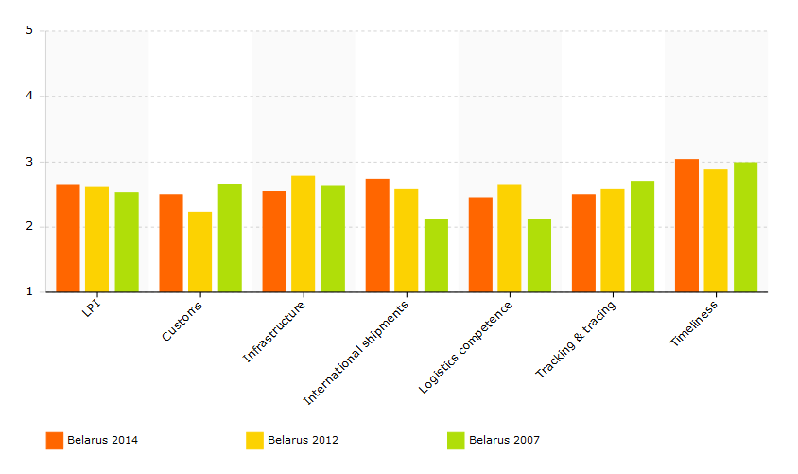  Source: WB  The Logistics Performance Index is an interactive benchmarking tool created to help countries identify the challenges and opportunities they face in their performance on trade logistics and what they can do to improve their performance. The LPI is based on a worldwide survey of operators on the ground (global freight forwarders and express carriers), providing feedback on the logistics "friendliness" of the countries in which they operate and those with which they trade.
 | EaP Road Network Indicators | Total length: 2.665 km  - Motorway with separated lanes (4 lanes in both directions): 232 km  - Expressway road (4 lanes in both directions): 741 km  - Single carriageway road (2 lanes in both directions): 2.695 km  Network indicators (km)  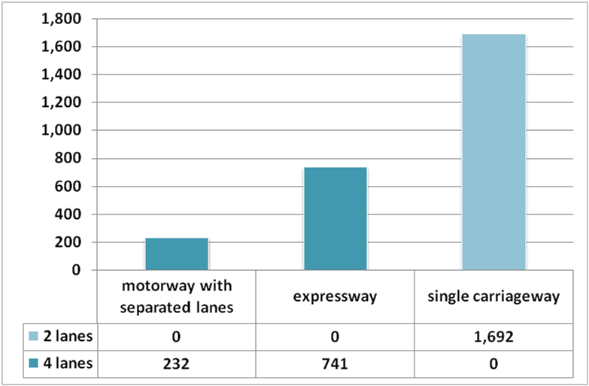  Design speed (km)  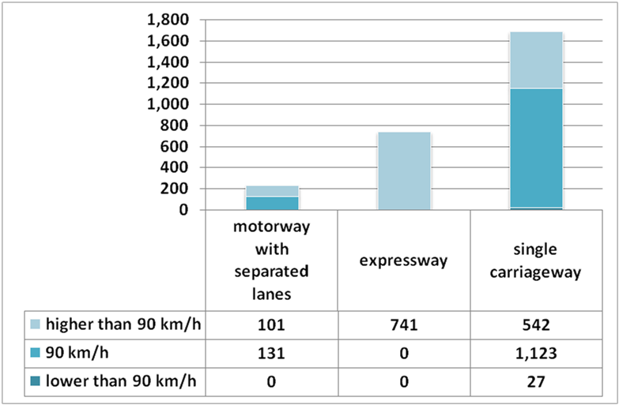  Road conditions (km)  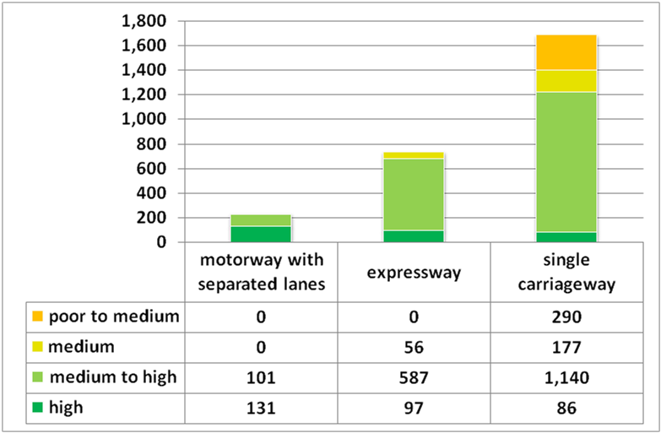  The survey on road quality performed on the context of the EaP regional transport study shows that 11% of the EaP strategic network in Belarus is characterized by poor to medium (290 km) road conditions. The remaining network is characterized by medium or high road conditions.  LEVEL OF SERVICE ON EaP ROAD NETWORK  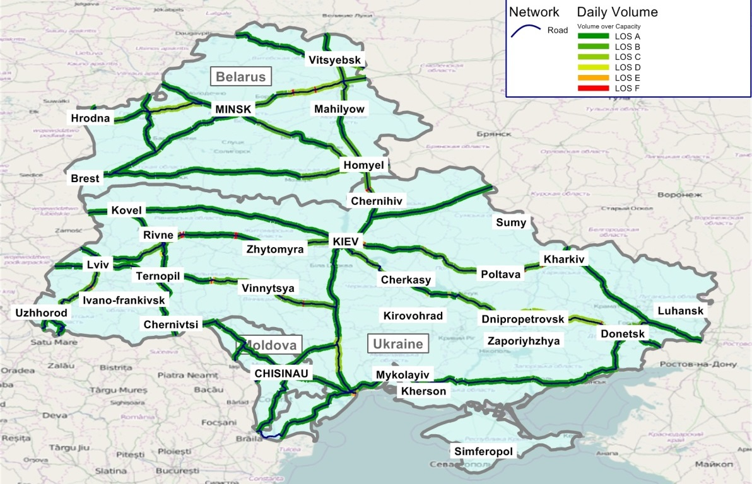  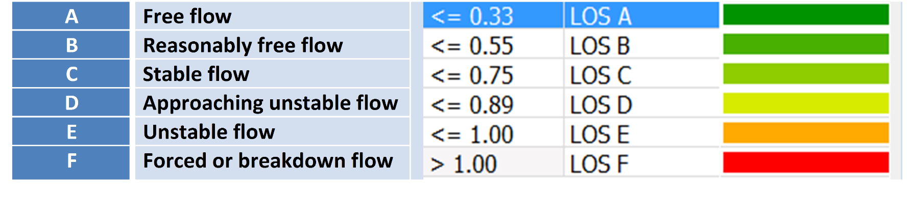
 | EaP Rail Network Indicators | The EaP rail network in Belarus is of 2.954 km length. 53% of EaP Belarusian network (1.572 km) has single-track sections, remaining 47% has double-track sections. Only 35% of the network is electrified (1.035 km length) at 25 kV AC and 3 kV DC (Source: BR), remaining 65% is non-electrified.  Traction  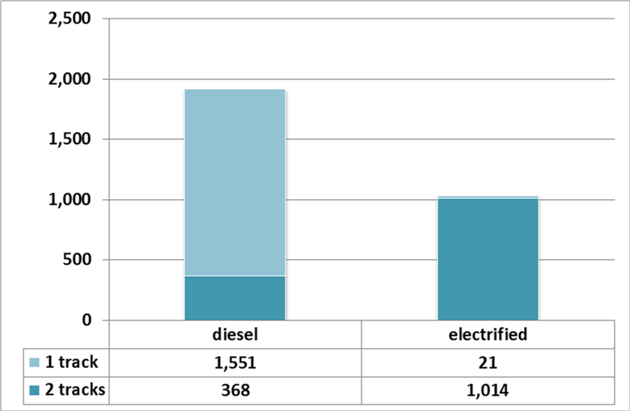
 | EaP Inland Waterway Network Indicators | n.a.
Projects included in the EaP Database |  | Title of project Year of approval Sector Total cost IFI funding  Improvements of express passenger service between Vilnius and Minsk n.a. Rail 80 mln EUR 442 ths. EUR (EU contribution for the third stage of the project)  Upgrade of road between Minsk and Vilnius n.a. Road 300 mln USD n.a.  Construction of a bridge across the river Zapadny Bug (Western Bug) at the road checkpoint Domachevo (Slovatichi) n.a. Road 7 mln USD (First option) or 11 mln USD (Second option) or 5 mln USD (Third option) n.a.  Feasibility study on the development of the water transport connection Dniepr-Visla-Oder (E40) 2008 Inland waterways 0.9 mln EUR n.a.  Reconstruction of border crossing point "Kamenny Log" 2011 Road 30 mln EUR n.a.
Macro-financial context |  | BASIC ECONOMIC INDICATORS  Indicator Unit of measurement 2010 2011 2012 2013 2014  GDP¹ million Euro 32.386 32.554 35.881 35.083 35.629  GDP per capita¹ Euro/capita 3.413 3.437 3.791 3.706 3.762  GDP growth % 7,7 5,5 1,7 1,1 1,6  Inflation² % n. a. n. a. n. a. n. a. n. a.  Unemployment % 6,2 6,1 5,9 6,0 5,9  Agriculture % of GDP 10,6 9,4 9,8 8,1 8,9  Industry % of GDP 42,2 42,7 43,0 42,0 42,4  Services % of GDP 47,2 47,8 47,2 49,9 48,7  Trade % of GDP 120,1 163,3 158,1 123,8 115,1  Public debt³ % of GDP 17,9 18,6 22,0 19,1 17,2  External debt % of GDP 51,4 56,8 53,1 54,1 52,6  Total loans % of GDP 8,9 8,5 7,6 4,2 n. a.  Import million Euro 26.314 32.873 36.118 32.394 29.763  Export million Euro 19.072 29.755 35.825 27.959 26.531  Balance million Euro -7.242 -3.118 -293 -4.435 -3.232  Real interest rate % -1,7 -33,7 -31,9 -1,6 0,6  Source: The World Bank (2014), EC (2014), National Bank of the Republic of Belarus (2014).  ¹ Constant prices 2005  ² Consumer annual price  ³ Data refer to January of each year  Explanatory Note: The external debt, at any given time, is the unresolved amount of current, and not contingent, liabilities that require payment of an interest by a debtor at some point in the future and that are owed to non-residents by residents of an economy.  The non-resident creditors that owns the external debt are disseminated by many economies. Official creditors are public bilateral bodies and multilateral organizations. Public bilateral creditors are lenders in individual countries (e.g., central governments and central banks), multilateral organisations are international institutions (e.g., the International Monetary Fund, the World Bank and regional development banks). The total loans supplied to the economy of a country characterise the borrowing capacity of that country, with respect to external financing.  Source: IMF (2014), External Debt Statistics Guide for Compilers And Users; The World Bank (2016), Joint External Debt Hub.  BASIC SOCIAL INDICATORS  Indicator Unit of measurement 2010 2011 2012 2013 2014  Total population Inhabitants 9.490.000 9.473.000 9.464.000 9.466.000 9.470.000  Urban population % 74,6 75,0 75,5 75,9 76,3  Rural population % 25,4 25,0 24,5 24,1 23,7  Gini Index adimensional 27,7 26,5 26,0 n. a. n. a.  Life expectancy years 70,4 70,6 72,0 72,5 n. a.  Poverty rate % 5,2 7,3 6,3 5,5 n. a.  Source: The World Bank (2014).  BASIC ENERGY AND ENVIRONMETAL INDICATORS  Indicator Unit of measurement 2010 2011 2012 2013 2014  Energy use Kg of oil eq./capita 2.897,6 3.097,7 3.222,6 n. a. n. a.  Electric power cons. kWh/capita 3.563,9 3.628,5 3.697,6 n. a. n. a.  CO2 emissions metric tons/capita 6,6 6,7 n. a. n. a. n. a.  Source: The World Bank (2014).  STRUCTURE OF THE ECONOMY  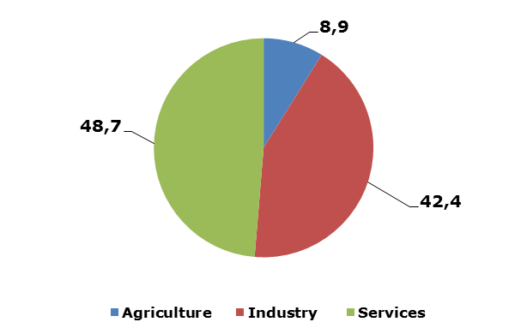  IMPORT AND EXPORT BY MAIN PRODUCTS AND LEAD MARKETS  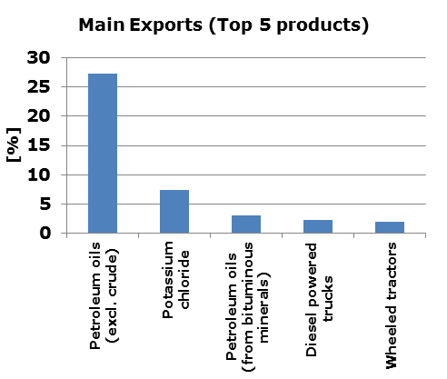  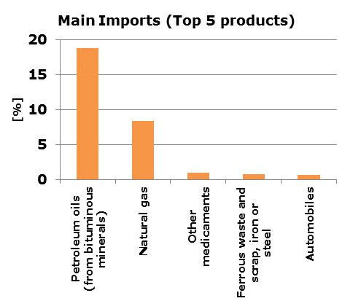  Source: The World Bank (2014).  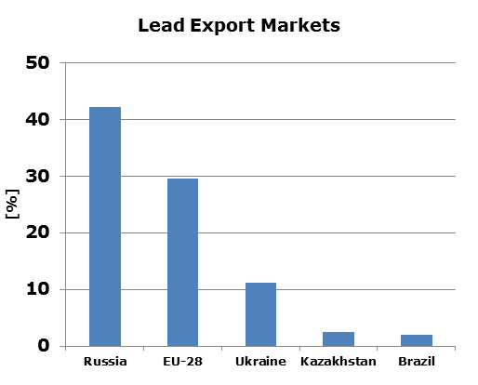  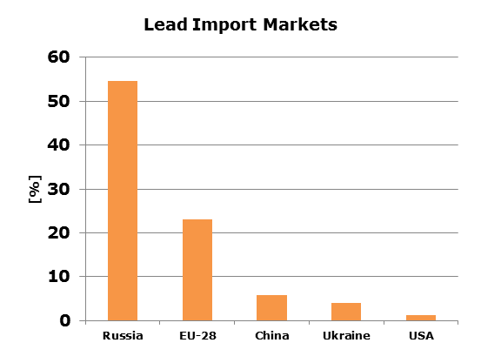  Source: EC (2014).
References |  | https://www.unece.org/fileadmin/DAM/trans/publications/Transport_Belarus_2013.pdf  http://www.unece.org/fileadmin/DAM/trans/main/eatl/in_house_study.pdf  http://web.archive.org/web/20110223194354/http://www.unece.org/trans/main/ter/Countries/PanEuCorridors.html  http://www.unece.org/trans/main/eatl/maps.html  http://eabr.org/general/upload/docs/EurAsEC_Trans_Cor.pdf  http://mfa.gov.by/en/mass_media/bbe40510dec5152d.html  http://www.europarl.europa.eu/RegData/docs_autres_institutions/commission_europeenne/comitologie/ros/2014/D033959-01/COM-AC_DR%282014%29D033959-01%28ANN1%29_EN.pdf  http://ec.europa.eu/transport/themes/international/european_neighbourhood_policy/european_eastern_partnership/doc/tenth-eastern-partnership-transport-panel/belarus_road_sector.pdf  http://www.ebrd.com/where-we-are/belarus/overview.html  http://belarusdigest.com/story/belarusian-roads-good-quality-bad-service-23195  http://www.tc.by/download_files/2016/t_l_2015_engl_small.pdf  https://hicl.org/publications/2015/20/256.pdf  http://www-wds.worldbank.org/external/default/WDSContentServer/WDSP/IB/2011/02/03/000356161_20110203004308/Rendered/PDF/550150ESW0whit1Box358280B01PUBLIC1.pdf  http://lpi.worldbank.org/international/global  http://ec.europa.eu/transport/themes/international/studies/doc/2015-06-eastern-partnership-regional-transport-study.pdf  http://www.rw.by/en/corporate/about_us/infrastructure/electricity_supply/  http://trt.serverlet.com/EaP  http://ec.europa.eu/eurostat/web/products-datasets/-/enpr_transp  https://www.cia.gov/library/publications/the-world-factbook/geos/bo.html  http://knoema.com/atlas/Belarus/topics/Transportation/Road-transport/Motor-vehicles-per-1000-people  http://www.belstat.gov.by/en/ofitsialnaya-statistika/real-sector-of-the-economy/transport/annual-data/private-transport-vehicles/  http://w3.unece.org/PXWeb2015/pxweb/en/STAT/STAT__40-TRTRANS__01-TRACCIDENTS/01_en_TRAccprofile_r.px/?rxid=a1761ca4-5d1e-43a5-a6f6-e83a08189ba4  http://www.who.int/violence_injury_prevention/road_safety_status/2015/country_profiles/Belarus.pdf?ua=1  http://databank.worldbank.org/data/reports.aspx?source=world-development-indicators  http://www.tradingeconomics.com/belarus/government-debt-to-gdp  http://trade.ec.europa.eu/doclib/docs/2006/september/tradoc_113351.pdf  http://wits.worldbank.org/CountryProfile/en/Country/BLR/Year/2014/Summary
This document has been prepared by the IDEA II project.
The content of this document does not reflect the official opinion of the European Union.
Responsibility for the information and views here expressed lies entirely with the author(s).

Inserted from <http://trt.serverlet.com/EaP/country_fiche.php?id=4>

