EaP Country Fiche - Moldova
Tuesday, May 16, 2017
5:11 PM

EU EaP Transport Connectivity Agenda
Country Fiche Moldova
Last Update: 17/06/2016
Version: 2.00
Background | Introduction | Moldova is a small south-eastern European country without any maritime borders. It borders Romania to the West and Ukraine to the North, East and South.  Moldova's public roads include: 67% surfaced and 33% unsurfaced roads. From these 3.339 km are national roads (37% in good, 38% in mediocre and 25% in poor condition) and 5.540 km are local roads (20% in good, 20% in mediocre and 60% in poor condition).  "Moldova Railways" is the state enterprise that currently has 1,157 km of railway line in operation. Railways of Moldova has no electrified lines, train traction is performed with diesel locomotives. Two Moldovan inland waterways (Dniester and Prut Rivers) are of international importance. Moldova has a stretch of the Danube River bank, with a length of 430 m.  The freight transport and logistics sector is small and has recently experienced a rapid decline as a result of the financial crisis. The sector is now showing some recovery signs.  There are four TRACECA links that are important for Moldova: Giurgiulesti-Chisinau (capital of the Republic of Moldova); Iliychevsk-Odessa-Tiraspol-Chisinau-Balti-Criva-Ukrainian border-Cernovti-Livov; Bucuresti-Leuseni-Chisinau-Dubasari-Liubasevka-Kiev and Chisinau-Soroca-Ukrainian border.  In addition, the following corridors pass through Moldova:  - 2 TEN-T corridors (corridor VII-Danube and corridor IX-road/railway)  - 2 OSJD corridors (corridors 5d and 12) - rail.  (Source: LOGMOS)
 | Transport infrastructure bottlenecks | Key problems identified in the field of transport are:  Road transport:  - poor condition and maintenance of existing roads;  - poor technical characteristics of national roads with respect to international requirements;  - poor conditions for transport operation along existing roads; new road facilities, enhancement of safety and reduction of transport costs are needed;  - A major bottleneck remains the separation of Transdniestria, cutting off some of the most developed regions of the country and severing traditional connections to Ukraine;  - Road safety remains a stringent issue. Various factors such as the poor state of the roads, their design, driver behaviour and insufficient enforcement of road traffic regulations play a significant role.  Rail transport:  - poor condition of railways infrastructure; modernisation needed; low commercial speeds of trains along TEN-T corridor IX;  - railway tariffs in Moldova are generally high when compared to neighbouring countries;  - poor condition of existing border crossing stations;  - Moldova needs an electrified railways;  - old rolling stock.  Inland water transport:  - port interfaces for operations, services, procedures etc. between land and sea are among the most critical points;  - inland waterways infrastructure (IWW) along the Dniester and Prut Rivers is in poor condition with respect to international requirements;  - the construction of a mixed gauge rail terminal for oil products of the oil terminal in Giurgiulesti port is needed;  - lack of port facilities for passenger and cargo traffic in the estuary of the Prut River.  Combined transport:  - lack of cargo processing and storage capacities, like multimodal transport terminals, which would provide a complete package of custom clearance and cargo handling services;  - lack of national intermodal transport operators capable of providing a full set of services based on through rates and control of cargo shipments along the whole route.  (Source: LOGMOS)
Flagship transport projects |  | Currently in the Republic of Moldova the infrastructure projects with highest priority, are:  - M3 Chisinau - Cimislia - Giurgiulesti national road, now under rehabilitation. Tenders for Comrat bypass, Vulcanesti bybass and Giurgiulesti bypass roads are planned to be launched by the end of 2016.  - M14 Ukrainian border - Criva - Balti - Chisinau - Tiraspol - Ukrainian border national road. The rehabilitation of expressway from Criva to Chisinau creates the shortest connection between Western part of Ukraine and North Europe with Pan - European Corridor IX. It is of great economic importance from the perspective of the transportation of goods and passengers within Northern EU countries and biggest Black Sea ports. The realization of the project will have direct impact on the improvement of the road connection with Ukraine and will contribute to the integration of Moldova into the transport system of the Eastern Europe Region. The current and urgent need in order to move towards rehabilitation of the road is the Update of the Feasibility Study and update of the Preliminary Design for the Criva - Balti section, as well, development of the Feasibility Study and Preliminary Design for the Balti - Chisinau section.  At the Ministerial Conference in Luxembourg on 9 October 2013, partner countries have agreed on priority connections in the Eastern Partnership region. M14 was proposed as a part of TEN-T connection network, starting in Criva (North of Moldova territory) and ending on Ukrainian border in Odesa district and intersecting 3 European ''E'' roads, 3 TEN-T corridors and the Pan - European Corridor IX.  - M21 Chisinau - Dubasari - Ukrainian border national road. Road M21 provides the shortest link between Chisinau and Ukrainian border, providing access to Kirovograd and Poltava from Ukraine. It is an integral part of the European highways E577, E581 and Pan - European Corridor IX. At km 15 Road M21 intersects with Road M14. Road M21 was constructed between 1961 and 1965.  In 2009 was developed the feasibility study and project documentation for Chisinau - Nistru river section (25 km long). According with feasibility study Internal Rate of Return (IRR) is 19,4 % with estimated cost - 25 million EUR. For project implementation is not necessary land allocation. Most of the road section have 2-3 lanes, concrete paved.  For section river Nistru - Ukrainian border (25 km long) is necessary to develop feasibility study and project documentation. Section represent concrete paved road with 2-3 lanes and estimated cost - 25 mil. Euro.  - Chisinau Ring Highway provides links between all TEN-T corridors in Moldova and create a ring bypass of Chisinau city. It is an integral part of the European highways E58, E581, E584 and Pan - European Corridor IX. The Route 8 is consist of 35 km of existent road and 49 km of a new construction 4 lanes road.  Chisinau Ring Highway (84 km long) includes:  - R6 M1- Ialoveni road, km 0 - km 6,6 (6,6 km length, now in rehabilitation). Cost of rehabilitation - 8,9 mil. Euro, financed by EBI. Rehabilitation is planned for 2017. The project includes rehabilitation of the existing road, upgrading an intersections, consolidation of a sector hit by landslides etc.  - M1 - Romanian border road, km 6-km 14 section (8 km modernization). Was elaborated feasibility study and technical documentation for modernization. The project includes extension from 2 to 4 lanes, modernization of 5 intersections. The project cost is 17 mil. Euro. Source of funding need to be identified.  - M21Chişinău - Dubăsari - Poltava road, section km 5 - km 15 (10 km modernization). Was elaborated feasibility study and technical documentation for modernization. The project includes extension from 2 to 4 lanes, modernization of 4 intersections with cost estimated to 25,7 mil. Euro. Source of funding need to be identified.  - M14 Brest - Chisinau - Odessa road, sector km 265 - km 275 (10 km modernization). In 2017 is planned to elaborate the feasibility study and technical documentation for modernization. The project will include extension from 2 to 4 lanes, modernization of an intersection with cost estimated to 15,0 mil. Euro. Source of funding need to be identified.  - Link construction between national road M14 Brest - Briceni -Chisinau - Tiraspol - Odessa (km 275)and R2 Chisinau-Bender (km 18,5), approximate length 17 km (new construction). In 2017 is planned to elaborate the feasibility study and technical documentation for modernization. The project will include new construction of 4 lanes road. The project cost is estimated to 46,0 mil. Euro. Source of funding need to be identified.  - Link construction between national road R2 Chisinau-Bender (km 18,5) and R3 Chisinau - Hincesti - Basarabeasca (km 10), approximate length 32 km (new construction). In 2017 will be elaborated feasibility study (prefeasibility study is elaborated now) and technical documentation for modernization. The project will include new construction of 4 lanes road. The project cost is estimated to 86,4 mil. Euro. Source of funding need to be identified.  In 2011was developed the prefeasibility study by GHIPROSTROIMOST-M SRL & BLOM SRL for M14 road - R3 road section of new construction part of Chisinau Ring Highway (49 km long). The Internal Rate of Return will be determined after feasibility study will be develop. Estimated cost is about 260 million EUR, including VAT and costs for land allocation. The Chisinau Ring Highway is four lanes, concrete and asphalt paved road.  (Source: Ministry of Transport and Road Infrastructure)
Institutional and legal framework |  | Created in November 2009 by Government Decision nr. 695 of 18 November 2009, the Ministry of Transport and Road Infrastructure is the body who develops and promotes national transport strategy in the road, rail, air and waterways sector.  The Ministry of Transport and Road Infrastructure has two subordinate regulatory institutions:  - "State Road Administration" state enterprise, who is responsible for rehabilitation, reparation and maintenance of the national and local roads in safe conditions;  - "Autoritatea Aeronoutică Civilă" - Civil Aviation Authority;  - Î.S. "Calea Ferată din Moldova" - "Railway of Moldova" State Enterprise;  - "Agenţia Naţională Transport Auto" (ANTA) who is responsible for monitoring the implementation of provisions and requirements contained in international agreements in road transport;  - "Căpitănia Portului Giurgiuleşti" a state organization overseeing navigational safety in ports and inland waterways.
 | Road sector | Ministry of Transport and Road Infrastructure is the central public administration in field of activity and is responsible for development of policies and long / medium plans.  The State Road Administration within the Ministry of Transport and Road Infrastructure manages national and local roads. The local governments on the left side of the Nistru river manage 1.200 km of local roads. (Source: Serviciilocale)  Task of the State Road Administration is the administration, maintenance, repair, modernisation, development and exploitation of public roads in order to ensure safe, fluent and continuous traffic conditions. The Administration has the following functions:  - It holds the title of ownership and beneficiary of construction, rehabilitation, repair and maintenance of the roads and it is the distributor of all resources allocated for these  - matters from the State Budget and the Road Fund;  - It ensures an efficient and economic use of financial and material resources, allocated for the development and maintenance of Moldova's public roads branch;  - It ensures the maintenance of roads' vital functions and their administration;  - The State Road Administration organises tender for road construction and capital reparation.  - ASD ensures maintenance of public roads included in Lists approved by Government in 2001 nr. 1323 (Source: TRACECA).  Tendering is mandatory for all road works, because Road Fund as well as external funds are public resources.  According with Governmental Decision nr. 244 of 19.04.2012, 38 small and highly inefficient state-owned companies was reorganized by merging in 12 companies for road maintenance. Based on recommendations of ROUGHTON report (ROUGHTON analysed road maintenance sector with WB support) Republic of Moldova implements a pilot project "Implementation of the multiannual maintenance contracts based on performance", and reorganization of state-owned companies is a part of this project.(Source: EBRD)  Interurban bus transport services form an important component of the travel network in the Republic of Moldova, since the provisions of rail passenger services is limited in some locations. Interurban transport services are organized through "Î.S. Gările şi Staţiile Auto", a state owned enterprise that provides for nation-wide ticket sales and compliance with regulations. (Source: Serviciilocale)
 | Railways sector | The railway system in Moldova was established and operated mostly on the basis of the soviet infrastructure. Currently the state enterprise "Railway of Moldova" (CFM) is the only railway undertaking (operator) in the country responsible for the development and management of railway infrastructure and transport of passengers and goods. (Source: LLDC)  Following the European model, a reform of the sector is currently on-going and should be finished until II quarter of 2016. In this regard, a current priority is separation of Infrastructure management from Operation, which will ensure: separation of profit and loss accounts, balance sheets, staff and activity. (Source: UNECE)  Beginning with April 2012, the S.E. "Railway of Moldova" adopted a new economic-organizational structure (in compliance with Council Directive 91/440/EEC of 29 July 1991 on the development of the Community's railways). (Source: UNECE)  The new structure of S.E. "Railway of Moldova" comprises four autonomous operating departments:  - Infrastructure;  - Transport of Goods;  - Transport of Passengers;  Social Activities and Auxiliary Patrimony. (Source: UNECE)
 | Aviation sector | In accordance with Government Decision no. 695 of 18 November 2009 Ministry of Transport and Road Infrastructure of the Republic of Moldova is the central public body responsible for all matters related to Moldovan civil aviation (policy and provisions for implementation of the requirements of international aviation organizations).  Administraţia de Stat a Aviaţiei Civile (ASAC) is responsible for certification of aircraft and equipment, personnel licensing, operational approval for aircraft operators, air navigation service, providers of airport services, aircraft accidents and their investigation and safety oversight for all certified or approved systems or processes.  The flag carrier, "Air Moldova" is small and is kept flying by increasing its debt to, for example, Chisinau International Airport by not paying airport charges. The airline lacks the critical mass to compete, while at the same time it is too inefficient to grow to something larger in a competitive market. (Source: Serviciilocale)  The market is further served by a number of "full services" carriers from both East and West. Around 31 destinations are regularly served from Chisinau. The destinations and flight frequencies are governed by bilateral agreements. Auxiliary services are provided by a number of public sector (municipality and state) owned companies that are currently the only providers of such services. None of the independent operators of Ground Support Services normally found on other airports is active in Republic of Moldova. (Source: Serviciilocale)  Air route charges are set on the basis of multilateral agreement according to the common principles adopted by the EUROCONTROL. Each year, ASAC regulator approves the prices for flights imposed by air carriers certified, countersigned by the Ministry of transport and Roads Infrastructure.
 | Navigation sector | Inside the Ministry of Transport and Road Infrastructure there are the following organizations dealing with shipping:  - Public Institution "Harbor Master Giurgiulesti";  - State Enterprise "Port Fluvial Ungheni";  - State Enterprise "Naval Register" and  - State Enterprise "Molovata ferry."  A port complex with an area of 120 hectares was developed at the South border of the country, in Giurgiulesti, comprising the Giurgiulesti International Free Port (GIFP) operated under concession by the private company ICS Danube Logistics SRL and the State passenger and cargo terminal operated by the state enterprise "Portul Fluvial Ungheni". (Source: LLDC)  Being the only direct river-sea transhipment and distribution point to/from the Republic of Moldova, the Port is a regional logistics Centre at the EU border that gives users a unique customs and tax regimes. THE GIFP has the status of Free Economic Zone until 2030. (Source: LLDC)
National transport policy and plan |  | The policy of Moldova in the field of transport is set by the following documents:  - The Transport and Logistics Strategy for 2013-2022 approved by Government Decision no. 827 of 28 October 2013 which covers roads, railways, road and rail transport, as well as trade facilitation, settlement of problems related to customs, border crossing, airports/air transport, ports and maritime/inland waterway transport. This Strategy focuses on making the transport and logistics sector an enabling factor for the development of Moldova's economy and export trade, and support the on-going process of harmonizing Moldova's transport system and legislation with EU standards, legislation, and related regulations.(Source: Serviciilocale)  - Water Transport Development Concept (published in 2008) that details further priorities for the water transport of Moldova for the period of 2008-2011  - Civil Aviation Development Strategy of the Republic of Moldova (Source: LOGMOS)  - National Road Safety Strategy, approved by Government Decision no. 927 of 21 December 2011 which includes many significant advances, among which are the establishment of road safety budgets and special attention to protect vulnerable road users.
Investments decision making process |  | Road infrastructure projects are financed from:  - Road fund (mostly for maintenance);  - External funds (for constructions, reconstructions, rehabilitations and other projects).  Ministry of Transport and Road Infrastructure is the central public administration in field of activity and is responsible for planning and monitoring of road fund and external financing. Accumulations and financing from Road Fund is in responsibility of Ministry of Finance, as well as, external funds.  To implement a project, MTRI develops an investment proposal, then "State Road Administration" launch a tender for feasibility study, design documents and monitoring unit.
Financing and Funding |  | Road sector  A "Road Fund" is used for the financing of maintenance, repair and reconstruction of national and local roads. (Source: ASD)  The Land Transport Infrastructure Strategy for 2008-2017 amended the old Road Fund Law of 1996, which allowed to increase significantly the revenue accumulated in the Road Fund (from MDL 241 million in 2009 up to MDL 1.225 million in 2013). Following stipulations from the Transport and Logistics Strategy for 2013-2022, road fund in 2022 will be MDL 2.920 millions. (Source: Serviciilocale)  Starting from 2009, road maintenance expenditure increased significantly and became rule-based (e.g. percentage of fue llevy) without annual negotiations with Ministry of Finance.(Source: EBRD)  Road Fund is composed by:  - fuel excises;  - Fares for the journey on public roads by the transportation means not registered in the Republic of Moldova;  - Fares for the use of public roads by owners of transportation means, registered in the Republic of Moldova;  - Dues for licenses issue for journeys of transportation means with axel loads and dimensions exceeding the admitted limits, as well as for execution of works within the road protection area;  - Dues for giving out licenses for the execution of the road works. (Source: ASD)  According to Government Decision No 1167 of 29 October 2007 "On the application of the methodology for calculating the fees for passenger and luggage transportation services by road", the fees for transportation services are approved by the Ministry of Transport and Road Infrastructure. (Source: Serviciilocale)  Road user charges are relatively high by regional standards. (Source: EBRD)  Rail sector  According to the Railway Code, adopted in 2003, the construction, modernization and reconstruction of main railway lines of general use, of objects for mobilitization and at the same time acquiring of rolling stock related to state needs is performed under the state budget funding and the railways financial resources. (Source: LLDC)  Construction and reconstruction of local railway lines and stations, pedestrian bridges, tunnels, passenger platforms and other railway facilities serving the local population, purchase of trains for suburban traffic can be financed through the budget, local budgets and own resources of the railways and voluntary contributions of organizations and individuals. (Source: LLDC)  The Moldovan Railways have been operated with little commercial autonomy.  Tariffs are set by the government (i.e. no independent price regulator) with limited correlations to costs. After the railways accumulated significant debts and arrears, the government considered restructuring options. A sector restructuring plan was approved in 2008, which envisages unbundling of infrastructure and freight and passenger services. However, implementation is delayed and the railway system remains highly inefficient. (Source: EBRD)  The local and suburban passenger operations are provided on the basis of state regulated tariffs and are internally cross subsidized within "Calea Ferată din Moldova", by the freight revenues. This is evidenced by stable passenger social-oriented tariffs over the last 15 years, while the freight rates were increased twice in 2010. (Source: Serviciilocale)  PPP  Although Moldova has a PPP legal framework and the relevant institutions in place, to date the PPP activity has been limited.  A number of government agencies consisting of the Ministry of Economy, Ministry of Finance, a National PPP Council and a PPP Unit (within the Public Property Agency under the Ministry of Economy) share responsibilities around the implementation, coordination and support of PPPs while operating under the 2008 PPP Law.  The PPP law was approved to allow different forms of PPPs of up to 50 years. The policy and political support is complemented by the National Council for Public-Private Partnership regulation , the Concessions Law (1995) and a Law on the Administration and Privatisation of Public Property (2007). (Source: PPP Knowledge Lab)
Donors coordination |  | The main donors/IFIs in the Sector organise every 6 months a Joint-Visit to review progress in the implementation of the Government's Transport and Logistics Sector Programs. This Joint Team is composed of the EBRD, the EIB, the EU and the WB which are currently the main donors engaged in the Transport Sector in Moldova. The main objectives of these visits are to perform a comprehensive review of the reform process and the ongoing projects with the Government, the Ministry of Transport and Road Infrastructure (MTRI), the State Road Administration (SRA) and other relevant Institutions in the Transport Sector. If Roads sector is the central topic of these missions due to important engagement of the donors in this sector, other areas such as aviation and railways are also being tackled all the more considering the start of an important railway rehabilitation project supported by the EBRD, the EIB and the EU. Following these visits, an Aide-Memoire is being prepared to present the main results of the visit and summarising key developments in the last period. In the framework of the visits, once a year, a High Level Steering Committee is organised and chaired by the Prime Minister of the Republic of Moldova. The goal of this Committee is to address some of the existing challenges in the sector. The last mission of the joint-team took place on April 25-28, 2016 and the last High Level Steering Committee was organised on April 26.
Transport Indicators | General | Mode Indicator Year Unit of measurement Value  Road Total length 2015 Km 10.573  Paved network 2015 Km 10.074  Total motor vehicles 2015 per 1.000 people 207  Cars 2015 per 1.000 people 153  Freight 2015 million tons∙km 2.775  Passengers¹ 2015 million pass∙km 2.802  Road accidents 2015 Accidents 2.527  Fatalities 2015 People 297  Serious injuries 2015 People 3.021  Railway Total length² 2014 Km 1.156  Electrified network - Km -  Freight 2014 million tons∙km 1.182  Passengers 2014 million pass∙km 257  Air Airports³ 2013 Units 7  Freight 2014 million tons∙km 1,0  Passengers 2014 million pass 0,9  Inland waterways Total length 2014 Km 558  Pipelines Total length 2013 Km 1.906  Source: National Bureau of Statistics of The Republic of Moldova, C.I.A. (The World Factbook), WHO, UNECE.  ¹ By buses and taxi  ² Railways of Moldova has no electrified lines, train traction is performed with diesel locomotives.  ³ With paved and unpaved runways
 | LPI (Logistics Performance Index) | Year 2007 2010 2012 2014  LPI Rank 106 104 132 94  LPI Score 2,31 2,57 2,33 2,65  Customs 2,14 2,11 2,17 2,46  Infrastructure 1,94 2,05 2,44 2,55  International Shipments 2,36 2,83 2,08 3,14  Logistics Competence 2,21 2,17 2,15 2,44  Tracking and Tracing 2,50 3,00 2,44 2,35  Timeliness 2,73 3,17 2,74 2,89  Source: WB  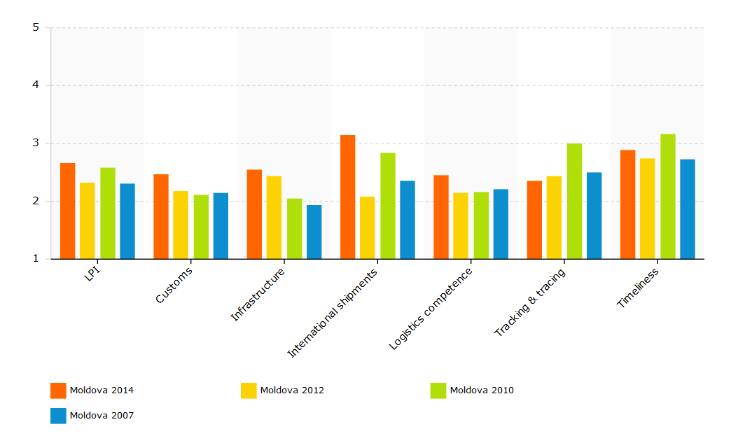  Source: WB  The Logistics Performance Index is an interactive benchmarking tool created to help countries identify the challenges and opportunities they face in their performance on trade logistics and what they can do to improve their performance. The LPI is based on a worldwide survey of operators on the ground (global freight forwarders and express carriers), providing feedback on the logistics "friendliness" of the countries in which they operate and those with which they trade.
 | EaP Road Network Indicators | Total length: 925 km  - Motorway with separated lanes (4 lanes in both directions): 32 km  - Single carriageway road (2 lanes in both directions): 893 km  Network indicators (km)  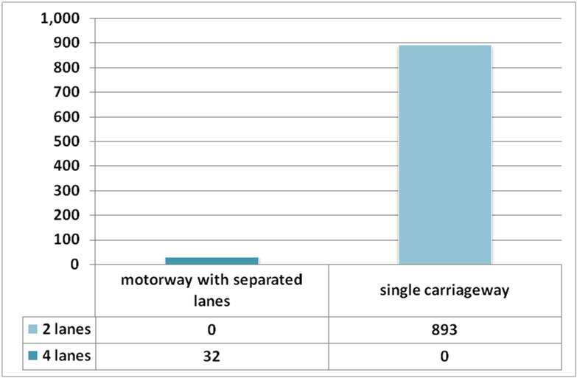  Design speed (km)  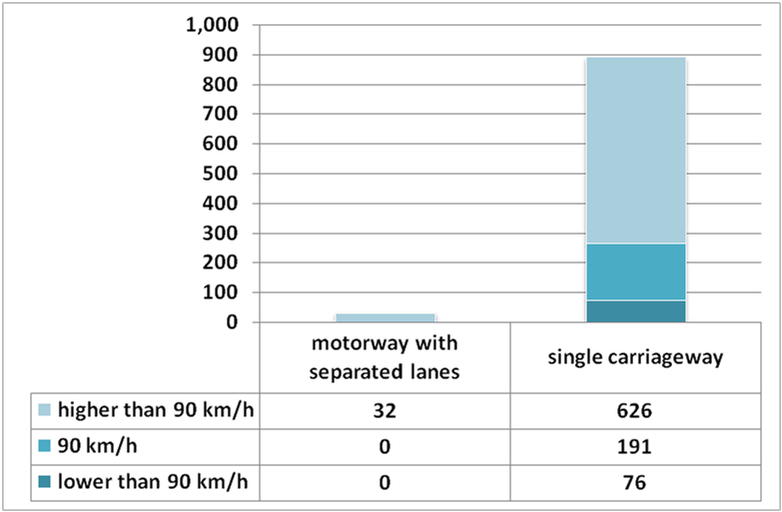  Road conditions (km)  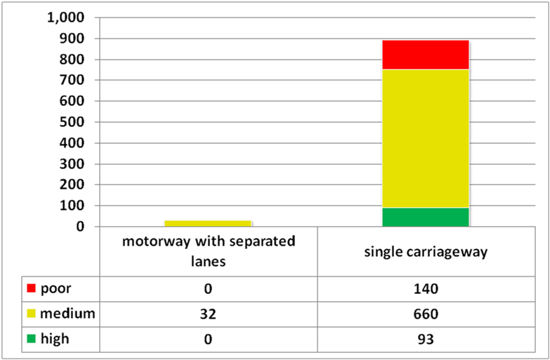  The survey on road quality performed on the context of the EaP regional transport study shows that 90% of the EaP strategic network in Moldova is characterized by poor (140 km) and medium (692 km) road conditions. The remaining network is characterized by high road conditions.  LEVEL OF SERVICE ON EaP ROAD NETWORK  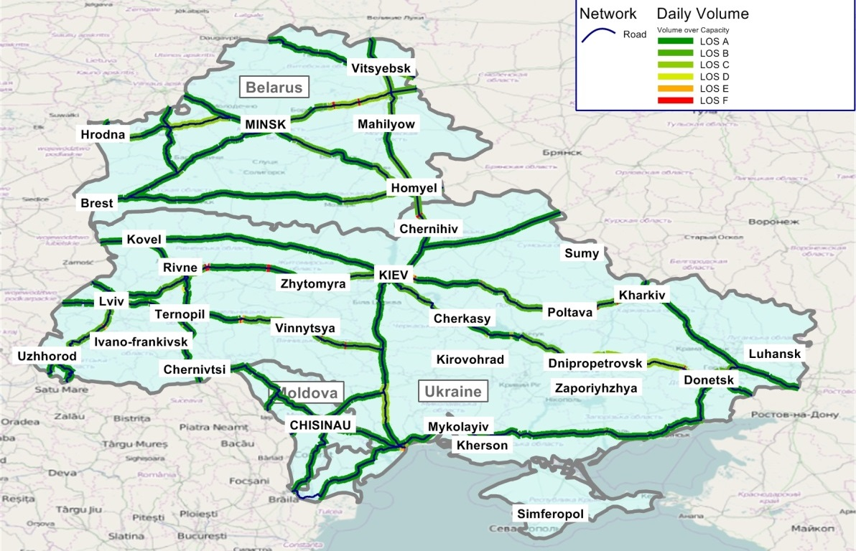  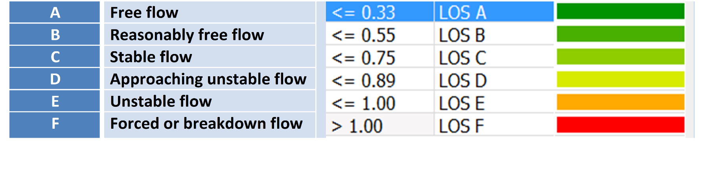
 | EaP Rail Network Indicators | The EaP rail network in Moldova is of 770 km length, single-track and fully non-electrified. Most railway tracks have CIS gauge (1,520 mm). However, in 2006 Moldova built a 14 km stretch of standard (1,435 mm) gauge track. At GIFP, there is a dual railway track (of 1,520 mm and 1,435 mm in width) allowing goods going through the port to arrive or depart at either of Moldova's neighbouring countries without subsequent bogey exchange or unloading/reloading.  Traction  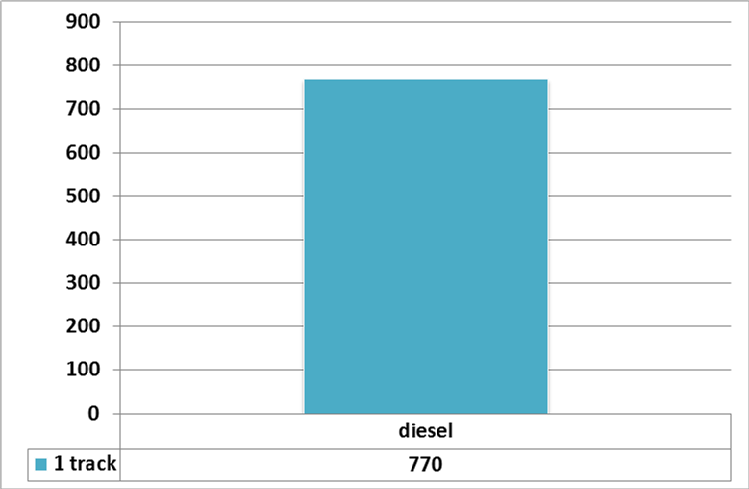
 | EaP Inland Waterway Network Indicators
Projects included in the EaP Database |  | Title of project Year of approval Sector Total cost IFI funding  R33 Hincesti - Lapusna - M1 n.a. Road 18,8 mln EUR EBRD  M3 Chisinau - Giurgiulesti motorway. Section Porumbrei - Cimislia n.a. Road 23 mln EUR EIB  M3 Chisinau - Giurgiulesti motorway. Comrat bypass n.a. Road 21 mln EUR EIB  M3 Chisinau - Giurgiulesti motorway. Slobozia bypass (Construction of the bypass of 3 villages) n.a. Road 24 mln EUR EBRD  Rehabilitation of National road M14 - Section Balti - Criva n.a. Road 133 mln EUR IFI  Rehabilitation of National road M14 - Section Balti - Chisinau n.a. Road 112 mln EUR IFI¹  Construction of European gauge railway track and electrification of Chisinau-Ungheni section n.a. Rail 401,7-536,6 mln USD² 135 mln USD³ IFIs; Government of RM; Moldovan bank (repayable by CFM)  National road R1 Chisinau - Ungheni - Sculeni - Romania Border. Construction of Ungheni Bridge over Prut River n.a. Road 35 mln EUR IFI  Moldovan railways restructuring project n.a. Rail 116,7 mln EUR 25 mln EUR (EBRD) 50 mln EUR (EIB) 5 mln EUR (EU through NIF)  Moldova roads rehabilitation III n.a. Road 166,2 mln EUR EBRD EIB (co-financing)  Moldova roads rehabilitation IV n.a. Road 315 mln EUR 150 mln EUR (EBRD) 1,2 mln EUR (NIF)  International Logistics Centre (ILC)at the free Marculesti International Airport n.a. Intermodal 12-20 mln EUR EBRD PPP  Rehabilitation of National road M21 Chisinau - Dubasari - Goianul Nou - Platonove (Ukrainian border) n.a. Road 50 mln EUR n.a.  Rehabilitation of National road R13 Balti - Sodanesti - Ribnita. Section Balti - Floresti - M2 n.a. Road 30 mln EUR n.a.  ¹ possible co-financing of 15%  ² except the purchase of electric rolling stock  ³ the purchase of new electric railway stock  EBRD European Bank for Reconstruction and Development  EIB European Investment Bank  IFI International Funding Institutions  NIF Neighbourhood Investment Facility  PPP Public-Private Partnership  RM Republic of Moldova
Macro-financial context |  | BASIC ECONOMIC INDICATORS  Indicator Unit of measurement 2010 2011 2012 2013 2014  GDP¹ million Euro 2.642 2.677 2.880 3.048 3.188  GDP per capita¹ Euro/capita 742 752 809 857 896  GDP growth % 7,1 6,4 -0,7 9,4 4,6  Inflation² % 7,4 7,6 4,6 4,6 5,1  Unemployment % 7,4 6,7 5,6 5,1 3,4  Agriculture % of GDP 14,4 14,8 13,4 14,8 15,0  Industry % of GDP 15,9 16,8 16,7 17,1 17,2  Services % of GDP 69,6 68,4 69,9 68,1 67,8  Trade % of GDP 117,8 130,8 127,4 123,9 119,7  Public debt % of GDP 26,5 23,4 24,1 23,6 24,6  External debt % of GDP 81,3 74,2 79,1 81,3 81,2  Total loans % of GDP 24,9 28,1 33,3 30,0 n. a.  Import million Euro 2.914 3.737 4.064 4.144 3.869  Export million Euro 1.164 1.595 1.678 1.796 1.681  Balance million Euro -1.750 -2.142 -2.386 -2.348 -2.188  Real interest rate % 4,8 6,3 5,1 7,8 4,4  Source: The World Bank (2014), EC (2014), Finance Ministry of the Republic of Moldova (2014).  ¹ Constant prices 2005  ² Consumer annual price  Explanatory Note: The external debt, at any given time, is the unresolved amount of current, and not contingent, liabilities that require payment of an interest by a debtor at some point in the future and that are owed to non-residents by residents of an economy.  The non-resident creditors that owns the external debt are disseminated by many economies. Official creditors are public bilateral bodies and multilateral organizations. Public bilateral creditors are lenders in individual countries (e.g., central governments and central banks), multilateral organisations are international institutions (e.g., the International Monetary Fund, the World Bank and regional development banks). The total loans supplied to the economy of a country characterise the borrowing capacity of that country, with respect to external financing.  Source: IMF (2014), External Debt Statistics Guide for Compilers And Users; The World Bank (2016), Joint External Debt Hub.  BASIC SOCIAL INDICATORS  Indicator Unit of measurement 2010 2011 2012 2013 2014  Total population Inhabitants 3.562.045 3.559.986 3.559.519 3.558.566 3.556.400  Urban population % 44,9 44,9 44,9 44,9 44,9  Rural population % 55,1 55,1 55,1 55,1 55,1  Gini Index adimensional 32,1 30,6 29,2 28,5 n. a.  Life expectancy years 68,5 68,6 68,7 68,8 n. a.  Poverty rate % 21,9 17,5 16,6 12,7 n. a.  Source: The World Bank (2014).  BASIC ENERGY AND ENVIRONMETAL INDICATORS  Indicator Unit of measurement 2010 2011 2012 2013 2014  Energy use Kg of oil eq./capita 956,0 933,6 920,4 n. a. n. a.  Electric power cons. kWh/capita 1.722,9 1.470,2 1.514,5 n. a. n. a.  CO2 emissions metric tons/capita 1,4 1,4 n. a. n. a. n. a.  Source: The World Bank (2014).  STRUCTURE OF THE ECONOMY  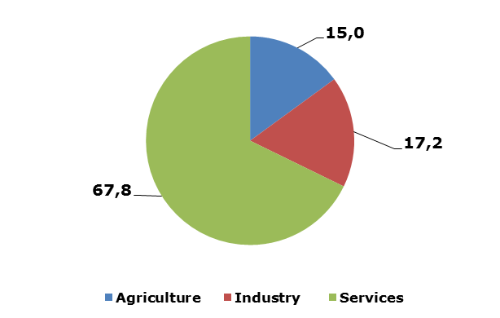  Source: The World Bank (2014).  IMPORT AND EXPORT BY MAIN PRODUCTS AND LEAD MARKETS  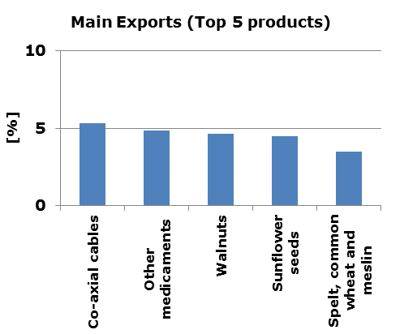  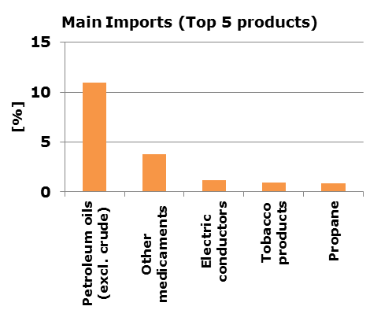  Source: The World Bank (2014).  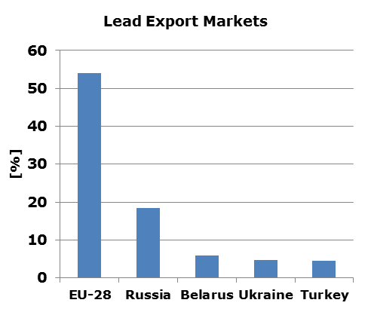  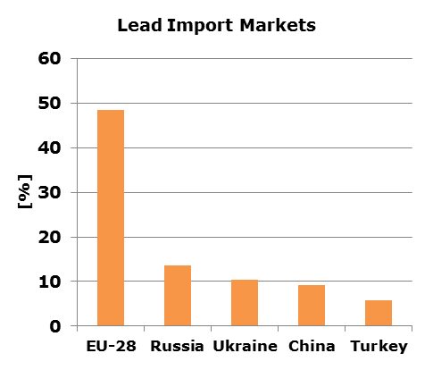  Source: EC (2014).
References |  | http://www.traceca-org.org/fileadmin/fm-dam/TAREP/65ta/Master_Plan/MPA9.1MD.pdf  http://www.internationaltransportforum.org/statistics/investment/Country-responses/Moldova.pdf  http://www.gifp.md/en/page/60/Terminalul-Produselor-Petroliere  http://ec.europa.eu/transport/themes/international/studies/doc/2015-06-eastern-partnership-regional-transport-study.pdf  http://trt.serverlet.com/EaP  http://www.statistica.md/category.php?l=en&idc=138&  http://www.who.int/violence_injury_prevention/road_safety_status/2015/country_profiles/Republic_of_Moldova.pdf?ua=1  http://w3.unece.org/PXWeb2015/pxweb/en/STAT/STAT__40-TRTRANS__01-TRACCIDENTS/01_en_TRAccprofile_r.px/table/tableViewLayout1/?rxid=a1761ca4-5d1e-43a5-a6f6-e83a08189ba4  https://www.cia.gov/library/publications/the-world-factbook/geos/md.html  http://databank.worldbank.org/data/reports.aspx?source=world-development-indicators  http://www.tradingeconomics.com/moldova/government-debt-to-gdp  http://trade.ec.europa.eu/doclib/docs/2006/september/tradoc_113419.pdf  http://wits.worldbank.org/CountryProfile/en/Country/MDA/Year/2014/Summary  http://www.serviciilocale.md/public/files/drumuri/STL_2013-2022_eng.doc  http://www.ebrd.com/downloads/country/strategy/moldova.pdf  https://pppknowledgelab.org/countries/moldova  http://www.traceca-org.org/fileadmin/fm-dam/Investment_Forum/101208_MLD%20country%20report.pdf  http://www.asd.md/asd-en.htm  https://www.unece.org/fileadmin/DAM/trans/doc/2015/wp5-eatl/3_WP5_GE2_13th_session_Mr_Mindra.pdf  http://www.lldc2conference.org/custom-content/uploads/2014/08/Moldova-National-report-english-2.pdf  http://databank.worldbank.org/data/reports.aspx?source=joint-external-debt-hub  http://www.jedh.org/jedh_home.html
This document has been prepared by the IDEA II project.
The content of this document does not reflect the official opinion of the European Union.
Responsibility for the information and views here expressed lies entirely with the author(s).

Inserted from <http://trt.serverlet.com/EaP/country_fiche.php?id=5>

