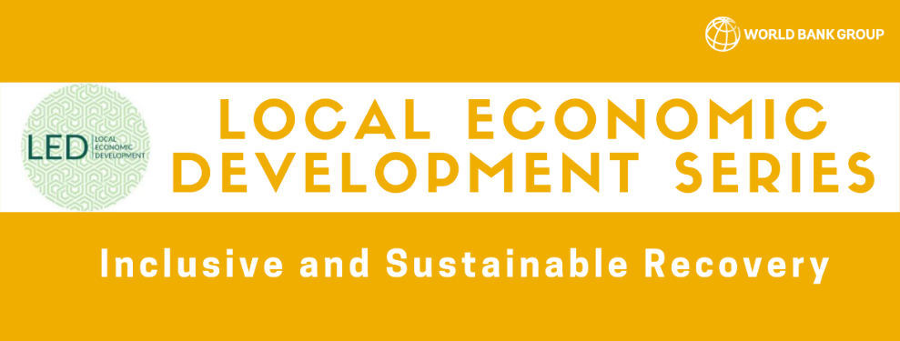
LED Session #6 How can Municipalities Hosting Refugees Work with the Private Sector for Economic Recovery?
Key Takeaways
Opening Remarks:
Moderator: Sara Boughedir, Consultant, CMI
Welcome everybody. This series focuses on the severe economic impacts of COVID-19, and ways to achieve sustainable and resilient recovery for communities. Today we will focus on how municipalities can work with the private sector for economic recovery. The Center for Mediterranean Integration is a knowledge platform that convenes actors across sectors to address challenges in the region.
Blanca Moreno-Dodson, Manager, CMI
Welcome all to this webinar. This is an important series which has discussed pressing issues that are only more relevant now in order to help hosting communities and refugees recover from COVID-19. The CMI works through 160 local governments that host refugees in the Middle East and Turkey. We strive to ensure the common welfare of both hosting communities and refugee populations. We have witnessed the importance of informed LED strategies and skilled municipal staff. Middle East countries are the largest recipients of displaced populations worldwide. While these issues began due to conflict, COVID-19 has worsened the situation by reducing job availability and health outcomes. In April 2020, we conducted rapid needs assessments with municipalities to assess the emergency costs incurred from COVID-19. Indeed, the only way recovery can occur is if the private sector intervenes.
Our speakers include:
- Giulia Marchesini, Senior Partnership Specialist, CMI
- Fuat Ozharat, Gaziantep Metropolitan Municipality, Turkey
- Nadine Burbar, Head of Local Economic Development and Deputy Chief Resilience Officer, Ramallah Municipality, Palestine
- Reham Jammal, Director of Planning Department & Director of International Projects and Programs Unit, Greater Irbid Municipality, Jordan
Fireside Chat
Sara: What have been the main challenges faced by your municipality regarding the local economy and welfare of inhabitants? Are there challenges specific to vulnerable groups and refugees?
Giulia: Thank you Sara. We have found through rapid needs assessments with municipalities, that municipalities have intervened in crisis management, while responding to preexisting socioeconomic needs like unemployment. COVID-19 has increased the workload of municipalities beyond their mandate. In order to deal with this emergency, they reallocated their budget. In most municipalities, there was a lack of digitalization, which made working from home and online services very difficult. More than 80% of Syrian refugees reside in these countries. Indeed, the crisis has caused 5.5 million new poor households in Lebanon and Kyrgyzstan. The region requires much greater support with consideration of the local level and the ability of the private sector to help.
Fuat: Hello everyone. Countries hosting refugees have experienced a more severe impact from the pandemic due to fragility and a greater collapse of health systems. In addition to financial support from the central government, our municipality has halted rental fee payments for workplaces, and we are taking only 50% of non-workplace rents for April, May, June, and July. We are also extending rental payment terms and providing food aid for workers. We have also disbursed healthcare and food packages to workers, raised awareness, conducted health screening, and provided sanitation services.
Nadine: In Palestine, our economy was hindered by feeble economic growth prior to the virus. The pandemic has especially affected marginalized communities; causing the loss of 18,000 jobs and closing many businesses owned by low- and middle-income people in the absence of government aid. There has been a slowdown in all economic sectors, which has reduced consumption and investment. The Palestinian economy consists of 90% of SME’s which were hardest hit by the pandemic. Also, purchasing power in Palestine largely comes from daily wages. With lockdowns, purchasing power dropped each day. Women have also had to compromise their work disproportionately in order to support their families.
Reham: The Irbid municipality lies in the North with a local population of 1 million citizens and 200,000 Syrian refugees. Indeed, 20% of our population are refugees, and they have a significant impact on the economy. The shortage of government support and decrease in municipal revenue plus the high cost of housing refugees and providing public services have all hindered private investment. Furthermore, pollution, poverty and unemployment are rampant. The lack of stability in neighboring countries also reduces the attractiveness of private investment in Jordan. Refugees and low-income families and women are the most affected by the lack of job opportunities.
Sara: Thank you all for your insight! What have been the most helpful actions taken by municipalities to engage the private sector for economic recovery?
Giulia: We asked our municipality network about actions they suggest to be implemented with the help of international organizations. First, municipalities can support local demand and supply to bolster local employment by contracting local firms. Second, municipalities can invest in infrastructure and agriculture in order to preserve food supply. Local authorities have in some cases bought and distributed locally produced food during lockdown. Furthermore, municipalities can attract private investment and stimulate business creation by providing direct enterprise support and facilitating registration processes through a one-stop shop. They can also speed up the digitalization process by providing trainings, supporting registration, allowing online payments and more. Municipalities can even facilitate matchmaking with employers by training residents for available jobs. Finally, municipalities have an important role in producing data and analysis and creating partnerships in their region.
Nadine: Our municipality has found that mental health has affected people’s ability to co-create, which has impacted the economy. Mental health encapsulates 4% of a country’s GDP. We are encouraging innovative ideas by offering three premises as co-working spaces for citizens. First, we have provided a craft and artisan space to connect artisans with the private sector to grow and monetize their ideas. Next, we are creating a business center that will offer co-working spaces for 500 beneficiaries, especially women. We are searching for a partnership to provide the seed funding for these innovative entrepreneurs. Partnering with the private sector has facilitated the digitalization of services and payments which have enabled economic recovery.
Reham: We have established many sustainable projects to benefit women and both local and refugee communities. Our municipality has constructed a vegetable market which created more than 300 job opportunities. We have also provided infrastructure and waste management jobs and rented facilities for entrepreneurs to use for selling their goods. Our composting plant has further provided economic opportunities for 20 people while improving agricultural productivity and food security. In addition, we have temporarily exempted tax payments for vulnerable small business owners.
Fuat: We support all people in our city and do not discriminate between citizens and refugees in the provision of services. It is anticipated that our income support will reduce the economic recession. Our support program also seeks to reduce income inequality through protecting employment and maintaining access to healthcare and education. We have supported individuals through tax delays, debt restructuring, short time work allowance, and extended employment opportunities. We are hopeful that economic recovery will begin in the second half of 2021, and we are working across ministries to achieve this end. For example, we are working with the chamber of commerce to extend loans for SMEs, reduce their taxes, and facilitate easy exportation by matching businesses with suitable markets. We are also supporting the manufacturing sector’s competitiveness through R&D.
Audience Q&A
Sara: Did municipalities reach out to diaspora for support in health and business consulting in order to benefit their communities?
Nadine: We reached out to diaspora for fundraising through our Diaspora Association in the United States. We fundraised to build a field hospital in 80 days. This was extremely helpful, but since health services come from the national level, contracting health services was outside of our mandate.
Sara: Can you tell us about municipalities’ support of social enterprises in refugee/host communities?
Fuat: We have done a lot of work with Syrian enterprises. There are over 3,000 enterprises in our region, most of which were not registered originally. In working with the Syrian Economic Forum and CMI, we have helped register many of these businesses (more than 95%), which are now paying taxes, and are able to benefit from banking and credit services available to Turkish firms.
Closing Remarks:
Vara Vemuru, Practice Manager, Social Sustainability and Inclusion, World Bank
Thank you all for sharing your experiences today. Municipalities in this region have certainly been dealing with compounded crises both in terms of health and economics. The informal economy has been especially vulnerable. Today we heard about the disruption of supply chains and food production. It is clear that some groups of the population such as women, youth, low-skilled workers, and refugees have been especially impacted. Furthermore, I heard issues regarding the unbanked being excluded from digital services. It is also clear that municipalities are looking at the medium term to prepare for future shocks. I value the integrated approach with the private sector and CSOs in order to collectively create an enabling environment for public services, agricultural productivity, digitalization, and innovation. At the Bank we also seek to launch a more inclusive process across our practices, and the ideas shared here today will help us sustain local economic recovery. Thank you all for your fantastic reflections.

