**Gender and Energy Access Resources: Household Energy and Rural Electrification**

**Full course:** <https://olc.worldbank.org/content/gender-equality-and-energy-self-paced>

* **Presentation and Speaking Points**

- [Module Overview and Speaking Points [pdf]](http://esmap.org/sites/esmap.org/files/DocumentLibrary/Gender_Energy_M02.pdf)

* **Introductory Video**

-  Video | [Sustainable Energy for All](http://www.youtube.com/watch?v=kh5KzBQBGcE)

* **Reading Materials**

        -  WEB Link | [Household air Pollution and Health](http://www.who.int/mediacentre/factsheets/fs292/en/)

        -  Report | [Scaling Adoption of Clean Cooking Solutions through Women’s Empowerment, Clean Alliance for Cookstoves (pages 6 and 7) [pdf]](http://esmap.org/sites/esmap.org/files/DocumentLibrary/scaling-adoption-womens-empowerment.pdf)

        - Resource | [Examples of Assessments, Actions, and M&E in the Energy Sector](http://esmap.org/node/2743)

* **Resources**

       -  WEB Link | [Soap operas: A Quilty Pleasure Good for Gender Equality Too!](http://blogs.iadb.org/y-si-hablamos-de-igualdad/2014/03/10/soap-opera/)

       -  WEB Link |: [What Motivates Women to Buy?](http://www.mercycorps.org/research-resources/what-motivates-women-buy)

       -  WEB Link |: [Promoting Productive Uses of Electricity in Rural Areas of Peru: Experiences and Lessons learned](http://www.worldbank.org/en/results/2013/04/10/pomoting-poductive-uses-electricity-rural-areas-peru)

       -  WEB Link | [The Multifunctional Platform, Good Practice Example, UNDP](http://www.un.org/womenwatch/feature/ruralwomen/undp-good-practice.html)

       -  Report | [The Gender-Energy-Poverty Nexus [pdf]](http://esmap.org/sites/esmap.org/files/DocumentLibrary/The%20Gender%20Energy%20Poverty%20Nexus.pdf)

       -  Report | [Energy, Poverty and Gender [pdf]](http://esmap.org/sites/esmap.org/files/DocumentLibrary/EnergyPovertyGenderStudySynthesisReport.pdf)

       -  Background Paper |  [Social Influences on Gender Equity in Access and Benefits from Energy [pdf]](http://esmap.org/sites/esmap.org/files/DocumentLibrary/clancy-WDR_Norad_ENERGIA-Main-Paper%281%29_0.pdf)

       -  WEB Link: [Smoke: the Killer in the Kitchen| Indoor Air Pollution in Developing Countries. Practical Action](http://practicalaction.org/smoke-report-2)

       - Resource | [Scaling Adoption of Clean Cooking Solutions through Women’s Empowerment, Clean Alliance for Cookstoves, 2013 [pdf]](http://esmap.org/sites/esmap.org/files/DocumentLibrary/scaling-adoption-womens-empowerment_0.pdf)

       -  Report | [The Impact of Energy on Women’s Lives in Rural India. ESMAP, WB, UNDP 2004 [pdf]](http://esmap.org/sites/esmap.org/files/DocumentLibrary/ESM2760PAPER0Impact0of0Energy%282%29.pdf)

       -  Report | [Boiling Point, A Practitioners journal on Household Energy, Stoves and Poverty Reduction. Issue 66,2015 –Women, Energy and Economic Empowerment [pdf]](http://esmap.org/sites/esmap.org/files/DocumentLibrary/GENDERWomen%20Energy%20and%20Economic%20Empowerment_0.pdf)

       - Resource | [Building a Safer World: Toolkit for integrating GBV Prevention and Response into USAID Energy and Infrastructure  Projects. 2015 [pdf]](http://esmap.org/sites/esmap.org/files/DocumentLibrary/FINAL_GBV_EI_Toolkit_Aug2015.pdf)

       -  WEB Link: [Social Gender Support to Indonesia Clean Stoves Initiatives –Field Notes and Guides, World Bank, ASTAE 2015](http://www.astae.net/social-gender-support-to-indonesia-CSI)

[**Gender and Energy Online Toolkit for Practitioners**](http://esmap.org/node/2757) <http://esmap.org/node/2757>  (Sample Surveys, TORs, Action Plans, etc)

* 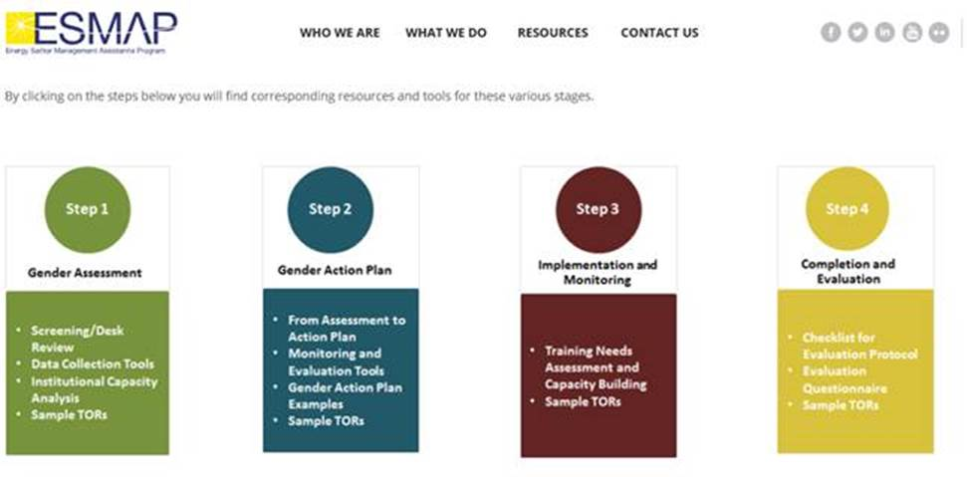

[**Gender and Energy Online Publications Library**](http://esmap.org/gender-energy-publications-library) <http://esmap.org/gender-energy-publications-library>  (Guidance Notes, Global  & Regional Research)