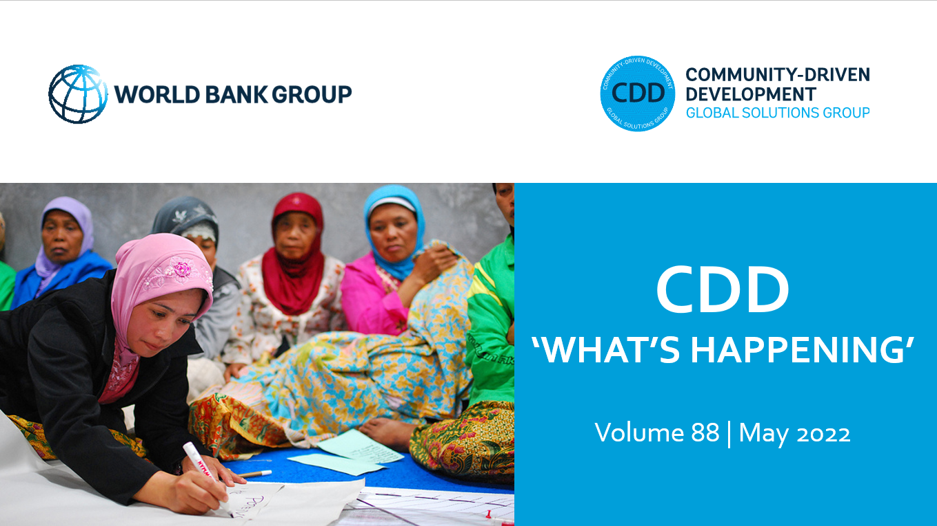
Dear CDD Community of Practice Members,

We hope this finds you all well. This month, we’re excited to share with you additional papers from the Forced Displacement and Social Cohesion series, the results of a partnership between the World Bank, UNHCR, and the UK FCDO. For more information on upcoming events and other papers in this series, please check out the series page.

This newsletter also highlights a new brief on combining hazard and FCV data with community insights to inform and drive resilience building. We also share recordings from recent events on ensuring persons with disabilities are engaged in each stage of Bank-supported projects and examples of indigenous peoples and local communities' engagement in conservation.

As always, we are eager to hear from you! Please share any relevant information and materials that you feel would benefit our community and stay in touch.

With best wishes,

Susan, Nik, Stephen, Helen, Camila and Anastasiia

RESOURCES AND REPORTS

Forced Displacement and Social Cohesion Series
The World Bank, UNHCR, and UK FCDO’s series on Forced Displacement and Social Cohesion examines how to prevent conflict and promote cohesion among communities experiencing forced displacement. Below, we’ve highlighted five papers that we think might be of interest to this community. We invite you to check out the other papers in the series, which can be found here.
- Displacement and Social Empowerment: Evidence from Colombia, Iraq, Philippines, and Uganda: Displacement experience is positively associated with increased sense of personal empowerment and efficacy, but the effect varies across and within countries. Those displaced to urban areas may experience an increased capacity for collective action relative to those displaced to rural or camp-based areas because of the public infrastructure and social density present in urban areas.
- Social Cohesion and Refugee-Host Interactions: Evidence from East Africa: Host community attitudes towards refugees are shaped by intra-group attitude formation at the neighborhood level and by inter-group interaction. The economic impact of refugees on local economies creates sympathy among some groups (landlords and employers, who rent to and hire refugees) and antipathy among others (tenants and prospective employees).
- Inclusive Refugee-Hosting in Uganda Improves Local Development and Prevents Public Backlash: Host communities with more exposure to refugee settlements experience substantial improvements in the provision of public goods and services. Proximity to refugee settlements does not affect attitudes towards migrants or migration policy.
- Long-term effects of the 1923 mass refugee inflow on social cohesion in Greece: Policies that promoted the integration of refugees into the community contributed to long term social cohesion in Greece. These policies included: granting farmland, building new houses and schools, and providing citizenship.
- How Do Shared Experiences of Economic Shocks Impact Refugees and Host Communities? Evidence from Afghan Refugees in Iran: Negative economic conditions in host communities decrease social cohesion between hosts and refugees. Positive economic conditions do not significantly improve social cohesion between hosts and refugees, but they do not worsen it and may improve refugee welfare. This suggests that there is minimal cost to pursuing policies that are generous toward refugees.

Results in Resilience: Informing and Driving Resilience Building at the DRM-FCV Nexus in South Sudan
This two-page brief summarizes the Global Facility for Disaster Reduction and Recovery’s analysis of the challenges and opportunities at the nexus of disaster risk management (DRM) and fragility, conflict and violence (FCV) in South Sudan. This analysis paired hazard and exposure data, FCV-related spatial data, and qualitative information from community members, government officials, and other stakeholders to assess the vulnerabilities, impacts on communities, and how they are responding.

BLOGS

Post-disaster Reconstruction: Lessons from Nepal and Pakistan
Author Kamran Akbar draws from his experiences in post-earthquake reconstruction in Nepal and Pakistan to highlight the importance of Owner-driven and community-supported approaches, engagement of civil society organizations, prioritizing the rebuilding of livelihoods, and nurturing existing cooperative social value systems.

RECENT EVENTS

Technical Note on Disability Inclusive Citizen Engagement
May 12, 2022
This technical note from the Citizen Engagement and Social Accountability GSG explains what to look for to ensure that individuals with disabilities and organizations of persons with disabilities are engaged in the planning, implementation, monitoring, and evaluation stages of Bank projects. It draws from examples from different sectors, including a Community Based Water Supply Project in Indonesia highlighted during the event, to present a summary of lessons learned.

Sharing successful experiences of Indigenous Peoples and Local Communities’ engagement in conservation
May 5, 2022
The webinar, hosted jointly by the World Bank-led Amazon Sustainable Landscapes Program and the Global Wildlife Program presented selected approaches and tools implemented in Africa and Latin America, that promote engagement with indigenous peoples and local communities in natural resource conservation and sustainable development. Presentations can be found here.
PROJECT APPROVALS

Afghanistan Community Resilience and Livelihoods Project (P178760)
This project was approved on April 29, 2022 for $265 million and will provide short-term employment and income to millions of Afghans while also improving access to basic services such as clean water and sanitation. Women and vulnerable groups such as internally displaced persons and persons with disabilities will be especially assisted. The project will also support community-level systems and institutions for long-term resilience, sustainability, and inclusive development.

Indonesia: Mangroves for Coastal Resilience Project (P178009)
This project was approved on May 20, 2022 for $419 million and seeks to enhance the management of mangroves and livelihoods of local communities in selected areas.

JOIN OUR COMMUNITY

The Community-Driven Development CoP and GSG connects peers, thought leaders, and practitioners across governments, agencies, and academia, to share ideas and experiences on CDD approaches. This CoP/GSG is facilitated by the Global Programs Unit of the Social Sustainability and Inclusion Global Practice at the World Bank, with inputs from around the world.
To share papers, project news, interesting blogs, or upcoming events on CDD and other relevant themes with the CDD CoP, please email the CDD email and we'll incorporate these in the next "What's happening in CDD" newsletter.

To sign up for CDD CoP membership and receive our monthly newsletter, please click here
Please visit and bookmark our sites!
CDD Global Solutions Group (WB internal):
https://worldbankgroup.sharepoint.com/sites/gsg/CDD/Pages/Home.aspx
CDD Collaboration4Development (C4D) (external):
https://collaboration.worldbank.org/content/sites/collaboration-for-development/en/groups/community-driven-development-global-solutions-group.html

GLOBAL PROGRAMS UNIT - SSIGL | THE WORLD BANK
Email: cddgsg@worldbank.org

