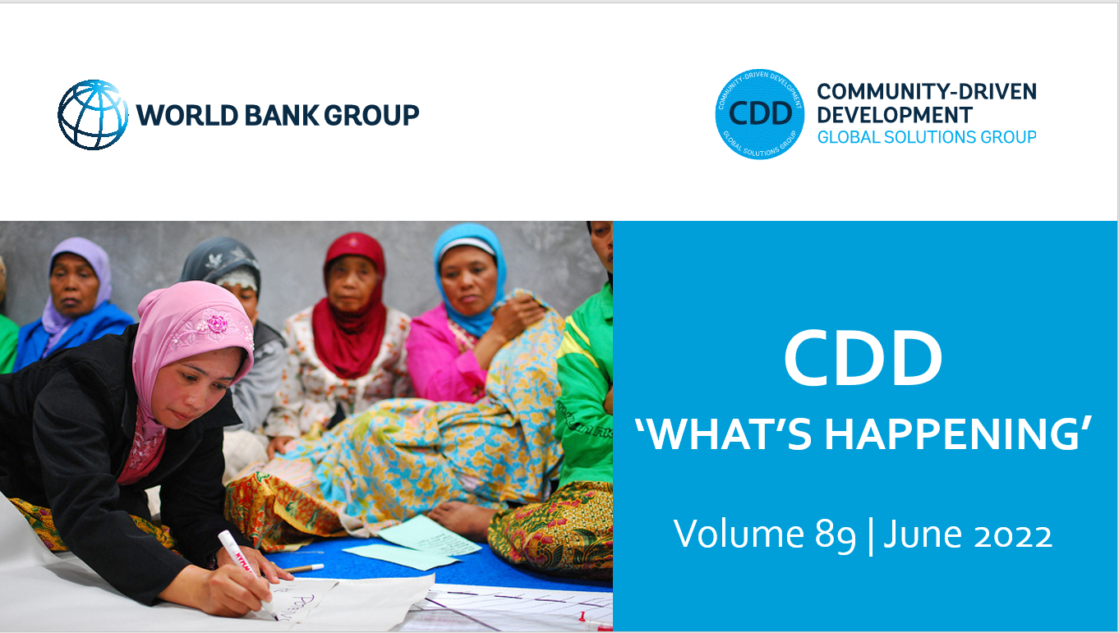
Dear CDD Community of Practice Members,

We hope this finds you all well! In this month’s newsletter, we share recent blogs from the World Bank and Evidence Consortium on Women’s Groups on the role of women and girls in fostering peace, community-led biodiversity conservation, and the impact of training self-help groups in finance and accounting. We also highlight resources on Mercy Corps’ community-led peacebuilding program in Niger and the U.S. Federal Reserve’s upcoming community development series on supporting an inclusive recovery.

In case you missed the Bank’s recent events on Inclusive Policies for Migrants and Refugees and Women’s Groups in South Asia: Landscape, Impact, and the Future, we’ve shared links to the recordings below.

As always, we are eager to hear from you! Please share any relevant information and materials that you feel would benefit our community and stay in touch.

With best wishes,

Susan, Nik, Stephen, Helen, Camila and Anastasiia

BLOGS

Empowering South Sudan’s women and girls is key to fostering peace
In this blog, authors Charity Nyombe Gabriel Modi and Daniel Balke reflect on the critical role that women and girls’ social and economic empowerment plays in fostering peace and sustainable development in South Sudan. In the face of extraordinary challenges, South Sudan’s women demonstrate extraordinary resilience through collective support and action in survivor networks, village savings and loan associations, and other women’s groups. Investing in their social and economic empowerment is foundational to the newly launched Women’s Social and Economic Empowerment Project (WSEEP), led by the Ministry for Gender, Child and Social Welfare in partnership with the World Bank and UN Women.

To protect nature, put local communities at the center of climate action
Authors Susan Shen and William Bleich share how achieving biodiversity conservation goals (like the “30x30” target in the draft Post-2020 Global Biodiversity Framework) requires engaging and empowering local communities and indigenous people. Examples of conservation initiatives with a community-led focus include participatory community-based forest management systems in Cameroon, decentralizing forest management decision-making to the village level in Lao PDR, and the first national-scale model of devolved climate finance in Kenya.

Empowering women’s economic groups with an innovative financial and accounting training
This blog from the Evidence Consortium on Women’s Groups outlines the process, materials, and preliminary results from delivering financial and accounting training to 30 self-help groups in India as part of the National Rural Livelihoods Mission program. Preliminary results suggest SHGs were more financially mature and members reported greater confidence in holding effective meetings and improved savings attitudes.

RESOURCES AND REPORTS

Mobilizing Communities to Build Social Cohesion and Reduce Vulnerability to Violent Extremism: Evidence from a Peacebuilding Program in Niger
This report examines the impact of Mercy Corps’ USAID-funded PEACE program operating in Niger’s Tillabéri region. This program used Mercy Corps’ approach to community mobilization and participatory planning to support communities in identifying local issues and implementing projects that addressed shared needs. Drawing on surveys with more than 1,800 respondents before, during, and after the program, this report presents findings on the program’s impact on multiple indicators of social cohesion and violent extremism.

Nominations for the GCA Local Adaptation Champions Awards
The Global Center on Adaptation has launched the Local Adaptation Champions Awards to highlight and reward inspiring, innovative and scalable locally led efforts that address climate change and build resilience among vulnerable communities. The call for applications opened on June 10th and runs to July 10, 2022.

UPCOMING EVENTS

Toward an Inclusive Recovery
The United States Federal Reserve is launching a Community Development Research Seminar Series that is focused on supporting an inclusive recovery. Each seminar will present research illuminating an issue critical to the economy and presenters will discuss how the community development field can use these findings to support a recovery that benefits everyone. Upcoming seminars include:
- June 29, 2022: Achieving an Equitable and Inclusive Wealth Recovery
- September 8, 2022: How the Rules of the Labor Market Matter for Workers
- October 20, 2022: Consequences of the Pandemic for Short and Long-Run Educational and Labor Market Outcomes
RECENT EVENTS

Inclusive Policies for Migrants and Refugees
June 7, 2022
The second event in our Forced Displacement and Social Cohesion series discussed the long-term impacts of inclusive refugee policies on social cohesion, with insights from Greece, Colombia, and elsewhere.

Women’s Groups in South Asia: Landscape, Impact, and the Future
May 25, 2022
This webinar, co-organized by the World Bank’s South Asia Gender Innovation Lab and the Evidence Consortium on Women’s Groups presented findings on recent work on women’s groups, including self-help groups, livelihood groups, and producer collectives.

PROJECT APPROVALS

As of June 21, 2022

Uganda: Generating Growth Opportunities and Productivity for Women Enterprises Project (P176747)
This project was approved on June 17, 2022 for $217 million and seeks to increase access to entrepreneurial services that enable female entrepreneurs to grow their enterprises in targeted locations, including host and refugee communities.

Development Response to Displacement Impacts in the Horn of Africa Phase II (P178047)
This project was approved on June 17, 2022 for $180 million and will be implemented in Djibouti, Ethiopia, Kenya and Uganda. The project aims to improve access to basic social and economic services, expand livelihoods opportunities and enhance environmental management for host communities and refugees in the target areas.

Burkina Faso Emergency Local Development and Resilience Project – Additional Financing (P178650)
This additional financing was approved on June 17, 2022 for $123 million. The additional financing will scale up the investment in food security, nutrition, and resilience, targeting hard-to-reach crisis-affected areas with interventions not already supported through the parent project.

Solomon Islands: Integrated Economic Development and Community Resilience Project (P173688)
This project was approved on June 9, 2022 for $23.5 million and aims to increase access to economic and social infrastructure in rural wards, deliver climate and disaster resilience actions and enhance Provincial Governments’ accountability to citizens.

Somalia Urban Resilience Project Phase II Additional Financing (P178887)
This additional financing was approved on June 3, 2022 for $41.5 million. The additional financing will allow the program to help address unmet urban service needs, scale up the successful model for delivering infrastructure investments using country government systems, and replenish the program’s CERC funds.

South Sudan Women’s Social and Economic Empowerment Project (P176900)
This project was approved on May 24, 2022 for $70 million and seeks to increase girls and women’s access to livelihood, entrepreneurial and GBV services and to strengthen the government’s capacity to provide these services.

JOIN OUR COMMUNITY

The Community-Driven Development CoP and GSG connects peers, thought leaders, and practitioners across governments, agencies, and academia, to share ideas and experiences on CDD approaches. This CoP/GSG is facilitated by the Global Programs Unit of the Social Sustainability and Inclusion Global Practice at the World Bank, with inputs from around the world.
To share papers, project news, interesting blogs, or upcoming events on CDD and other relevant themes with the CDD CoP, please email the CDD email and we'll incorporate these in the next "What's happening in CDD" newsletter.

To sign up for CDD CoP membership and receive our monthly newsletter, please click here
Please visit and bookmark our sites!
CDD Global Solutions Group (WB internal):
https://worldbankgroup.sharepoint.com/sites/gsg/CDD/Pages/Home.aspx
CDD Collaboration4Development (C4D) (external):
https://collaboration.worldbank.org/content/sites/collaboration-for-development/en/groups/community-driven-development-global-solutions-group.html

GLOBAL PROGRAMS UNIT - SSIGL | THE WORLD BANK
Email: cddgsg@worldbank.org

