Armenia

General Map of Armenia: administrative division
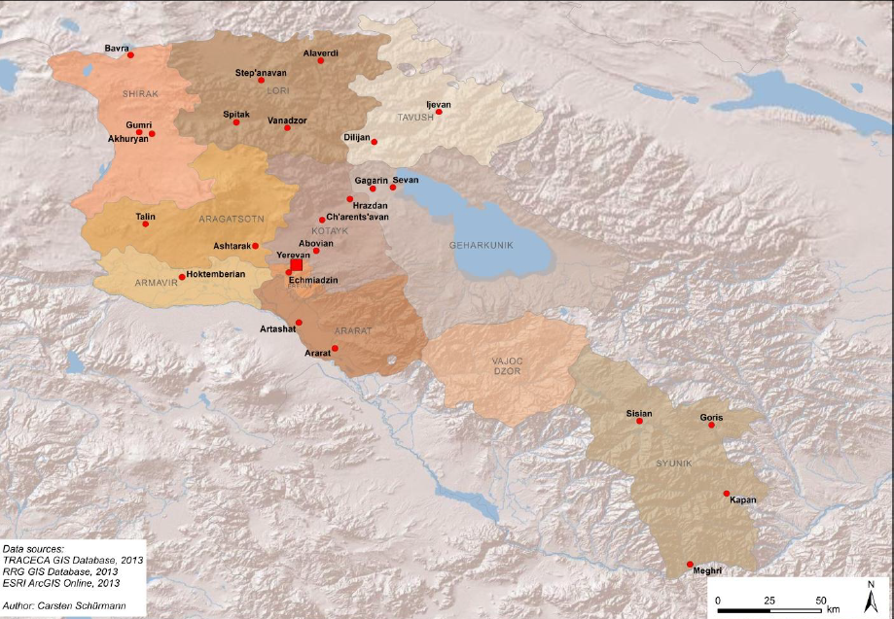

Armenia Potential Trade with TRACECA Countries and Europe, 2010, in tones
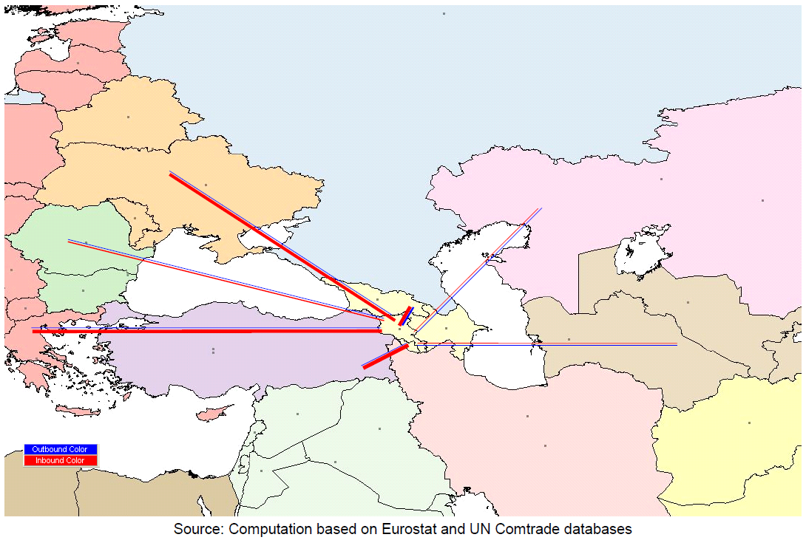
Armenia Potential Trade with TRACECA Countries and Europe, 2010, in tones and %
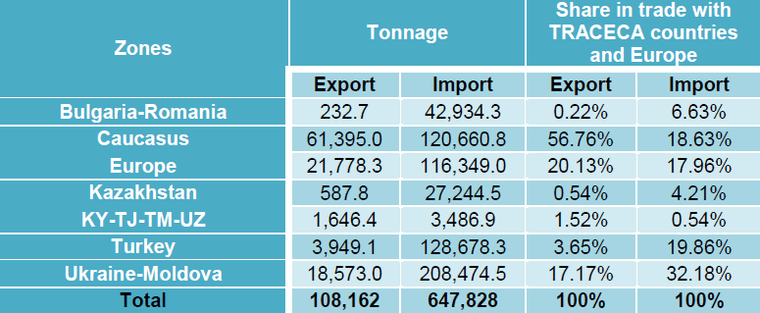
Inland Transport Mode: Railways
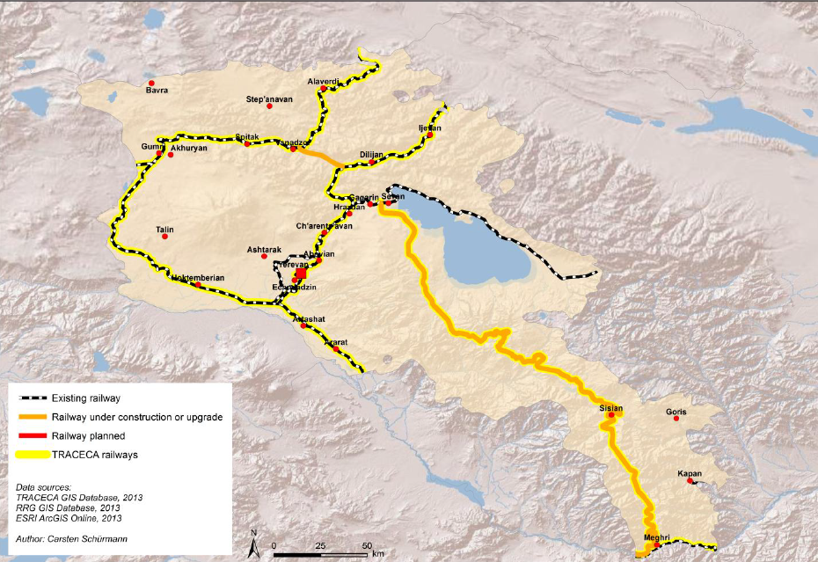
The total length of the railway tracks in Armenia is 1,328.6 km (including 780 km of express tracks)
but only 704 km is operated. Double tracks constitute 2.56% of the network. These are Russian-gauge (1520 mm) rail tracks. Almost all the rail tracks are single, electrified and equipped with semi-automated blocking and modern communication systems.

Inland Transport Mode: Roads
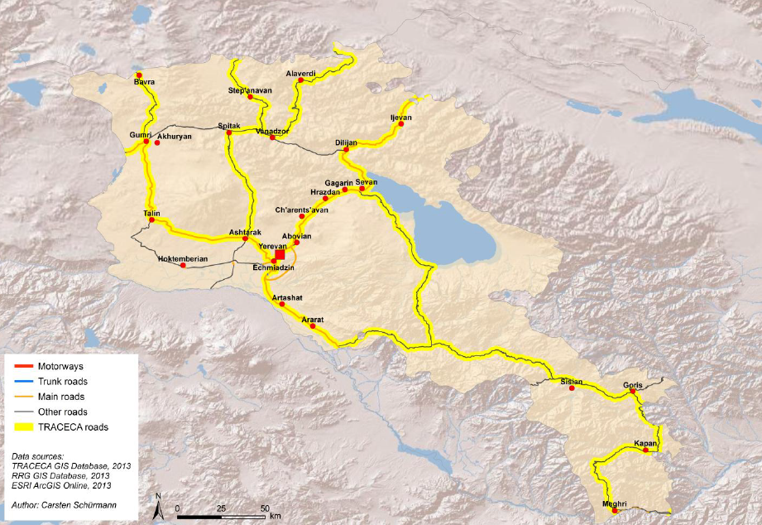
The total length of road network in Armenia is about 7,743 km divided into 1,686 km of inter-state roads, 4,049 km of state roads and 2,008 km of local roads. The road network is the backbone of the country‟s economic development and has undergone drastic evolution over the past 20 years.

Inland Transport Mode: Roads. Level of services on EaP roads.
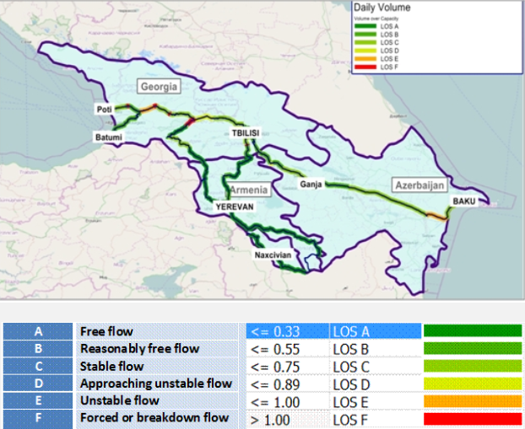

Sources:
http://www.traceca-org.org/fileadmin/fm-dam/TAREP/65ta/Master_Plan/MPA9.1AM.pdf

