EaP Country Fiche - Georgia
Tuesday, May 16, 2017
5:10 PM

EU EaP Transport Connectivity Agenda
Country Fiche Georgia
Last Update: 25/05/2016
Version: 3.00
Background | Introduction | Georgia occupies a very central and strategic geographical position in the Southern Caucasus region. The importance of Georgia is also reinforced by its role as the main gateway to the neighbouring and landlocked Republic of Armenia.  Georgia borders Russia in the North, Azerbaijan in the East, Armenia in the South as well as Turkey. A common maritime border is also shared with Ukraine.  Georgia's transport network has been undergoing a great development since the independence of the country. It is today composed of nearly 1,600 km of rail line and 19,100 km of road. It also possesses a number of international ports including Poti and Batumi, which serve as the European gateways for international dry-cargo trade in the whole Caucasus region and beyond. (Source: LOGMOS)  The 400 km East-West Highway (EWH) is the main road link, providing the fastest surface access from the east to the west. It plays a strategic role, and is part of three international road networks-the Central Asia Regional Economic Cooperation, European, and Asian networks-extending from Red Bridge at the Azerbaijan border to Sarpi at the Turkish border. Nearly 60% of international trade crossing Georgia moves on the EWH. (Source: ADB)
 | Transport infrastructure bottlenecks | Key problems identified in the field of transport are:  - Road transport: Beyond large infrastructure construction on motorways, the sustainability of the national road network remains a challenge. This is primarily due to insufficient funding of routine and periodic maintenance, and a significant backlog of repairs. Some 38% of the secondary roads and 54% of the local roads, many linking to major agricultural hubs and tourist attractions, are in poor or very poor condition. Several access roads from the EWH to the seaports and railway terminals are functionally obsolete and structurally inadequate. (Source: ADB)  - Road safety is a serious issue in the country. Poor road conditions,unsafe driving behaviour,and ineffective enforcement of traffic laws and regulations contribute to this problem.  - Rail transport: The transit time between Poti/Batumi and Baku is high, the transit procedures are challenging (poor coordination of transport operations between ports), the existing service is irregular and unreliable and the capacity is not enough. The Tbilisi-Yerevan line suffers from a severe backlog of maintenance and modernisation resulting in speed restrictions due to insufficient track quality. Due to the different rail gauge standards between Turkey, one the one hand, and Georgia and Azerbaijan, on the other, a bogie exchange and cargo transhipment point is under construction at Akhalkalaki (Georgia) railway station.  - Maritime transport: Georgian Ports cannot accept Panamax type Vessels. There is a need for construction of new Deep Sea Port.  - The logistics situation in Georgia is critical given to underdeveloped logistics infrastructure. Another problem is lack of specific education in this highly technological sector which results in a shortage of competencies and skills. Also the logistic chain is underdeveloped which causes increased cost and mistakes in operation representing a barrier for traders and manufacturers to set their operation in the country.  - Intermodal transport: Distribution of traffic among the modes is inefficient, because multimodal and intermodal connections are poor and service information is unavailable (Source: ADB)
Flagship transport projects |  | Improvement of the East-West Highway (EWH), which requires removing some of the bottlenecks and introducing advanced traffic management systems, remains the priority for public investment. (Source: ADB)  These works are technically challenging because of the environmentally and geologically sensitive terrain of the road alignment, and are likely to cost substantially more than the earlier works. Given this context, and the significance of the EWH to Georgia and the region, development partners are combining their efforts to mobilize adequate financing and technical support to complete critical segments. These efforts will help create the first high-speed road across the country. (Source: ADB)  Placing EWH improvement at the top of the investment list is justified because it is the fastest and shortest surface transport link between the east and west of the country, and is important for the cohesiveness and security of the country. It is also the only alternative to the railway, which runs parallel in close proximity, in the case of an emergency. (Source: ADB)  The government is also proposing spending more to improve secondary roads, because more than 70% of them are in poor condition, reducing freight and passenger transport services in some rural areas, and resulting in high unemployment and poverty. (Source: ADB)  Lastly, improving maintenance efficiency through new forms of procurement such as performance-based contract work, and developing the transport-related workforce with more knowledge and advanced skills, addresses the need to increase sector productivity. (Source: ADB)
Institutional and legal framework |  | The Ministry of Economy and Sustainable Development (MESD) has jurisdiction over road transport, maritime transport, railways, and aviation infrastructure and services.  Institutional reforms were implemented in 2011 to increase the efficiency of the transport sector. One of the biggest achievements was the separation between the policy making body and the regulatory one.  The policy making function was allocated to the Transport and Logistics Development Policy Department of the MESD and the regulatory one to three separate and independent agencies - Land Transport Agency (LTA), Maritime Transport Agency (MTA), and Georgian Civil Aviation Agency - established after the division of the United Transport Administration of the Ministry.  Each agency is responsible for its own sphere and operates with its own budget. (Source: LOGMOS)  Coordination of modes is done through the Commission of Transport, chaired by the Prime Minister. It meets only when called by MESD to discuss matters related to proposed legislation, foreign funding, project implementation, and technical standards. (Source: ADB)
 | Road sector | The Roads Department of Ministry of Regional Development and Infrastructure (MRDI) is responsible for planning, designing, constructing, and maintaining secondary and international roads. Most of its work, except some planning and programming work, is outsourced to national and international private companies.  Local authorities are responsible for the other roads in the network, which are classified as local roads. (Source: ADB)  All road infrastructures are owned and managed by public authorities. Private concessionaires are under consideration.  Currently there are no tolls or vignette system, but road infrastructure charging is under consideration.  The Land Transport Agency (LTA) oversees road transport services, both freight and passenger. It is also mandated to implement international conventions on trucking; issue certifications, permits, and concessions for operators; and introduce computer systems for transport management and monitoring. (Source: ADB)  Regulatory reforms in 2005 and 2006, which removed market-entry requirements for private operators, have increased the supply of intercity bus services. These vehicles are operated mostly by owner-drivers, and according to informal schedules and tariffs. (Source: ADB)  Services on the international routes are provided by operators, mostly foreign companies. (Source: ADB)  Georgia has simplified procedures at its borders and eliminated almost all causes of delay and corruption for trucks entering and leaving the country. Service providers in the freight sector are mostly foreign companies. A toll is levied on foreign trucks with containers transiting the country. This toll is based on an agreed protocol between Georgia and Azerbaijan. (Source: ADB)
 | Railways sector | Georgian Railway is a state-owned company acting as regulator and service provider in the sector. (Source: ADB)  JSC "Georgian Railway" and JSC "Partnership Fund" are in charge of planning, procurement, management and maintenance of the whole national network.  Georgian Railway's core business is train operations, and it has three subsidiaries specializing in container handling, construction, and property management. (Source: ADB)  Georgian Railways is not subsidized.  JSC "Georgian Railway" operations are divided into three strategic business units: freight, passenger, and infrastructure. Each unit is a separate profit centre under an executive director reporting to the chief executive and is responsible to the board of directors. The freight and passenger units make an internal ledger payment to the infrastructure unit for track use. (Source: ADB)  Nowadays there are no private operators in the rail transport.  Private industries strongly support the development of railway freight capacity since cost, if not for the delay, is considered to be half that of trucking for certain cargoes. (Source: ADB)  Since 2005, partly thanks to significant international cooperation, the Georgian government has accelerated the railway reform process, especially work to prepare the sector for privatisation. However, the railways are still operated as a state owned, vertically integrated company. Third party access has been granted and there are a number of private operators running businesses associated with the railway infrastructure. (Source: EBRD)  Under the EU-Georgia Association Agreement, Georgia has the obligation to create a regulatory body in the railway sector until 2022. (Source: Davit Gochava)
 | Maritime sector | Ministry of Economy and Sustainable Development of Georgia and LELP Maritime Transport Agency are the relevant authorities in the maritime sector. Their meain responsibilities are policy development andSafety, Security and Environmental Protection.  The LELP Maritime Transport Agency was established in April 2011 with a mandate to create a sustainable maritime system in Georgia. Its immediate tasks were to build industry capacity, intensify cooperation with international maritime authorities, enable the Batumi State Maritime Academy to regain authority to issue certificates of competency for seafarers, and help the Georgian shipping fleet obtain technical certificates for international operations. (Source: ADB)  Georgia's sea ports are booming since 2000 and were privatised in 2008.  The Port of Poti is operated by APM Terminals, a subsidiary of Maersk Shipping of Denmark, which in 2011 paid the RAK Investment Authority of the United Arab Emirates $300 million for an 80% stake in the port. The RAK Investment Authority purchased the port from the government in 2009 and invested in port infrastructure and the adjacent Poti Industrial Free Zone of around 8,000 square meters. (Source: ADB)  The Port of Batumi is owned and operated by Batumi Industrial Holdings, a subsidiary of KazTransOil of Kazakhstan, under a 49-year agreement signed with the government in 2008. (Source: ADB)  The Port of Supsa is an offshore oil terminal, owned and operated by British Petroleum (BP). Opened in 1999, Supsa is the terminus of the 833 km Baku-Tbilisi-Supsa pipeline. (Source: ADB)  The Port of Kulevi, constructed in 2000, is an oil-exporting terminal owned and operated by a consortium comprising the State Energy Company of Azerbaijan Republic (51%), Middle East Petroleum (34%), and various Georgian investors (15%). (Source: ADB)  Ferry connections are governed by specific bilateral agreements with partner countries. (Source: LOGMOS)  There are no subsidies for private operators.
 | Aviation sector | The Georgia Civil Aviation Agency oversees safety in this sector, and develops regulations and procedures. It is responsible for certifying and licensing aircrafts and airline crew members, and ensuring that aircraft, aviation services, and airports conform to international and European standards. (Source: ADB)  United Airports of Georgia LLC, a state-owned enterprise in operation since April 2011, owns all airports in Georgia. (Source: ADB)  One of the main responsibilities of United Airports of Georgia is providing the aviation security services in all airports.  Operations of two international airports are outsourced by United Airports of Georgia under a Concession Agreement (BOT) with TAV Georgia.  TAV Airports Holdings, a Turkish partnership, was awarded a concession for operating the Tbilisi and Batumi International airports starting in October 2005. (Source: ADB)  United Airports of Georgia operates the newest international airport in Kutaisi (formerly a regional airport, it was upgraded to international standards and opened for traffic in September 2012), Mestia Airportand all regional airports. (Source: ADB)  Privately owned Airzena Georgian Airlines is the national flag carrier with a fleet of seven aircrafts. FlyGeorgia is the latest Georgian airline to enter the market, offering scheduled flights to Tehran and Amsterdam. (Source: ADB)
National transport policy and plan |  | The transport policy of Georgia targets integration into the world economy attracting international business and establishing a favourable investment environment, including legal provisions for the policy of economic liberalisation. The main objectives of Georgian Transport Policy are:  - Facilitation of competition with the aim of creating incentives for the operator to be more efficient. Another objective is to improve technical and safety controls in order to establish confidence with regard to safety and reliability for Georgian and international operators and customers.  - Facilitation of transit mainly aimed at reaping all possible benefits from Georgia's role as a transit country. This will contribute to the economic efficiency of the country while harmonization with regulations of the EU will facilitate operation of European transport companies within Georgia and the whole Caucasus region.  - Integration with Trans-European Transport network (TEN-T) by development of infrastructure and legal approximation with EU standards. EU-Georgia cooperation in transport is based on Association Agreement (AA), including Deep and Comprehensive Free Trade Agreement (DCFTA) and European Common Aviation Area Agreement signed between Georgia and EU and its Member States (CAA-A). Under AA deadlines for implementation of 23 maritime, 10 road and 8 railway transport directives and regulations are defined, while CAA-A envisages obligation of Georgia to implement 69 EU Directives and Regulations in Georgian legislation. As of May 2016, Georgia has implemented 5 maritime (out of 23), and 9 aviation (out of 69) directives and regulations. Moreover, 3 maritime and 3 road transport (out of 10) directives have been partially implemented.  Transport & logistics is a priority sector for the government. The Strategic "10-Point Plan" for Modernization and Employment 2011-2015 provides for the "Improvement of Infrastructure" and "Formation as a Regional and Logistic Hub". To support the implementation of the plan, incentive schemes are offered to potential investors:  - Free Industrial Zone (FIZ): exemption from most taxes for international operations registered within the FIZ of Kutaisi, Poti and Tbilisi;  - Free Warehouse Enterprise: exemption from profit tax applied to income received from re-exporting goods and 0% VAT rate on the supply of goods to a VAT taxpayer.  The government aims to leverage Georgia's transit and trade potential to boost private sector competitiveness and inclusive economic growth. The Socio-economic Development Strategy of Georgia (2014) emphasizes environmental sustainability and integrating Georgia within regional and international transport systems.  The broad strategic directions are to improve the transport system to link all parts of the country, and to connect its ports and airports to neighbouring countries and beyond.  Key to this strategy is streamlining transport infrastructure and developing logistical centres, mobilizing public-private partnerships (PPPs) where feasible.  Road network development is a top priority. Since 2008, the upgrading of international roads to European standards, in particular the East-West Highway (EWH), has received the largest share of public funds in the sector.  There is also increasing emphasis on north-south international roads, and secondary and local roads that connect regional centres and markets.  Formulating a national transport policy and developing the technical and managerial capacities of the core ministries is also a strategic priority. (Source: ADB)  In December 2014 The Ministry of Economy and Sustainable Development of Georgia with technical assistance of the Asian Development Bank (ADB) commenced working on the elaboration of the National Transport Policy and its Action Plan. The National Transport Policy reviews the Georgian transport sector, identifies issues that impede the development of the sector and recommends a series of measures designed to improve the delivery of transport services and capacity in Georgia. Elaboration of National Transport Policy and its Action Plan will contribute to promote Georgia as a multimodal logistics hub linking Asia and Europe. Project has been completed in the first half of 2016.  Today the "Law of Georgia on management and regulation of transport sector" determines the main organizational principles and legal basis of management of the transport sector, also state policy and technical regulating bodies and division of their activities. (Source: Georgia Ministry of Economy and Sustainable Development.  Road Department has prepared "Plan for Five Year Road Network Rehabilitation and Maintenance" and "Plan for Construction works 2016-2020". These plans are updated annually.  Transport legislation also consists of sectoral codes and laws.  - In the field of civil aviation acts the "Air Code of Georgia", according to which management of air space, issuing of permits, certification of aviation staff etc. is regulated.  - Road transport field is regulated by "Law on road transport", which determines the main goals of the field, management and rule of issuing of permits.  - The National Road Safety Action Plan (MESD 2010) sets out the strategy for cutting accidents by improving road geometry, conducting safety studies and educational campaigns, and increasing enforcement.  - In the Maritime transport, besides of "Maritime Code", there is a law of Georgia on "Maritime Space" and law of Georgia on "Marine-Rescue Service". Maritime Code is the main act Governing the industry while by the law on "Maritime Space" there is determined the legal status of internal state water, territorial sea, sea bed and fossils, also jurisdiction of Georgia etc. The law of Georgia on "Marine-Rescue Service" regulates the legal status, scope and organizational structure of the service.  - In the railway transport field acts the "Railway Code of Georgia", which defines the general principles of transportation organization process, freight transportation and general procedure rules.  - Technical regulation in the transport sector is realized by the subordinate regulatory acts adopted by the Government of Georgia. In some cases, elaboration of orders and their adoption is delegated to the Ministry of Economy and Sustainable Development of Georgia or its Legal Entities of Public Law Civil Aviation Agency and Maritime Transport Agency. (Source: Georgia Ministry of Economy and Sustainable Development)
Investments decision making process |  | In Georgia there are several actors playing a role in the investments decision making process.  The Ministry of Economy and Sustainable Development of Georgia is responsible for decision making of the following investments:  - Anaklia Deep Water Black Sea Port Project,  - Development of Logistics Centres in Georgia,  - Construction of Baku-Tbilisi-Kars new railway line.  The National Road Authority is responsible for investments on:  - Roads  - East-West Highway.  JSC Georgia Railways is responsible for investments on:  - Georgian railway modernization project  - Tbilisi Bypass Railway Project  TAV Georgia is responsible for investments on:  - Tbilisi International Airport runway  The project concept phase is generally in charge of different Ministry Departments / Agencies.  Feasibility studies are generally executed by external consultancies hired by the relevant Agencies / Ministry departments. The nature of feasibility study depend on the type of project.  Moreover, depending on the project, financing and funding are provided by IFIs and/or State Budget and/or private sector.  Relevant Ministry departments are in charge with coordination, implementation and monitoring of the project.
Financing and Funding |  | Road sector  Road construction and maintenance are financed from government revenue and donor funds. (Source: ADB)  A toll is levied on foreign trucks with containers transiting the country. This toll is based on an agreed protocol between Georgia and Azerbaijan (Source: ADB)  A road fund, financed from taxes on fuel, transit tolls, and a road-use levy on individuals and enterprises, was reportedly liquidated in 2005 after 10 years in existence. (Source: ADB)  Road user charges are enough to cover maintenance and rehabilitation costs. (Source: EBRD)  Concession legislation was adopted in 2006 but so far no PPP project in roads has materialised. (Source: EBRD)  A consultancy project (developed by assistance of EBRD) is currently ongoing for drafting the law on PPP covering not only transport sector but all sectors, since it is believed that a unified approach is more favorable .  The Budget for Roads Department of Georgia is reported in the table below.  Year 2009 2010 2011 2012 2013 2014 2015 2016  Mln. Gel 509 549 581 377 523 523 488 526  Source: Ministry of Economy and Sustainable Development of Georgia  Railways sector  The freight unit of Georgian Railways pays taxes and dividends to the government. The most of its revenues come from transporting oil from Kazakhstan and Azerbaijan to Georgia ports on the Black Sea. (Source: ADB)  The Budget for railways sector is reported in the table below.  Year 2010 2011 2012 2013 2014 2015  Mln. Gel 175.2 313.0 419.4 113.7 115.3 160.8  Source: Ministry of Economy and Sustainable Development of Georgia  Aviation sector  The Budget for aviation sector is reported in the table below.  Year 2010 2011 2012 2013 2014 2015  Mln. Gel 20.7 22.3 97.2 6.3 8.1 20.4  Source: Ministry of Economy and Sustainable Development of Georgia  Statistics on the aviation sector budget include information on United airports of Georgia (Kutaisi International Airport, Mestia domestic airport and LTD "Sakaeronavigatsia"). They don't include statistics on Tbilisi andand Batumi International Airport.  Maritime sector  The Budget for maritime sector is reported in the table below.  Year 2010 2011 2012 2013 2014 2015  Mln. Gel 56.7 31.4 16.2 26.0 7.4 n.a  Source: Ministry of Economy and Sustainable Development of Georgia
Donors coordination |  | There is a formal structure of donor coordination, made of an Annual Development Partnership Forum, Thematic Coordination Groups, an Aid Information Management System and Sectoral Coordination Meetings.  Transport falls under the "Economic Growth thematic group". There are no specific meetings on infrastructure development across sectors. Ad-hoc meetings are organised usually by the IFIs on specific projects.
Transport Indicators | General | Mode Indicator Year Unit of measurement Value  Road Total length 2015 Km 19.109  Paved network 2015 Km 19.109  Total motor vehicles 2015 per 1.000 people 297  Cars 2015 per 1.000 people 240  Freight 2015 million tons∙km 664  Passengers¹ 2015 million pass∙km 6.756  Road accidents 2015 Accidents 6.432  Fatalities 2015 People 602  Serious injuries 2015 People 9.187  Railway Total length 2015 Km 1.576  Electrified network (broad gauge) 2015 Km 1.251  Freight 2015 million tons∙km 4.261  Passengers 2015 million pass∙km 465  Air International Airports² 2015 Units 3  Freight 2014 million tons∙km 0,9  Passengers 2015 million pass 2,3  Maritime Ports and terminals 2015 Units 3  Container traffic 2015 TEU 379.816  Pipelines Total length 2013 Km 2.800  Sources: National Statistics Office of Georgia, C.I.A. (The World Factbook), WHO, LOGMOS Master Plan, Ministry of Economy and Sustainable Development of Georgia.  ¹ By bus  ² With paved and unpaved runways
 | LPI (Logistics Performance Index) | Year 2007 2010 2012 2014  LPI Rank n.a. 93 77 92  LPI Score n.a. 2,61 2,77 2,67  Customs n.a. 2,37 2,90 2,63  Infrastructure n.a. 2,17 2,85 2,38  International Shipments n.a. 2,73 2,68 2,75  Logistics Competence n.a. 2,57 2,78 2,75  Tracking and Tracing n.a. 2,67 2,59 2,50  Timeliness n.a. 3,08 2,86 3,00  Source: WB  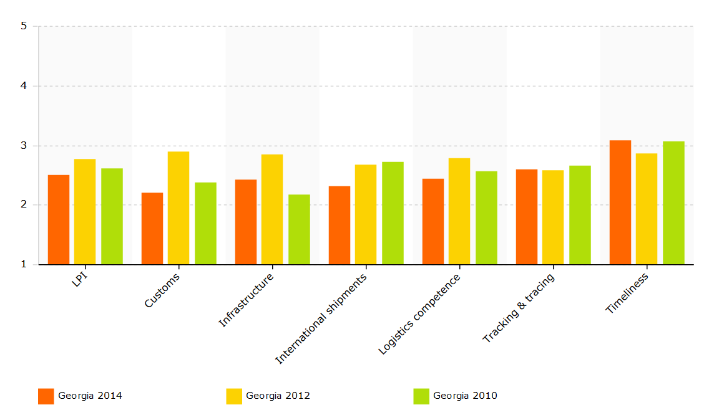  Source: WB  The Logistics Performance Index is an interactive benchmarking tool created to help countries identify the challenges and opportunities they face in their performance on trade logistics and what they can do to improve their performance. The LPI is based on a worldwide survey of operators on the ground (global freight forwarders and express carriers), providing feedback on the logistics "friendliness" of the countries in which they operate and those with which they trade.
 | EaP Road Network Indicators | Total length: 806 km  - Expressway with separated lanes (2 lanes in both directions): 40 km  - Expressway with separated lanes (4 lanes in both directions): 296 km  - Single carriageway road (2 lanes in both directions): 460 km  - Single carriageway road (4 lanes in both directions): 10 km  Network indicators (km)  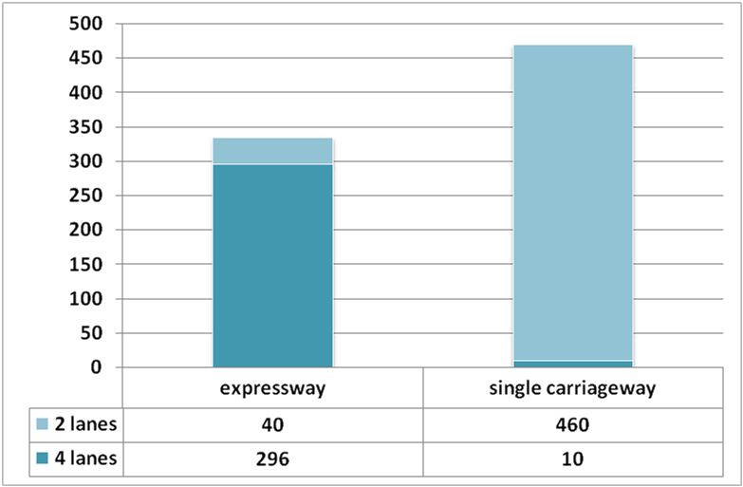  Design speed (km)  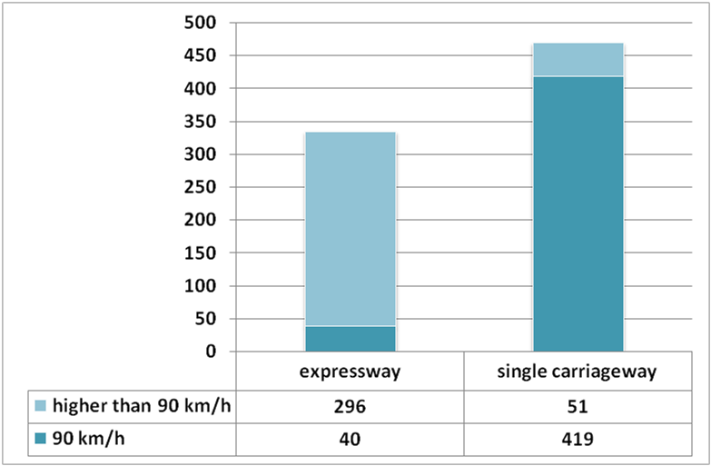  Road conditions (km)  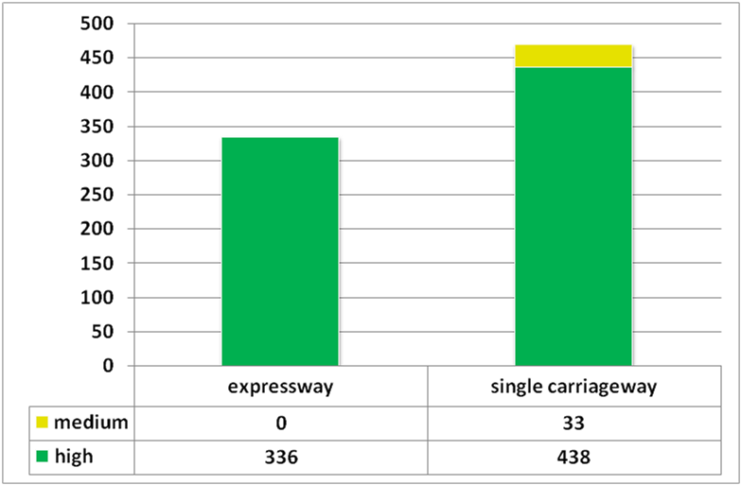  The survey on road quality performed on the context of the EaP regional transport study shows that only 4% of the EaP strategic network in Georgia is characterized by medium (33km) road conditions. The remaining network is characterized by high road conditions.  LEVEL OF SERVICE ON EaP ROAD NETWORK  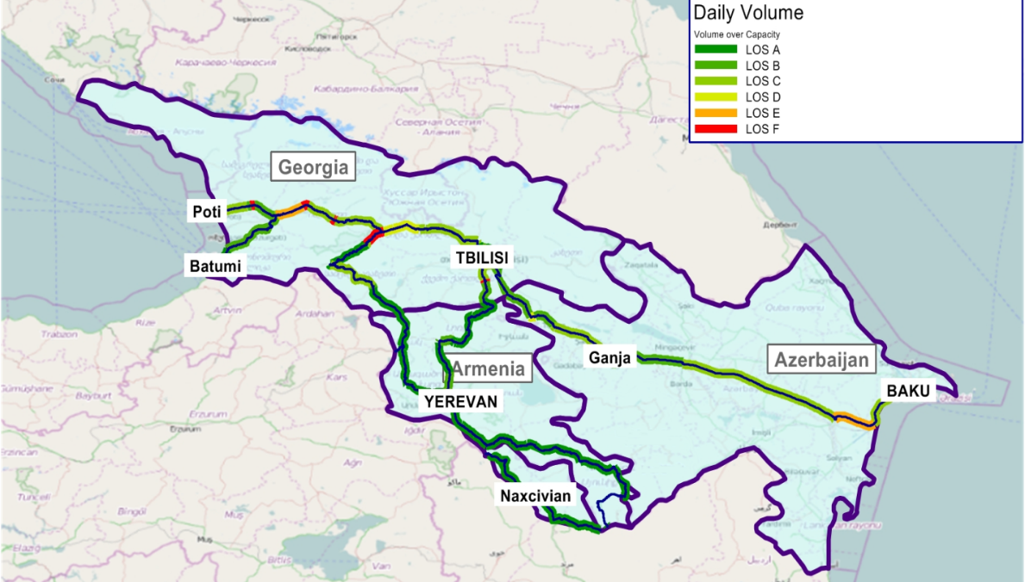  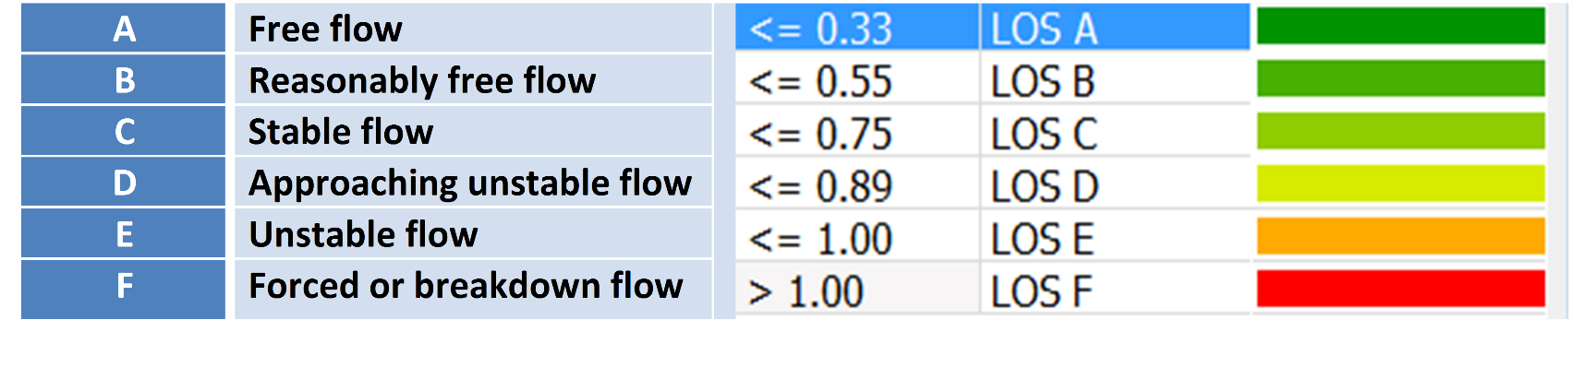
 | EaP Rail Network Indicators | The EaP railway network is composed by 402 km of singe-track and 290 km of double-track lines, fully electrified at 3kV DC.  Traction  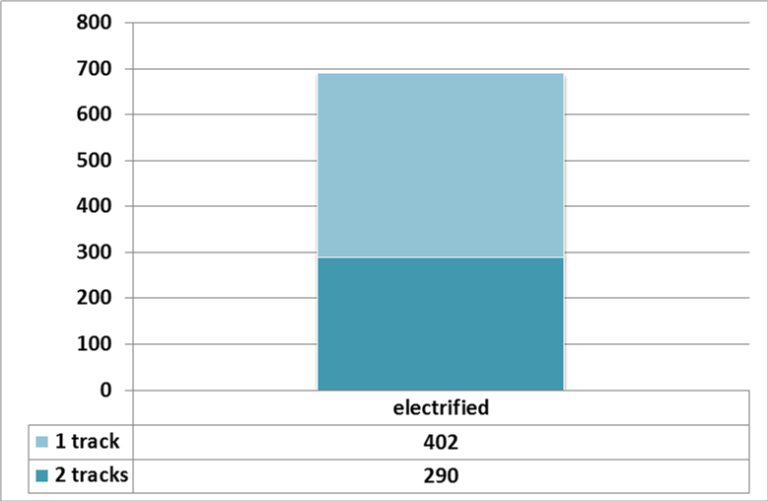
Projects included in the EaP Database |  | Title of project Year of approval Sector Total cost IFI funding  East-West Highway (E60 Tbilisi-Senaki-Leselidze): Section Chumateleti - Argveta 2016 Road 820 mln USD Multi donor funding  Rustavi-Red Bridge Highway 2016 Road 110 mln USD n.a.  Modernization of Tbilisi - Marneuli road section n.a. Road 80 mln USD n.a.  International Logistics Centre (ILC) at TAM/Veli site in Tbilisi n.a. Intermodal 41,3 mln EUR n.a.  Tbilisi-Rustavi Urban Road (Sustainable Urban Transport Investment Program Tranche 2 and 3) 2016 Road 70 mln USD ADB  Kobuleti Bypass Road (Road Corridor Investment Program Projects 1 and 3, Loan 2560-GEO) n.a. Road 256,7 mln USD ADB  Secondary Road Improvement Project n.a. Road 80 mln USD ADB  East-West Highway: Section Samtredia-Grigoleti 2015 (Lot II) Road 200 mln EUR EIB  East-West Highway (E60 Tbilisi-Senaki-Leselidze): Section Zemo Osiauri - Chumateleti 2016 Road 200 mln USD EIB WB  Batumi Bypass 2016 Road 200 mln USD n.a.  Construction of the new road Batumi bypass-Sarpi (border of Turkey) 2017 Road 100 mln USD n.a.  Rehabilitation of Grigoleti - Choloqi / Grigoleti - Poti road 2017 Road 180 mln USD n.a.  Container block train Poti-Tbilisi-Baku* n.a. Rail 36 mln EUR (only rolling stock) n.a.  Iliychevsk - Samsun - Poti maritime-based Service** n.a. Maritime 3 mln EUR*** 0,18 mln EUR: national stakeholders (UkrFerry and BMF) 2,72 mln EUR: external sources to be defined  Rustavi-Sadakhlo Expressway 2016 Road 70 mln. USD  Tbilisi Bypass 2016 Road 350 mln. USD  Baku-Tbilisi-Kars new railway line 2017 Rail 775 mln USD  Modernization of Georgian Railway (Tbilisi-Batumi): Zestaphoni-Khashuri section 2019 Rail 260 mln EUR.  Feasibility study on the creation of Logistics Centres 2016 Intermodal n.a. WB  Anaklia New Deep Water Black Sea Port Maritime 2,5 bln USD  * the project involves also Azerbaijan  ** the project involves also Ukraine  *** Related investments: 3 mln EUR for the rehabilitation of Samsun rail ramp and construction of rail gauge-break (from Russian to European) and marshalling yard facilities.  ADB Asian Development Bank  EIB European Investment Bank  WB World Bank
Macro-financial context |  | BASIC ECONOMIC INDICATORS  Indicator Unit of measurement 2010 2011 2012 2013 2014  GDP¹ million Euro 6.216 6.347 7.301 7.298 7.643  GDP per capita¹ Euro/capita 1.396 1.416 1.626 1.626 1.697  GDP² million USD 11.637 14.439 15.847 16.140 16.508  GDP per capita² USD/capita 2.623 3.231 3.523 3.600 3.676  GDP growth % 6,3 7,2 6,2 3,3 4,6  Inflation³ % 7,1 8,5 -0,9 -0,5 3,1  Unemployment % 16,3 15,1 15,0 14,6 12,4  Agriculture⁴ % of GDP 8,4 9,3 8,6 9,4 9,3  Industry⁴ % of GDP 22,2 23,1 24,5 24,0 24,4  Services⁴ % of GDP 69,4 67,6 66,9 66,6 66,4  Industry⁵ % of GDP 16,1 17,1 16,7 17,3 16,9  Trade % of GDP 87,7 91,0 95,9 102,3 103,3  Public debt % of GDP 42,4 36,5 34,8 34,7 35,7  External debt % of GDP 83,0 78,7 78,1 85,0 84,2  Total loans % of GDP 39,4 38,9 37,3 33,0 n. a.  Import million Euro 3.965 5.056 6.255 6.033 6.468  Export million Euro 1.265 1.571 1.849 2.191 2.154  Balance million Euro -2.700 -3.486 -4.406 -3.842 -4.315  Real interest rate % 6,7 5,0 13,4 14,4 7,8  Source: The World Bank (2014), EC (2014), National Bank of Georgia (2015), Geo stat (2015), Ministry of Finance of Georgia(2015).  ¹ Constant prices 2005. Source: World Bank  ² Current prices. Source: Macroeconomic Analysis Service Department of MOESD (2015).  ³ Consumer annual price  ⁴ Source: World Bank  ⁵ Source: Macroeconomic Analysis Service Department of MOESD (2015).  Explanatory Note: The external debt, at any given time, is the unresolved amount of current, and notcontingent, liabilities that require payment of an interest by a debtor at some point in the future and that are owed to non-residents by residents of an economy.  The non-resident creditors that owns the external debt are disseminated by many economies. Official creditors are public bilateral bodies and multilateral organizations. Public bilateral creditors are lenders in individual countries (e.g., central governments and central banks), multilateral organisations are international institutions (e.g., the International Monetary Fund, the World Bank and regional development banks). The total loans supplied to the economy of a country characterise the borrowing capacity of that country, with respect to external financing.  Source: IMF (2014), External Debt Statistics Guide for Compilers And Users; The World Bank (2016), Joint External Debt Hub.  BASIC SOCIAL INDICATORS  Indicator Unit of measurement 2010 2011 2012 2013 2014  Total population Inhabitants 4.452.800 4.483.350 4.490.700 4.487.200 4.504.100  Urban population % 52,9 53,0 53,2 53,3 53,5  Rural population % 47,1 47,0 46,8 46,7 46,5  Gini Index adimensional 42,1 41,6 41,4 40,0 n. a.  Life expectancy years 73,7 73,8 73,9 74,1 n. a.  Poverty rate % 20,9 17,7 14,8 n. a. n. a.  Source: The World Bank (2014).  BASIC ENERGY AND ENVIRONMETAL INDICATORS  Indicator Unit of measurement 2010 2011 2012 2013 2014  Energy use Kg of oil eq./capita 701,2 790,6 825,2 831,05 895,8  Electric power cons. kWh/capita 1.742,9 1.918,0 1.934,7 2.023,9 2.179,2  CO2 emissions metric tons/capita 2,9 3,6 3,8 3,7 n.a.  Source: The World Bank (2014), Ministry of Energy of Georgia (2015), Ministry of Environment and Natural Resources Protection of Georgia (2015)  STRUCTURE OF THE ECONOMY  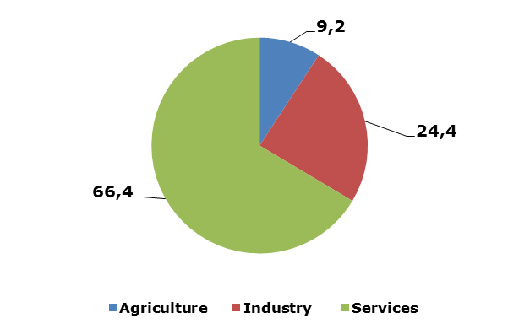  Source: The World Bank (2014).  IMPORT AND EXPORT BY MAIN PRODUCTS AND LEAD MARKETS  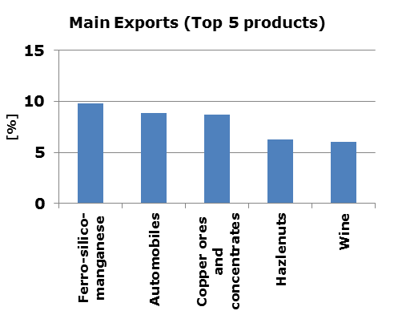  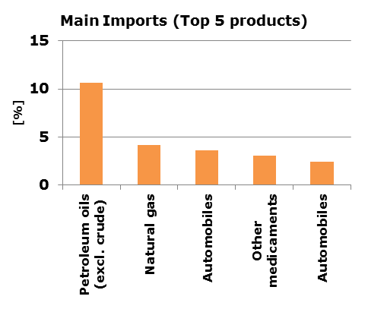  Source: The World Bank (2014).  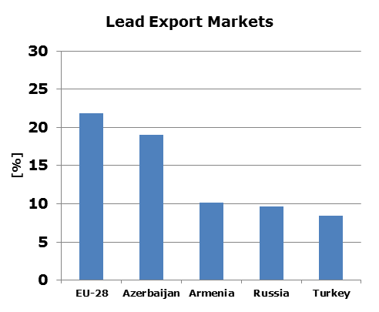  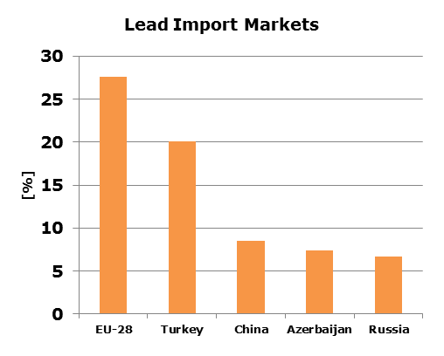  Source: EC (2014).
References |  | http://www.traceca-org.org/fileadmin/fm-dam/TAREP/65ta/Master_Plan/MPA9.1GE.pdf  http://ec.europa.eu/transport/themes/international/studies/doc/2015-06-eastern-partnership-regional-transport-study.pdf  http://trt.serverlet.com/EaP/login.php  https://www.cia.gov/library/publications/the-world-factbook/geos/gg.html  http://www.geostat.ge/cms/site_images/_files/yearbook/Yearbook_2015.pdf  http://www.who.int/violence_injury_prevention/road_safety_status/2015/country_profiles/Georgia.pdf?ua=1  http://www.traceca-org.org/fileadmin/fm-dam/TAREP/65ta/Master_Plan/MPA9.1GE.pdf  http://www.economy.ge/en/economy-in-figures/transport  http://databank.worldbank.org/data/reports.aspx?source=world-development-indicators  http://www.tradingeconomics.com/georgia/government-debt-to-gdp  http://trade.ec.europa.eu/doclib/docs/2006/september/tradoc_113383.pdf  http://wits.worldbank.org/CountryProfile/en/Country/GEO/Year/2014/Summary  http://gov.ge/files/238_33228_344995_2011_11_28_17_05_14_1.pdf  http://www.adb.org/sites/default/files/linked-documents/cps-geo-2014-2018-sd-02.pdf  http://www.ebrd.com/downloads/country/strategy/georgia.pdf  http://www.economy.ge/en/economic-legislation/transport  https://georgia2020site.wordpress.com/2016/02/26/regulatory-bodies-in-the-railway-sector/  http://www.adb.org/sites/default/files/linked-documents/cps-geo-2014-2018-ssa-01.pdf  http://databank.worldbank.org/data/reports.aspx?source=joint-external-debt-hub  http://www.jedh.org/jedh_home.html
This document has been prepared by the IDEA II project.
The content of this document does not reflect the official opinion of the European Union.
Responsibility for the information and views here expressed lies entirely with the author(s).

Inserted from <http://trt.serverlet.com/EaP/country_fiche.php?id=3>

