PROPOSAL (draft)

for ending ENERGY POVERTY in ETHIOPIA

# it takes

CONCEPT NOTE

Practical and convenient way to fight ENERGY POVERTY

(work-in-progress, needing inputs and contributions by anyone interested. Thank you.)

Is it bold and crazy (innovative) enough?

Is it fair to plan 156 billion $ for the grid, and far less than 1% for the rest > 80% (off-grid ) of Ethiopia’s > 90 million inhabitants? No wonder then the massive exodus to cities and dangerous migration abroad, especially of young women living in extreme poverty.

Salvatore Chester
Tsere lamba – solar energy (initiative)
https://www.facebook.com/groups/TEA.ethiopia/

(Addis Ababa, 02.12.2013)

Images of the problems:

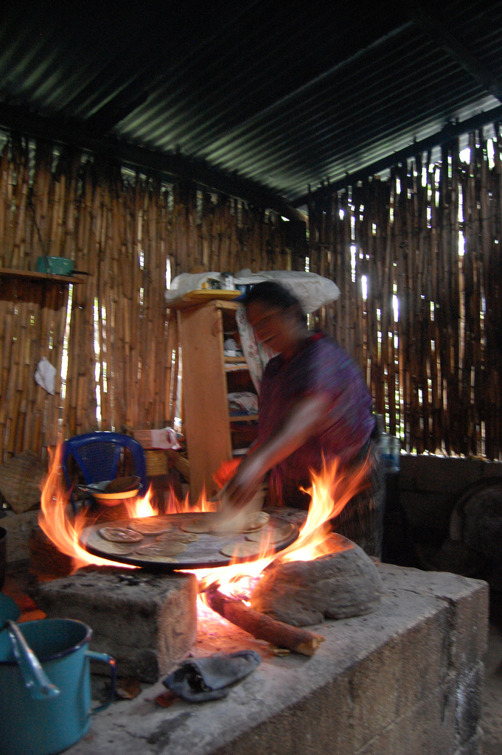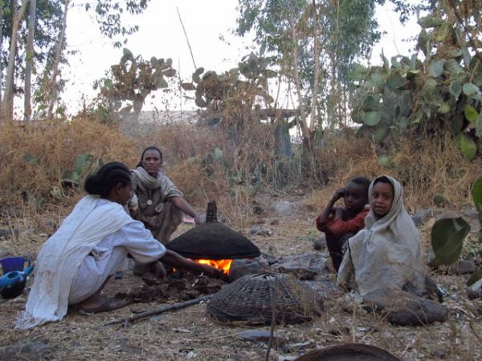

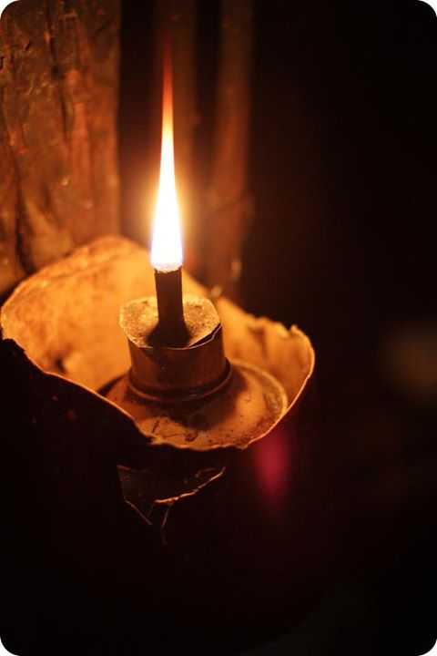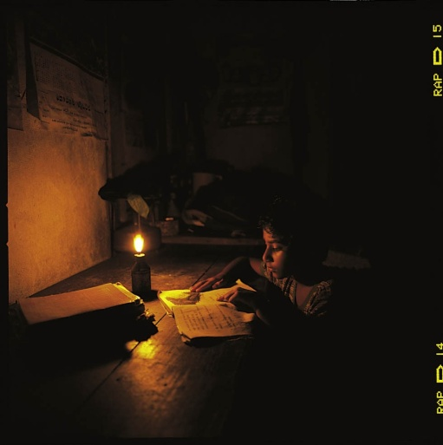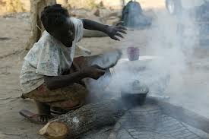

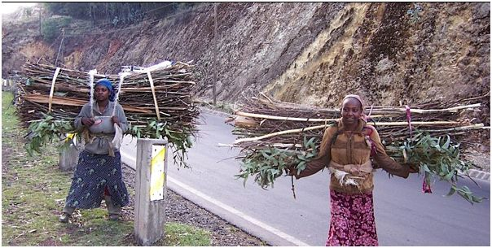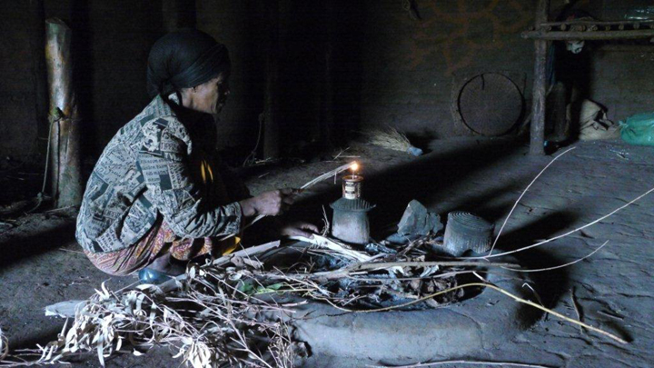

Images of the solutions:

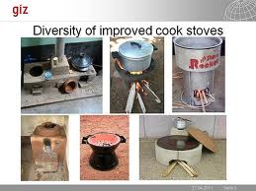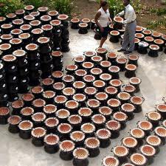

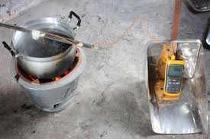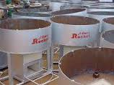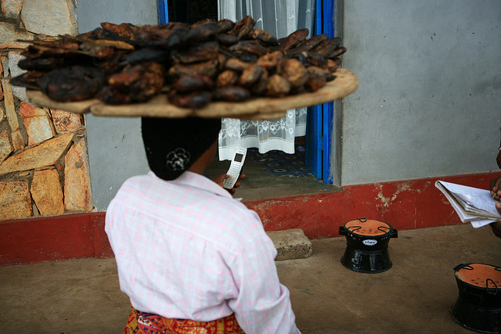

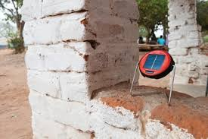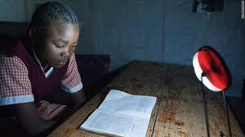

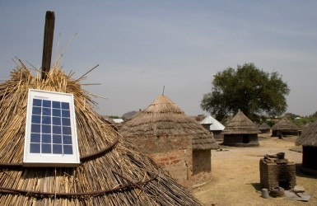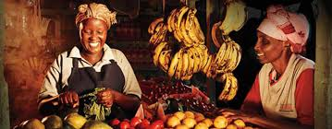

# it takes

Practical and convenient way to fight ENERGY POVERTY in rural Ethiopia

IEA definition www.iea.org :

- Energy poverty is a lack of access to modern energy services. These services are defined as household access to electricity and clean cooking facilities (e.g. fuels and stoves that do not cause air pollution in houses) http://www.iea.org/topics/energypoverty/ .

- According to the International Energy Agency (IEA), sub-Saharan Africa will require more than $300 billion in investment to achieve universal electricity access by 2030. http://allafrica.com/stories/201306300216.html?viewall=1&goback=.gde_1968968_member_254303534

- The worst kind of poverty: Energy Poverty -
http://www.time.com/time/health/article/0,8599,2096602,00.html

About transformation:

- We can't solve problems by using the same kind of thinking we used when we created them.
Albert Einstein

- Quite interestingly, the wonderful reforestation achievements in Ethiopia happened following such teachings (motto) by the rural communities: “Igna yatefanewn, ignaw inalemewalen !”

http://replantingtherainforests.org/site/index.php/Rainforest-Solutions/ethiopia-is-king-of-reforestation.html

http://allafrica.com/stories/201305210327.html

Thus: “we must solve the problems, we ourselves created”.

1/7

CONCEPT NOTE

(work-in-progress, needing inputs and contributions by anyone interested)

This draft concept note is based on currently available databases:

- LuminaNET: http://luminanet.org/forum/topics/country-data-ethiopia ,

- UNEP: https://www.facebook.com/unep.org ,

- Lighting Africa: http://www.lightingafrica.org ,

- WB: http://www.worldbank.org/en/news/feature/2013/05/28/infographic-sustainable-energy-for-all,

- Energypedia: https://energypedia.info/wiki/EnDev_Report_on_Impacts ,

- Talk Energy Ahead (TEA-Ethiopia): https://www.facebook.com/groups/TEA.ethiopia/,

- The Global Alliance for clean cookstoves: https://www.facebook.com/cookstoves.

- Aprovecho: http://www.aprovecho.org/lab/home ,

- The Light Foundation : https://www.facebook.com/TheLightFoundation.org , http://lifelineenergy.org/kerosene-a-burning-issue-in-human-rights/ ,

- Hedon Household Energy Network: https://www.facebook.com/HEDONEnergy ,

- Sun-connect: http://www.sun-connect.org/ ,

- D.Light Design: http://www.dlightdesign.com/productline/ ,

- Out of poverty: https://www.facebook.com/groups/OutofPoverty/

- Replanting the rainforests: http://replantingtherainforests.org/site/index.php/Rainforest-Solutions/ethiopia-is-king-of-reforestation.html ,

- Images: http://www.google.com/search?q=clean+cookstoves&tbm=isch&tbo=u&source=univ&sa=X&ei=AQTPUazlK-So4ATu3IDoBg&ved=0CGIQsAQ&biw=962&bih=559&sout=0

- Ideally, such databases and current objective realities on the ground may be used in the preparation of a formal draft proposal for a prospective NEPAP (National Energy Poverty Alleviation Program) similar to current NNP (National Nutrition Program). Yes this problem demands bold and meaningful remedy – as much as it can be - both on responsible actions (due priority) and adequate investments.

2/7

Basis for this proposal:

- the energy poverty agenda needs to be put ‘front and center’ whenever considering energy issues at large and extreme poverty, anywhere (global or local) ;

- our shameful energy poverty affecting the vast majority (>80%) in the country with no access to electricity, and many more using primitive and inefficient cookstoves;

- the poverty penalty of rural communities spending on average 5 times more for lighting than grid power users;.

- Ethiopia’s current extensive reforestation efforts (No.1 in the world!) based on free-labor of millions of same rural people;

- the inadequate provisions of current GTP of Ethiopia, UN MDGs ( SDG 2015-2030 ? );

- renewed programs by UN + WB to eradicate extreme poverty by 2030;

- pro-poor legacy of the late PM. Meles Zenawi towards fighting poverty as the paramount responsibility and objective of the Government;

- the missed opportunities and inadequate actions (whatever the narratives) taken so far in this respect;

- the misplaced subsidy and focus in favor of grid power users, at the expense of the vast majority living dispersed in off-grid rural areas;

- the revised grid power Master Plan envisages public and private financing of 156 Billion $, by 2037, while insignificant percentage, far less than 1, is planned for the rest > 80% of > 90 million suffering because of energy poverty;
http://addisfortune.net/articles/increase-in-electricity-tariffs-required-to-realise-power-generating-projects/

- grid based rural electrification projects can hardly trickle-down (?) to adequately reach the dispersed rural settlements and nomadic pastoralists all over Ethiopia. Viability, competitiveness and reliability apart.

- extreme poverty, energy poverty in particular, is responsible for the massive exodus to cities and dangerous migration abroad, especially of young women (push and pull factors). http://www.youtube.com/watch?v=OGnZTLcuSGA

3/7

Things make you go hmmm? (NB. Indicative figures; Exch./rate 1 $ = 19 Birr)

- Less than $.50 per family is enough to effectively reduce the chronic energy poverty in rural Ethiopia. This is a one-time help/incentive for them to escape from bad habits, or initial push for switching to modern energy and benefit from a huge market of innovative green technologies.
- “The difficulty lies not so much in developing new ideas as in escaping from old ones”.
John Maynard Keynes

- About 18 million poor families are still forced to use “imported kerosene” and primitive coostoves, for lack of cleaner and cheaper options, even though currently available.

- When allowed, tens of millions rural customers use mobile phones of their choice which they have bought COD. They too require energy at home for charging same (about 50 M. planned by 2015).

- Rural families spend annually, on average, $ 60 for kerosene (plus candles and batteries), and $ 133 for fire wood and charcoal. Clear case of poverty penalty, while grid power users are highly subsidized: http://papers.ssrn.com/sol3/papers.cfm?abstract_id=1741826.

- Long lasting solar pico lanterns (> 5 years, maintenance free) can allow 100% saving on kerosene for lighting, while improved cookstoves could be responsible for > 50% savings on fire wood and charcoal.

- It is possible to completely displace kerosene, and halve the need of wood fuel, and to significantly reduce both indoor & outdoor pollution (better health), in addition to corresponding carbon emissions and deforestation.

- Rural families in Ethiopia could save as much as $ 2.3 billion, every year, from direct expenditures of their energy bill (kerosene + wood fuel).

- The Ethiopian Government could save over $ 1 billion, every year, on foreign currency needed for importations of kerosene (prevalently), candles, batteries, and medicines. Talk about smart import substitution.

- The Government (Ethio-Telecom) could have near 100% energy coverage for its customers, sharing conveniently this initial investment. As an additional option, Ethio-Telecom could couple this initiative with a free-of-charge distribution of solar chargers for its rural customers, also as a marketing move.

- This way, rural families could have: modern lighting, improved cookstoves, access to telecoms and FM radio, all at once with relatively modest investment. Think about the overall impact on rural life.

- Tens of thousands new jobs could be directly created, both on manufacturing and distribution of improved cookstoves and solar lanterns.

4/7

- NEPAP, a time based program, could in addition to fighting EP boost the local market for solar products and modern cookstoves, leaving the private sector open space to do its business both during and afterwards. Short to medium term results are what matter most at this stage of alleviating the suffering of so many.

- What Ethiopia needs now is less than $ 1 billion, as one-time investment to end this scourge, over 5 to 10 years.

- The Gov. could obtain a soft loan (and possibly grants) from its Development Partners in line with the UN+WB programs for eradication of extreme poverty, by 2030.

- NB. Such loans are usually condoned and likely to be (justly) cancelled, sooner or later.

- The Gov. could also claim from the international community, CDM carbon credits and pass them over back-to-back to rural families. Probably equal to the required $ 50 per family (?).

- The Gov. could - as a lasting solution for cooking needs – allow and promote local production of bio-fuels and bio-diesel to energize cookstoves in rural areas, instead of using ethanol exclusively for blending it with petrol.
http://topics.nytimes.com/top/news/business/energy-environment/biofuels/index.html

- As for the implementation method, PPP could be used to administer the whole dissemination process at district (woreda) level, all under the control of MoWE (for example).

Of course with zero tolerance for mismanagement and corruption, petty or grand.

- An alternative to such level of investment and implementation methodology, could be, to leave it to the private sector to handle it, by just creating a conducive business friendly climate. Maybe a viable proposition, but not sufficient in reality for this particular purpose (rapid and adequate actions to compensate for the long neglect). Simply, it is possible to have them both: a working PPP and a conducive free market climate all at once.

5/7

CONCLUSION of the concept note (draft proposal):

- The problem:

- ENERGY POVERTY affecting > 80% in rural Ethiopia, home to about 90 million people.

- Inadequate attention and investment for energy poverty here (156 B.$ for grid power development, and far less than 1% for off-grid).

- The appropriate technology (as a package):

- 2 basic solar lanterns (S2 type, or equivalent, for $ 28) ;
2 improved cookstoves (Lakech type, or equivalent, for $ 8 ) ;
1 injera baking stove (Mirt type, or equivalent, for $ 14).

b.1) - Optional: 1 basic mobile phone with FM radio + flashlight, and a solar charger for $ 25.

- The solution:

- Pro-poor POLITICAL WILL (NEPAP) to help with FREE-OF-CHARGE distribution of the above products (in a PACKAGE), valued at $ 50 for each family accepting to give up - for good - using polluting and expensive kerosene, and inefficient cookstoves.
Rural people may be poor but not stupid to refuse the offer.

- One-time INVESTMENT of $ 1 billion by the GOVERNMENT and its Development Partners (soft loan from WB, plus CDM carbon credits) over 5 to 10 years.

- PPP for the administration of the whole DISTRIBUTION AT WOREDA LEVEL.

- Making locally produced BIO-FUELS available for cooking purposes, in due course.

- Benefits and beneficiaries:

- More than 18 million rural families (rural and pastoralist communities) in Ethiopia.

- The likely outcome of this initiative is an overall positive impact on rural life of million BOP families, rectifying a vicious circle of: neglect, poverty, chronic environmental degradation.

- In addition to improved living conditions, families could SAVE over $ 2 billion every year.

- The Government SAVING over $ 1 billion, every year, on foreign currency for importation of kerosene, candles and batteries. Smart IMPORT SUBSTITUTION.

- Local and global ENVIRONMENT protection, on account of billions of trees spared while increasing current extensive reforestation and fighting land degradation efforts.

- Dulcis in fundum, the Government will benefit from the “VOTING POWER” of about 18 million families lacking electric power .

6/7

- Bottom line:

- Ultimately, besides pro-poor actions and the environment protection, this country needs to spend 1 to save 16.5 billion $, in just 5 years time. Is this cost effective, sustainable enough and/or viable ROI?

- As a matter of fact, rural communities are currently offering free-labor for the extensive reforestation and land preservation activities which will definitely benefit themselves, the environment, the Government and the International Community.

- Fair enough, they ought to be adequately compensated by the latter. So no case of free-lunch here, rather a well deserved compensation.

- Precedents and examples of similar programs:

- Current National Nutrition Program in Ethiopia

- Free mosquito net distribution program in Ethiopia

- Free CFL lamps distribution for displacing incandescent bulbs, cleverly banned here.

- Indonesia’s 15 million poor to receive aid package of $ 60 for each family (total $ 2.8 billion) http://www.aljazeera.com/video/asia-pacific/2013/06/201362574550916488.html

Yes, the solution is there calling for responsible actions. Best wishes.

Salvatore Chester
Tsere lamba – solar energy (initiative)
https://www.facebook.com/groups/TEA.ethiopia/

(Addis Ababa, 02.12.2013)

7/7

