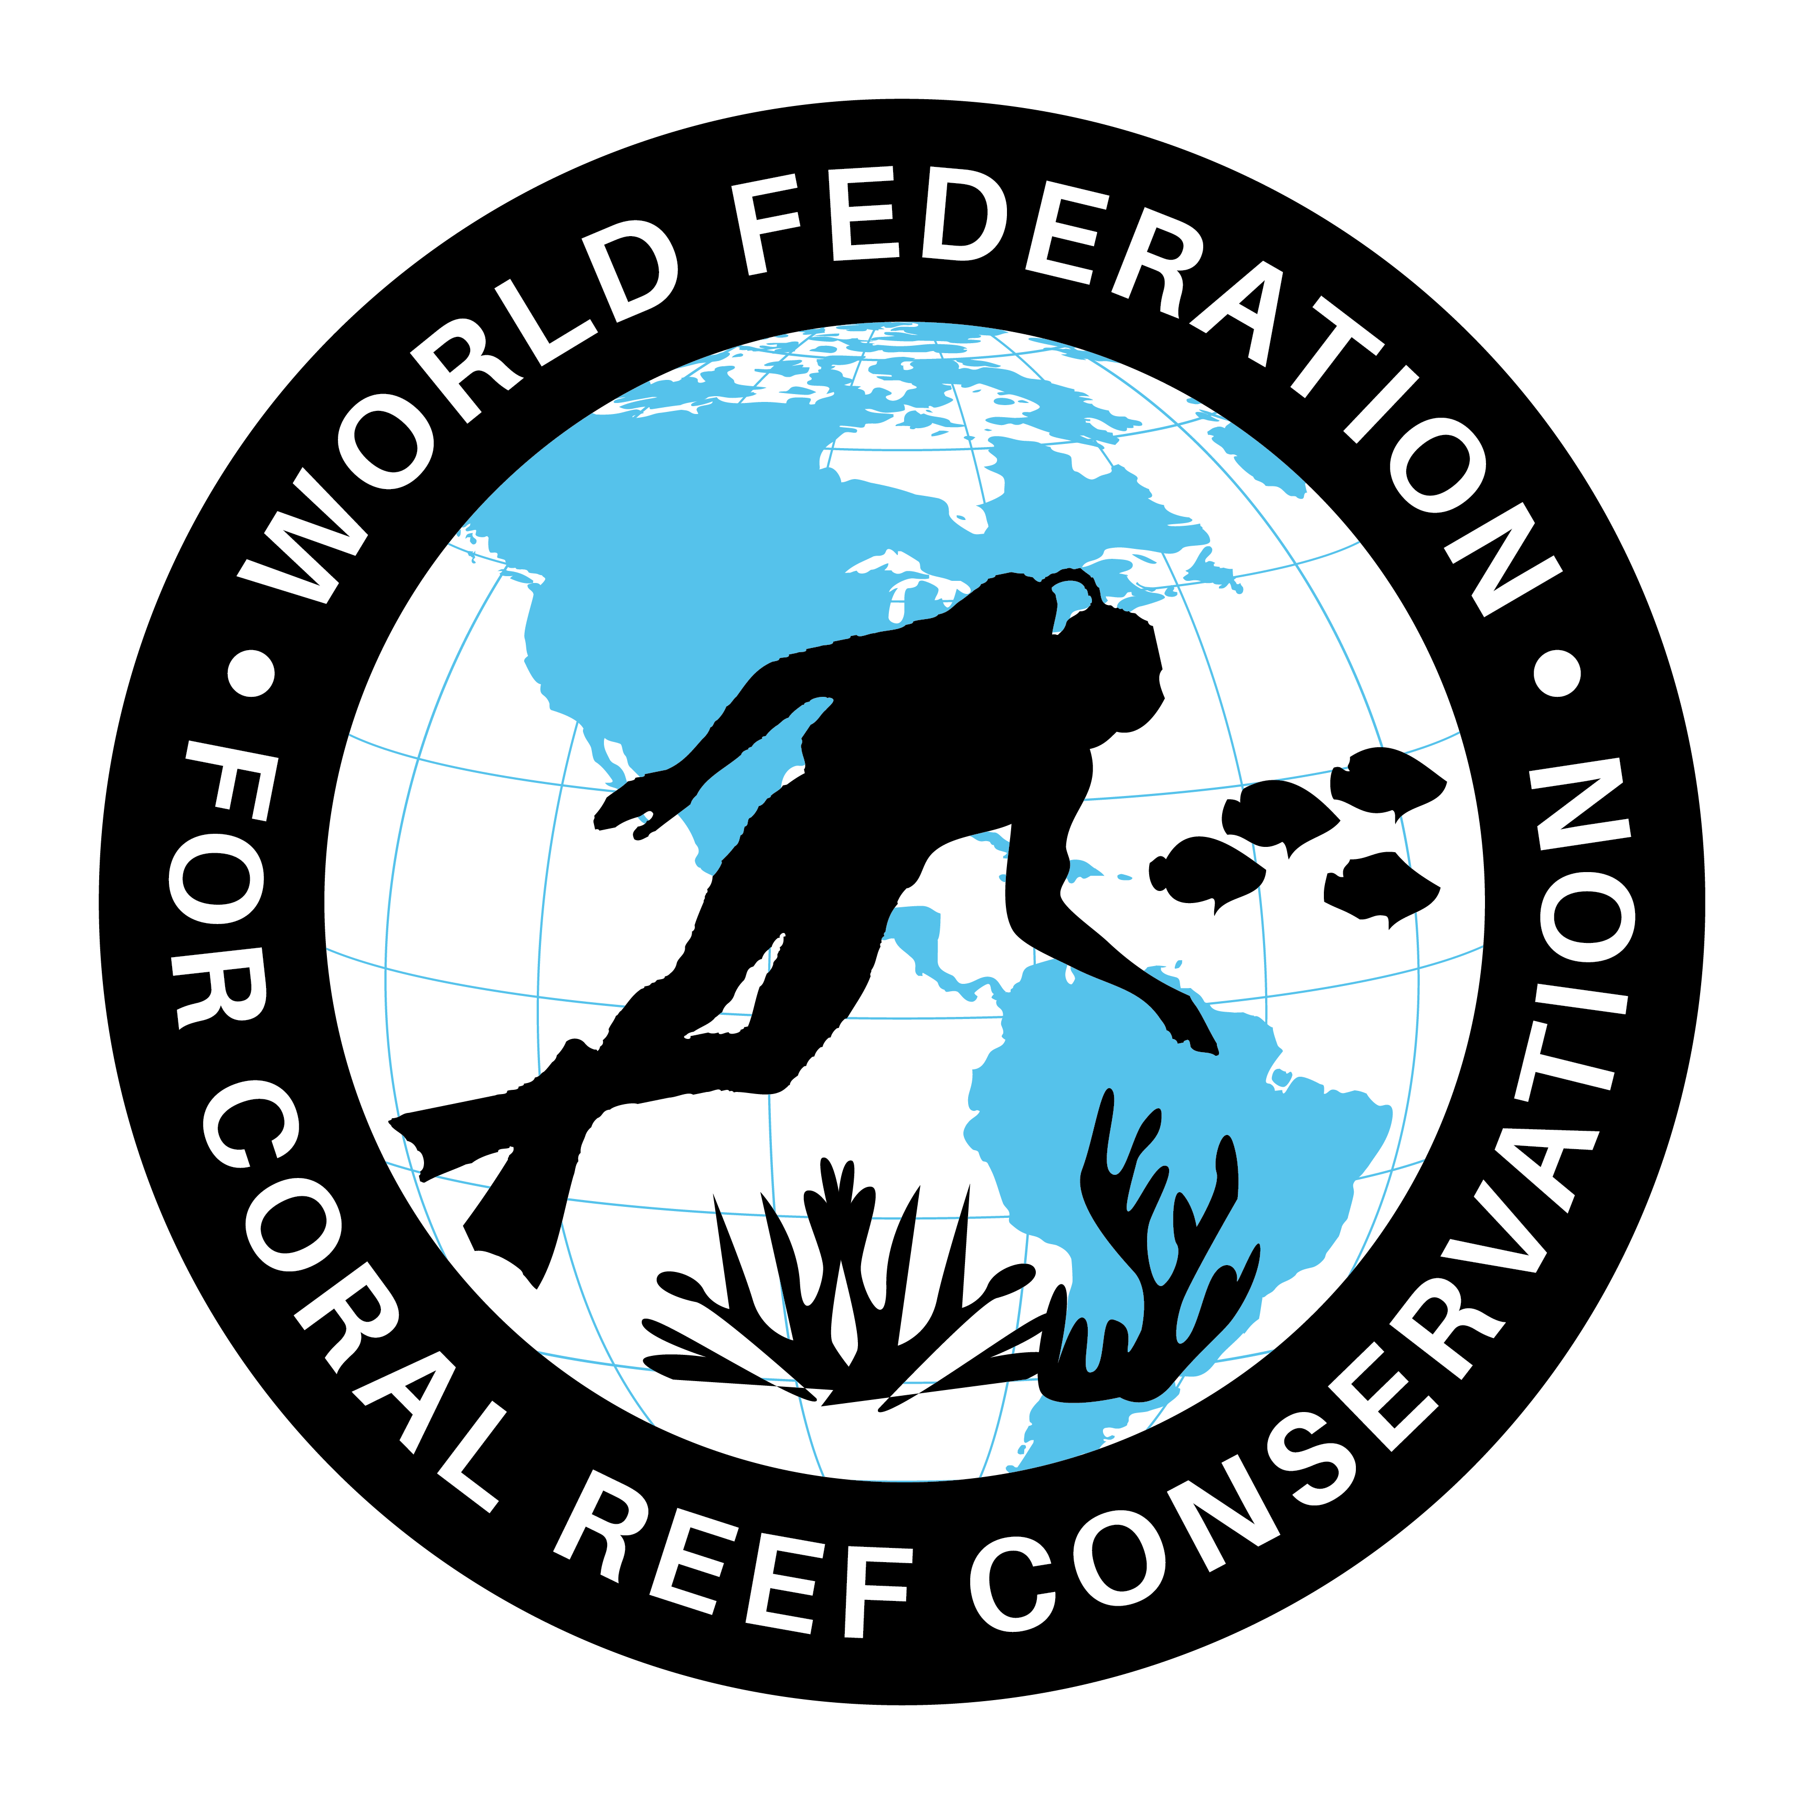
SDG14 & Caribbean Ring of Hope Sites
Executive Summary

The World Federation for Coral Reef Conservation 281.971.7703 P.O. Box 311117 Houston, TX 77231
Vic Ferguson Executive Director 512.986.1902 vic.ferguson@wfcrc.org info@wfcrc.org

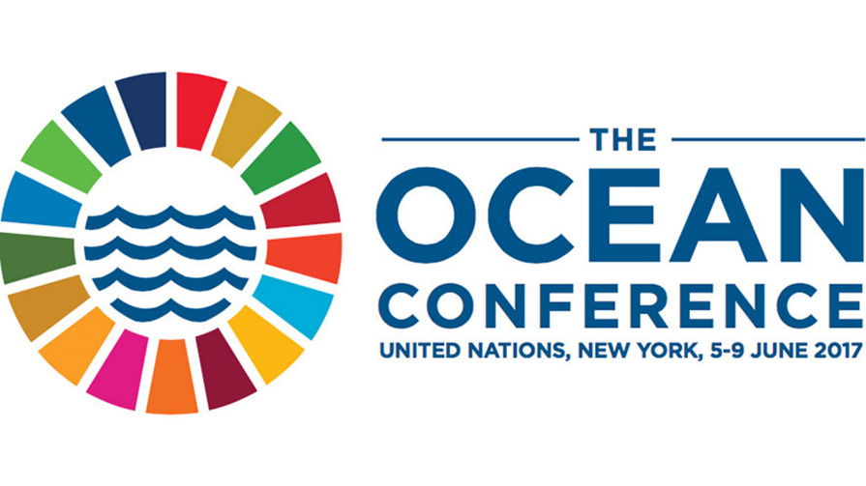
3/22/17

“Changes in attitudes….
Changes in latitudes”

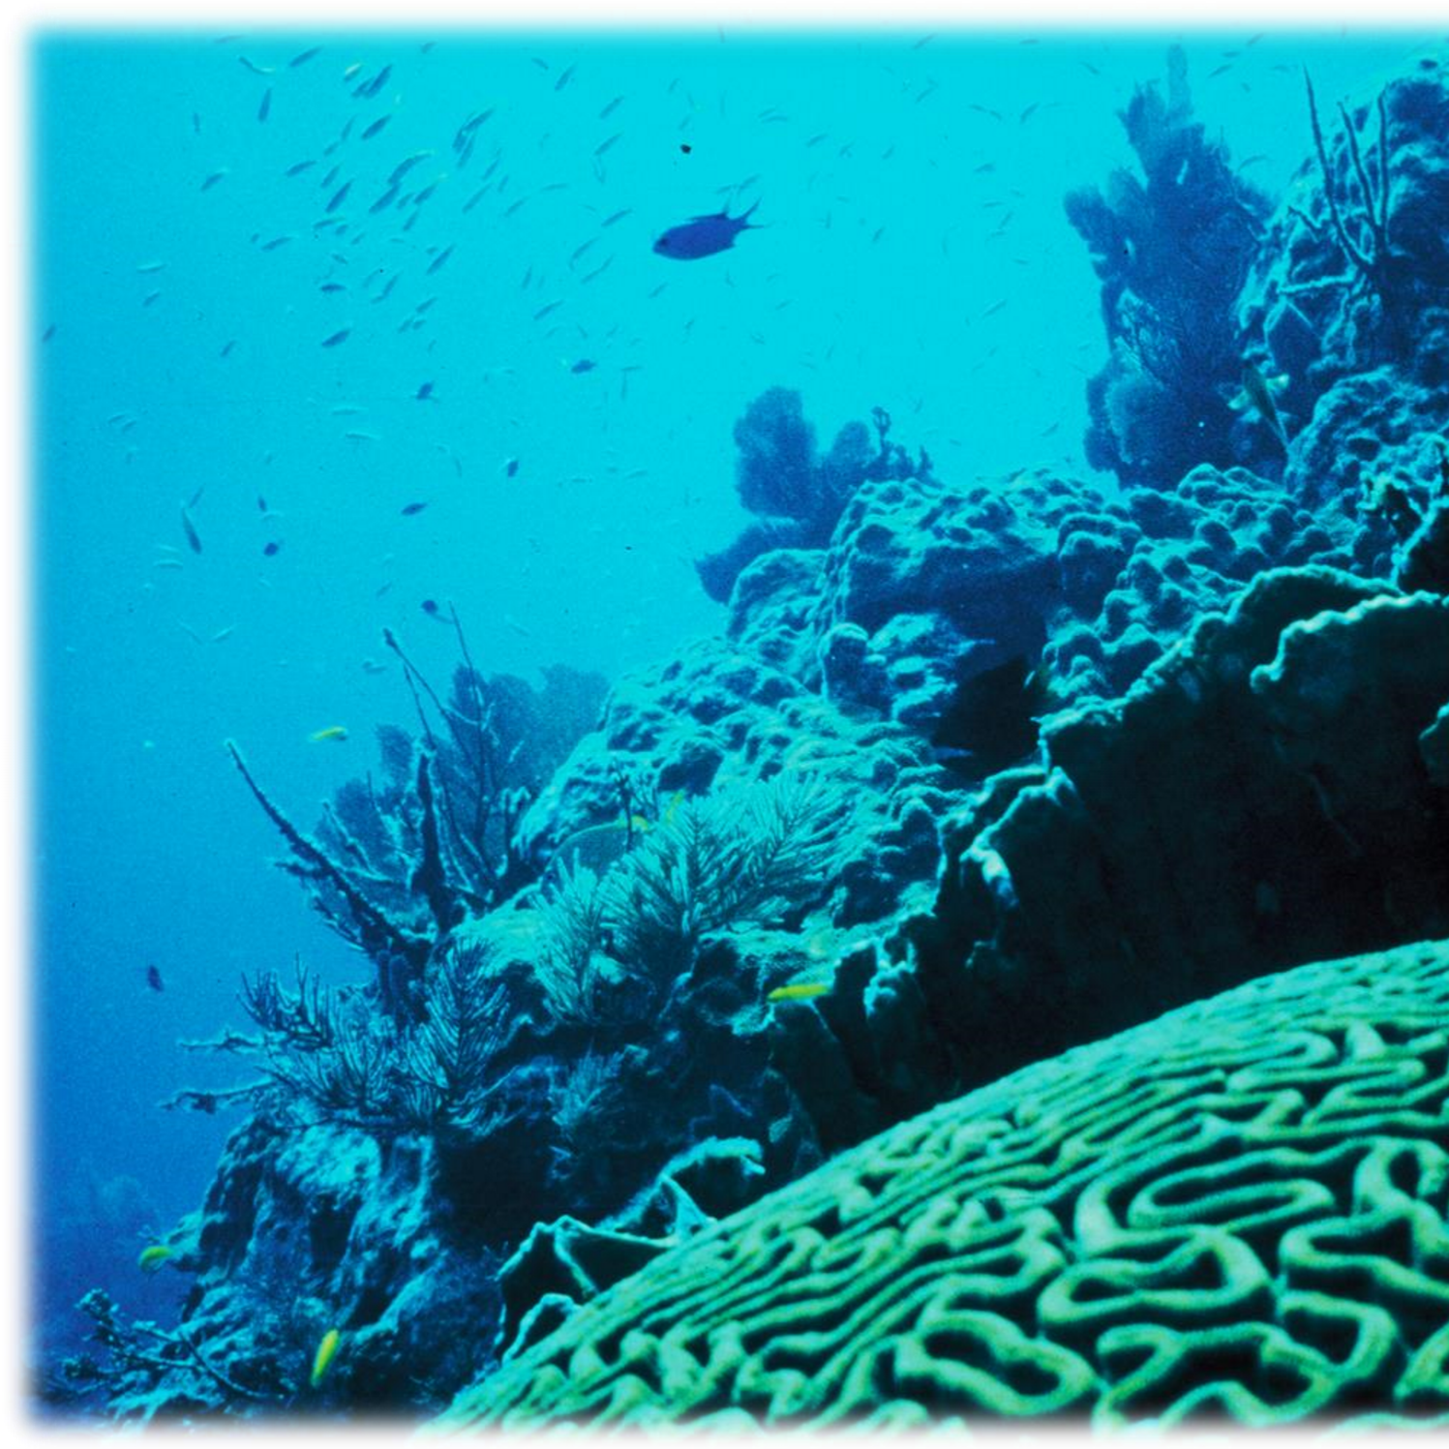
St. Maarten Coral Summit 2017

This is an opportunity to give a higher value to your vacation dollar this year by participating and attending an environmental conservation effort, “The International St. Maarten Coral Summit 2017”. Our wish is to change the attitude about how we are altering our oceans. It’s our ocean to save. It belongs to us all, it has no boundaries.

By supporting this event you will have chance to participate with us at our 2017 Fundraiser/Gala. The event in St. Maarten will be The Fundraiser/Gala Event of the year for St. Maarten. The plans are for speakers and knowledge sharing about the value of maintaining the current status of coral reefs and coastal environments and how it pertains to keeping the local tourism business healthy. There will be hor d’oeuvers provided by The Random Wind, a cash bar and a silent auction.
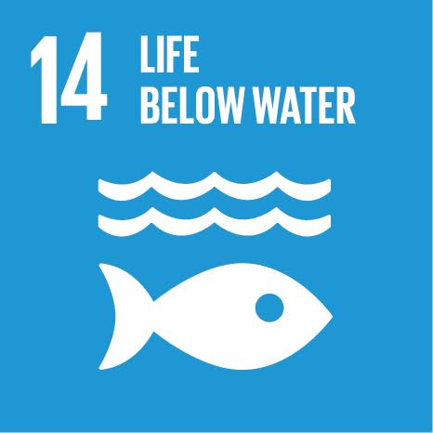
The World Federation for Coral Reef Conservation is focusing its efforts to comply with The UN Sustainable Development Goal number 14, “life below water” by attending the conference. WFCRC was involved in this high-level United Nations Conference that aims to be the game changer that will reverse the decline in the health of our ocean for people, planet and prosperity.

Oceans comprise roughly three-quarters of the Earth’s surface and play an essential role in human well-being, producing half the oxygen necessary for life on the planet. They also serve as the backdrop for another important component of a well-rounded life: recreation.

The multiple benefits provided by the world’s oceans, seas and marine resources are the focus of the first-ever Ocean Conference at The UN Headquarters in New York. The Conference seeks to achieve the targets laid out under Sustainable Development Goal (SDG) 14, including galvanizing action on ocean-related issues such as protecting coral reefs, reducing plastic pollution, and addressing the impact of climate change.

The initiative brings together leading ocean, climate earth and marine scientists to develop a list of the of the most critical coral reefs to protect, while leading conservation practitioners are working together to establish the best practices to protect these reefs.
We are developing this consortium of leading ocean, climate, earth and marine scientists together in one event in St Maarten. Some of the organizations we are contacting for participation are The Dutch Caribbean Nature Alliance, The Global Island Partnership, The United Nations SDG, and Mission Blue as well as local stakeholders.to be part of “The Caribbean Ring Of Hope Sites” event.
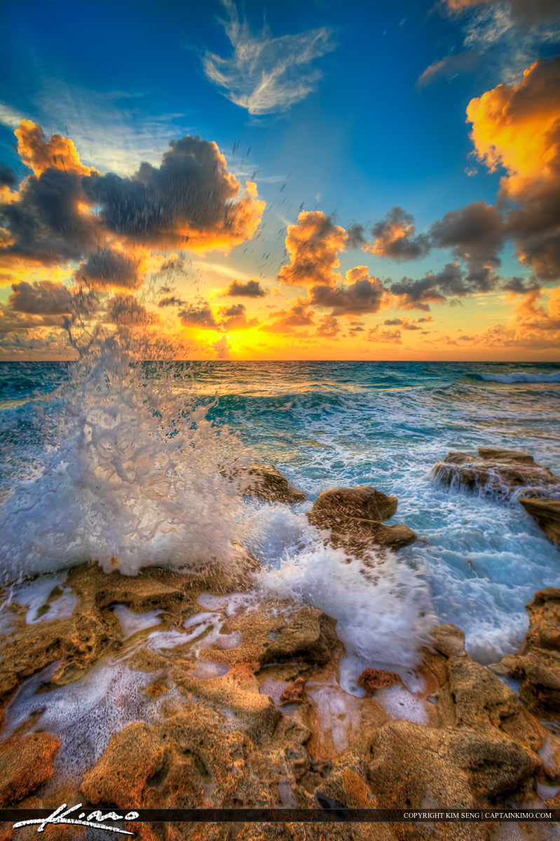
It is the purpose that the “Caribbean Ring of Hope Sites”, an idea built upon Sylvia Earls Hope Spots to be one of the focal points at the Coral Summit in St. Maaarten. To host a conference of Caribbean Nations in one location to align themselves with an effort to collaborate with each other to share what is working for conservation and what needs work will surly bring results in a way that will benefit all nations equally.

The St. Maarten Coral Summit will have several modules to be presented like the science of coral reefs, the protection, the monitoring, sediment flows, storm water runoff, 1st response, preparedness, oil spills, GIS, local content and long term management.
We are planning for a day of coral planting and mangroves the following day after the Gala. The tentative line up of speakers will be:
- Sylvia Earl of Mission Blue as the keynote speaker
- Tiffany Babcock Marine Biologists and teacher will present “the science of coral reefs” along with her slide show.
- Maria Alejandra Faria, who will share the value in “Sustainable Development of the Caribbean”
- Rod Tyler with Filtrexx International. Rod will explain how sediment and storm drainage has an impact of coral and how it can be averted.
- Austin Kerby, Marne Biologists and coral reef scientists
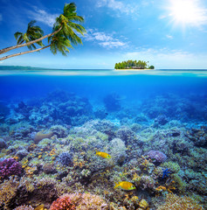
- Sam Purkis, Head scientists for The Living Ocean Foundation will shed light on how long term management will provide the best plan to keep coral reefs healthy and intact.

While on the island of St. Maarten there are many events to attend and beaches to relax on. For those attending the event there will be discounts on car rentals from Thrifty Car Rental, restaurants, guest accommodations and beautiful beach lounging in two different countries. Both the Dutch Side and the French Side with its outstanding French dining at Friars Bay on the beach. Not to be out done by the Lottery Farm a rainforest dining experience and of course the Dutch hospitality.

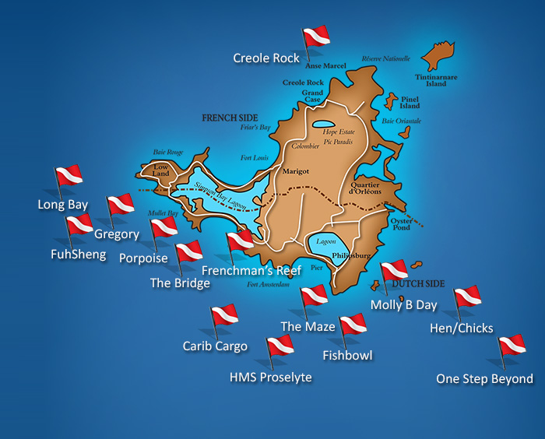
Also The Random Wind Charter Co. has offered a complementary day of sailing with wind in your face, a run drink in your hand and a special lunch prepared on board while under sail. With anchor stops to snorkel, swim and lay on the beach. It is a day not to be missed and is available only to the summit participants.

For divers, St. Maarten has many dive sites to take advantage of as well as those on St. Barts, Saba and other islands in proximity.

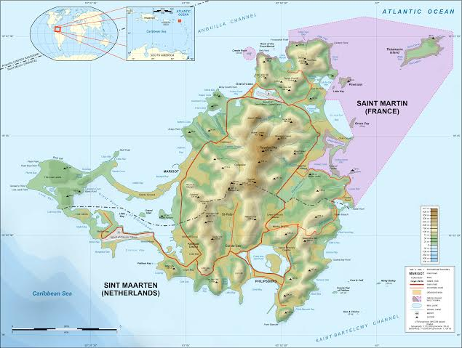
Upon completion of the presentation and the execution of the proposal, the template we will have created will be moved to the next island location, most likely St. Barts then Saba and so on.
It’s our ocean to save, ONE OCEAN……………ONE PLANET!
We look forward to hearing from you.
Thank You
Vic Ferguson
Executive Director
World Federation for Coral Reef Conservation
P.O. Box 311117
Houston, Texas 77231
vic.ferguson@wfcrc.org
www.wfcrc.org
281.971.7703 (office)
1.512.986.1902 (cell)
The only thing necessary for the triumph of evil is that good men do nothing”….Edmund Burke

