New: Gender and Universal Health Coverage (UHC) A Self-Paced Learning Module – Released: July 1, 2022 – Enroll or Pass the Word to Colleagues
Enroll Now
A self-paced training module on gender as a social determinant of health, its interaction with health systems. This module focuses on the role that gender plays in health and the rationale for paying attention to gender in healthcare systems, its relevance to achieving universal health coverage and in addressing pandemics. Please allow yourself between 1 hour to 1.5 hours to complete the course. The course has 5 sections: 1. Understanding Gender 2. Gender as a Determinant of Health 3. Gender and Health Systems 4. Closing gender gaps in Health Data and Research 5. Gender and Pandemics
This course is part of the Health Systems Flagship Program of the World Bank Group
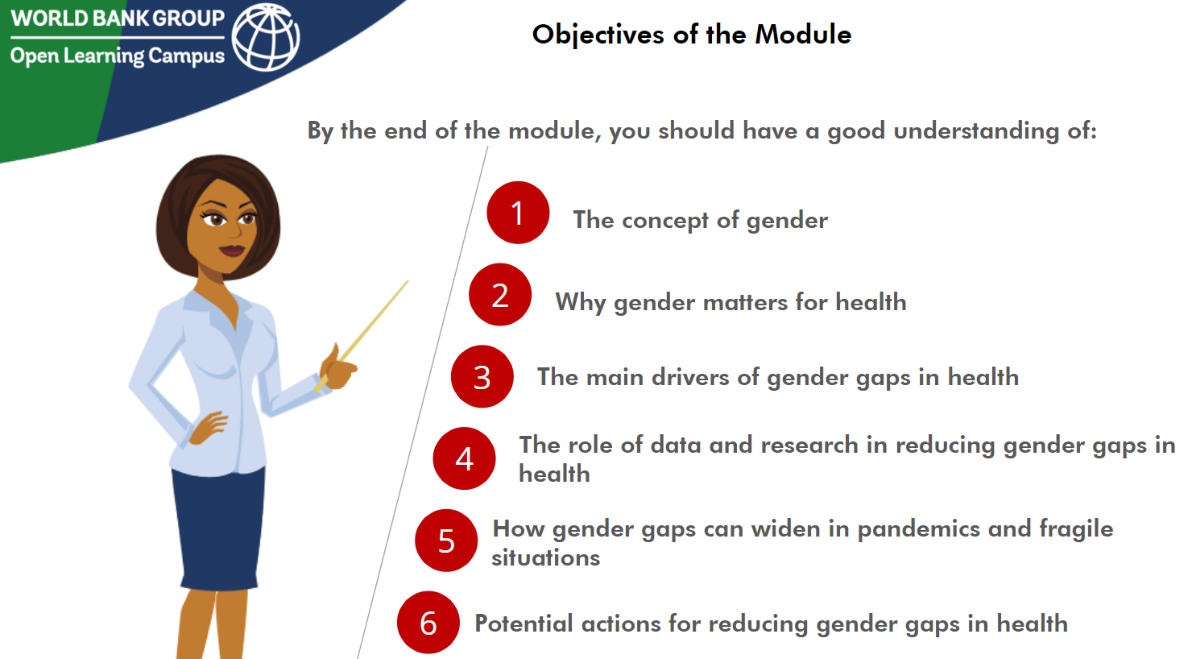
About the Course

Course Overview
This module consists of five sections. Each section builds on the previous sections to develop an understanding of gender issues in healthcare from the perspective of the Flagship Framework of Health Systems. The course begins with a refresher on gender in section 1, followed by discussion of gender as a determinant of health in section 2. Section 3 focuses on addressing gender gaps for achieving universal health coverage. Section 4 discusses measurement of gender gaps in health; and Section 5 focuses on addressing gender in health emergencies like pandemics.
Objectives
This module focuses on understanding gender and why it matters for health systems using the flagship framework. By the end of the module, the audience should have a good understanding of the concept of gender, the main drivers of gender gaps in health, and how to address these, including in pandemics and fragile situations, as well as the role of data and research in addressing health related gender gaps.
Target Audience
All staff, general audience, colleagues around the globe working on gender and/or health systems and Universal Health Coverage (UHC)
Credits
Course commissioned by the World Bank Health Systems Flagship Program, course authors – Developed by Sameera Maziad Al Tuwaijri (Lead Health Specialist) and Seemeen Saadat (Consultant, Gender and Health)
Course Link
https://olc.worldbank.org/content/gender-and-universal-health-coverage-uhc

