

**To Save your Document Drafts**

1. Click on “My Content” in the top bar



1. On the left bar, click on “Drafts”

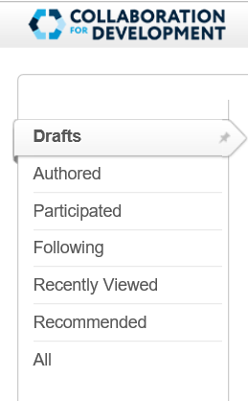

1. On the right-side menu, Actions
   1. Choose “View as a PDF”
   2. Click “Save As” to save the file to your documents

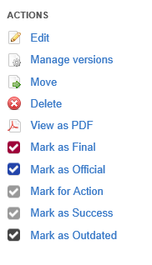

**To Save your Private Content**

1. Click on “Content” in the top bar



1. On the left bar, click on “Authored”

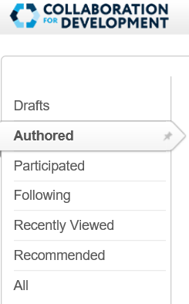

1. Look for any private content you might have (You will notice that a lock symbol appears next to it and that no space/group name is listed under the title).

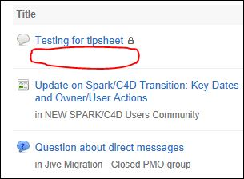

1. Click on the link, and then on “View as PDF” under Actions. Finally “Save as” a file on your personal computer or USB.

