Integrated Urban Water Management
Financial and Economic Module

Simulation Game
Materials

Version: Final draft
October 31, 2016
OVERVIEW OF IUWM ROLE PLAY MATERIALS

Materials | Number | Included in this document
Laptop | 1 for facilitators
Script | 1 per facilitator
Slide deck with 4 parts: Introduction Round 1, Results Round 1, Introduction Round 2, Results Round 2 | 1 for facilitators
Laptop | 1 per team
Round 1 Tool | 1 per team
Round 2 Tool | 1 per team
Handout: “Case description” | 1 per person | x
Handout: “Alternatives” | 1 per person | x
Handout: “Economic Impact Assessment” | 1 per person | x
Scoring form Round 1 | 1 per team | x
Handout: “Case description addendum” | 1 per person | x
Handout: “Letter from water utility” | 1 per person | x
Handout: “Note from Blue Green Infrastructure Program” | 1 per person | x
Handout: “Letter from developer” | 1 per person | x
Scoring form Round 2 | 1 per team | x

CASE DESCRIPTION ROUND 1

Bay City is located in a delta area. The natural water system of Bay City consists of one main river with some lakes and ponds, which discharge into a bay that is linked with the wider ocean. A wastewater treatment plan is located downstream along the river at the bay which collects sewage from the city and conducts primary treatment of sewage before discharging it directly into the bay.

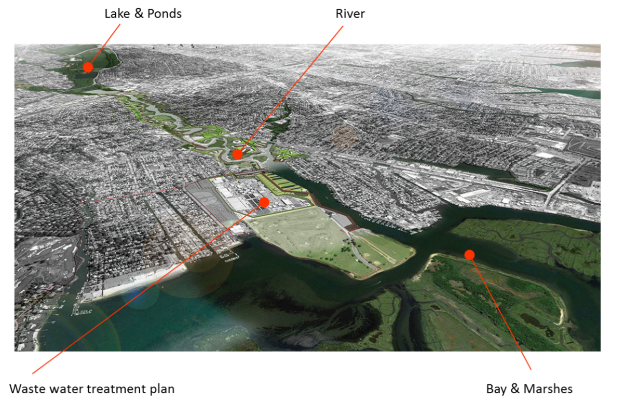

The discharged wastewater increasingly causes water quality degradation and ecosystem damages in the bay. This has significant negative effects on recreation and tourism activities and surrounding property values.

With increasing urbanization and population growth in the city, the capacity of the wastewater treatment plant is no longer sufficient. Therefore, enhancing the capacity of the plant is necessary.

The city is expecting to have an annual revenue stream of $1,000,000 in water treatment fees available for the investments in capacity expansion over the coming 30 years.

You are the Bay City task force responsible for the water management investment program.

ALTERNATIVE PROJECT SOLUTIONS

The working group responsible for developing alternative technical investment programs came up with the following three alternatives which all have the main objective to solve the wastewater treatment capacity problem:

ALTERNATIVE 0
This is the baseline alternative, where the minimal level of investment is made, i.e. augmenting the capacity of the current wastewater treatment plan (WWTP) to meet the growing demand due to population growth, with an estimated investment cost of $5,000,000 and annual maintenance costs are 3% of the initial investment cost. This alternative is expected to only collect and treat the increased volume of sewage (due to population growth) to the primary level, before discharging it into the bay. Hence, the expanded capacity of the treatment plant will, as a minimal requirement, avoid discharging untreated effluents into the bay as the city grows. However, no improvement of the water quality is expected in the long term as compared to the current situation.

ALTERNATIVE 1
In addition to expanding the capacity of the current WWTP, this alternative involves investing in treatment upgrades in the plant so that the entire volume of collected sewage from the city will be treated to the secondary level. This will not only reduce pollution and negative impacts on the aquatic ecosystem in the bay, but may help support tourism and recreational activities in the bay while safeguarding public health through these activities. The total investment cost of this alternative is estimated to about $8,000,000 and annual maintenance costs are 4% of the initial investment cost.

ALTERNATIVE 2
In this alternative, the capacity of the current WWTP will be expanded to meet the growing demand, without investing in any treatment upgrade. This is achieved by subjecting the wastewater to primary treatment only but moving the discharge point for the primary-treated effluent further into the ocean, outside of the bay through an extended outfall pipe. The total investment cost of this alternative is estimated at about $7,000,000 and annual maintenance costs are 3% of the initial investment cost. This alternative is based on scientific studies showing the decreased level of pollution impact in the bay that could be achieved with this alternative, obviously leading to increased tourism and recreational activities in the bay. However, the study also showed projections of potential negative environmental impact on the aquatic ecosystem outside the bay, as well as potential negative economic impacts in the long run due to reduced flexibility for future residential, touristic, and recreational development around the bay.

ECONOMIC IMPACT ASSESSMENT

The working group went ahead and hired an established A&E firm to prepare a high-level assessment of the economic impacts of the two project alternatives, compared to the baseline alternative. The assessment has been overseen by a steering group, in which representatives of the key stakeholders and some well-respected professors in cost-benefit analysis were represented. The following results of the economic assessment are reviewed and approved by the steering group:

Economic benefit | Alternative 1 | Alternative 2
Environmental benefits in the river, bay and ocean
Improvements of aquatic ecosystems in river and bay | $270,000 / year | $40,000 / year
Improvements of aquatic ecosystems in ocean | Significant positive effect  Not quantified | Positive effect  Not quantified
Increase in carbon capture and storage | $30,000 / year | $10,000 / year
Avoidance of eutrophication events that can lead to biodiversity loss | Significant positive effect  Not quantified | Positive effect  Not quantified
Total environmental benefits | $300,000 / year | $50,000 / year
Social and economic benefits from development around the bay
Tourism benefits related to the bay landscape | $100,000 / year | $150,000 / year
Reduction in cases of illness and the avoidance of premature mortality arising from water-borne disease | Positive effect  Not quantified | Positive effect  Not quantified
Eco-efficiency gains from higher fish provision due to healthier ecosystems | $50,000 / year | $50,000 / year
Avoided costs of hospitalization and lost days at work from health impacts | Modest positive effect  Not quantified | Modest positive effect  Not quantified
Development of new industries of the economy | Modest positive effect  Not quantified | Modest positive effect  Not quantified
Safeguarding of, and access to, natural heritage | N/A | -/- $50,000 / year
Viability of coastal communities and employment/livelihoods in fisheries | $50,000 / year | $100,000 / year
Social cohesion related to  employment opportunities | Positive effect  Not quantified | Positive effect  Not quantified
Total social and economic benefits | $200,000 / year | $250,000 / year

RESULTS ROUND 1

Project Alternatives | FNPV | eNPV | Additional considerations
Alternative 0
Alternative 1
Alternative 2

CASE DESCRIPTION ROUND 2

Your city has recently started embracing an integrated approach to urban water management. In this context, your team has been asked to widen your scope and assess other water management challenges in the area. The Water Diagnosis Tool of the Integrated Urban Water Management toolkit has been used. You found out about several additional water challenges that are interrelated:

Groundwater Depletion & Water Supply Challenges
Population growth and rapid urbanization is causing significant increases in water demand, leading to over-abstraction of groundwater and the lowering of the groundwater table. This depletion of groundwater plus reduced river flows cause salt water intrusion, degrading groundwater quality in the coastal aquifer. The lower groundwater levels and poorer quality increases costs of pumping and treatment for water supply. In addition, land subsidence due to lower groundwater levels causes damages to properties, increases flood damages, thereby reducing property values.

Storm Water Management Challenges
The current combined sewerage system in the city collects and transports untreated storm water to the wastewater treatment plant. In major storm events, the system overflows and discharges into freshwater streams (rivers, lakes) surrounding the city, which eventually reach the bay. Untreated discharging leads to pollution issues in rivers and lakes which have traditionally been used for recreational and tourism activities. Furthermore, the pollution is a public health risk. In addition, the current capacity and design of the drainage system is insufficient to efficiently convey storm water during heavy rainfall events to near-by streams. This causes frequent urban flooding problems and is likely to aggravate in the future due to climate change.

The mayor has asked your team to reach out to the following stakeholders in order to explore opportunities to work together on several of these challenges and to seriously consider any proposals they may bring forward:
- the Bay City water utility,
- ABCD, a major developer in the region, and
- the regional Blue Green Infrastructure Program.

The engagement of stakeholders from different urban water sectors can help to provide a comprehensive understanding of the water cycle and develop strategies that balance the interests of different water users. Additionally, the inclusion of stakeholders fosters ownership of jointly developed solutions and can help reduce barriers to the implementation of innovative IUWM strategies. At the same time, please be aware that working together with stakeholders and exploring alternative and integrated solutions will take time and will therefore result in transactions costs – estimated at roughly $ 100.000 extra per stakeholder group.

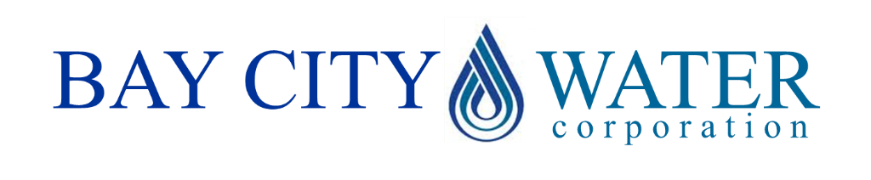

The Honorable Mayor of Bay City

Dear Mayor Smith,

Bay City Water Corp has been facing serious challenges due to significant increases in water demand, leading to over-abstraction of groundwater and the lowering of the groundwater table. We are expecting that these challenges will intensify over the next coming years and will have catastrophic effects in the long run. Therefore, we believe we need to act now to restore the ground water levels. In addition to the project alternatives for the wastewater treatment plant (WWTP) that the Bay City municipal government has developed, Bay City Water Corp has developed an alternative investment alternative, that we refer to as Alternative 3.

ALTERNATIVE 3 KEY FACTS
Through this alternative, the capacity of your WWTP will be coupled with additional investments to upgrade treatment to the tertiary level. This advanced treatment will allow a significant reduction in pollution loads discharged to the bay, with high expected benefits in terms of water quality. In addition, the treated effluent can be used to replenish the depleting groundwater aquifer, therefore mitigating the impact of over-abstraction, preventing coastal salt intrusion, and reducing land subsistence – and thereby, closing the urban water cycle. This alternative addresses not only the management of wastewater and groundwater, but also provides a solution for our concerns regarding the increased water demand.

ALTERNATIVE 3 COSTS AND FUNDING
We have asked your financial advisor to develop a cost estimate, on the basis of the same methodology as was used for your other cost estimates. The overall (risk adjusted) investment cost would be $13,000,000, with annual maintenance costs of 6% of the initial investment cost.

Bay City Water Corp is expecting to experience a significant reduction in the cost of supplying water in the long run. In addition, recent research in this area demonstrates that more than 90% of the consumers are willing to pay for better water quality. These two effects allow us to contribute $750,000 on an annual basis for the next 30 years, which we are pleased to commit in the case of your selection of alternative 3.

ALTERNATIVE 3 ECONOMIC IMPACTS
The A&E firm that you hired to assess the economic impacts of your project alternatives, has prepared a high-level assessment of the economic impacts of Alternative 3 in the annex of this letter.

We sincerely hope that you will consider this alternative, that we believe has great benefits for the people of Bay City.

Yours sincerely,
Mr. Jones - CEO of Bay City Water Corp
ANNEX ALTERNATIVE 3 ECONOMIC IMPACT ANALYSIS

Economic benefit | Alternative 3
Environmental benefits in the river, bay and ocean
Improvements of aquatic ecosystems in river and bay | $450,000 / year
Improvements of aquatic ecosystems in river and bay | Significant positive effect  Not quantified
Increase in carbon capture and storage | $50,000 / year
Avoidance of eutrophication events that can lead to biodiversity loss | Significant positive effect  Not quantified
Total environmental benefits | $500,000 / year
Social and economic benefits from development around the bay
Tourism benefits related to the bay landscape | $400,000 / year
Reduction in cases of illness and the avoidance of premature mortality arising from water-borne disease | Positive effect  Not quantified
Eco-efficiency gains from higher fish provision due to healthier ecosystems | $100,000 / year
Avoided costs of hospitalization and lost days at work from health impacts | Modest positive effect  Not quantified
Development of new industries of the economy | Modest positive effect  Not quantified
Safeguarding of, and access to, natural heritage | N/A
Viability of coastal communities and employment/livelihoods in fisheries | $100,000 / year
Social cohesion related to  employment opportunities | Positive effect  Not quantified
Total social and economic benefits | $600,000 / year
Additional benefits
Avoided groundwater damage | $350,000 / year
Total additional benefits | $350,000 / year

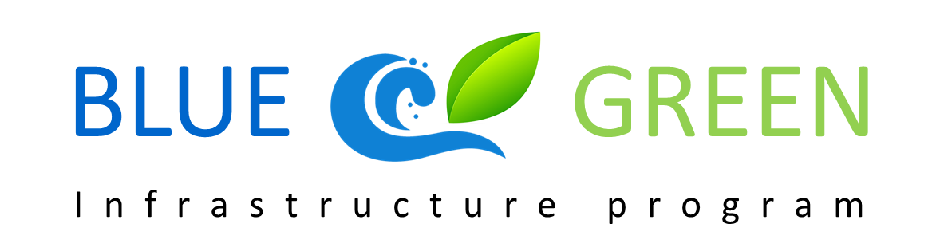

INTERNAL MEMO

SUMMARY OF TECHNICAL STUDY ON STORM WATER SOLUTIONS FOR BAY CITY

The Regional Blue Green Infrastructure Program Board has conducted a detailed technical study to explore alternative storm water solutions for Bay City. The immediate reasons are the recent flooding events due to capacity constraints of the current storm water system, as well as the high levels of pollution of the river, lakes and bay that are caused by unfiltered run-off of the storm water into the surface water. The technical study has resulted in two discrete storm water solutions, that will be summarized below.

SWM OPTION 1
SWM option 1 aims to reduce floods by increasing the capacity of the existing urban storm water drainage system (canals/pipes) and building additional storage space. The stored water will not be infiltrating into the groundwater. The proposed approach can be qualified as conventional and consists mainly of further development of concrete structures (“gray infrastructure”). This option can be combined with all wastewater management alternatives that are currently discussed.

The investment costs of this option are estimated at $2,000,000. This amount can be covered entirely by available budgets for storm water. O&M costs of this option are estimated at 3% of the investment costs, also covered by the available budget.

SWM OPTION 2
For the development of SWM option 2, the outcome of the Water Diagnosis Tool has been embraced which identified groundwater recharge as a pathway for Bay City and the Technology Selection Tool of the Integrated Urban Water Management toolkit has been applied to select appropriate technologies. SWM option 2 adopts the approach of Low Impact Development (or Water Sensitive Urban Design) to address storm water management challenges in the city. It consists of integrating permeable pavements, rain gardens, and bio swales, as well as rainwater harvesting in the urban landscape to favor infiltration of storm water at the source as well as its harvesting and treatment through natural filtration systems, before discharging to nearby freshwater streams or allowing for other storm water re-use. This option provides additional social and environmental benefits in the city by creating green spaces, increasing livability, and helping to restore more natural storm water flow regimes. In addition, improvement of water quality in rivers and lakes around the city is expected due to increased infiltration, thereby supporting tourism and recreational activities while safeguarding public health.

The investment costs of this option are estimated at $1,500,000 with O&M costs at 10% of the investment costs. There is currently no additional public funding available for O&M over the budget that is also available for SWM option 1.

The A&E firm that has been involved in the economic impact assessment of the wastewater management project alternatives, has prepared a high-level assessment of the economic impacts of the SWM options.

Economic benefit | SWM Option 1 | SWM Option 2
Additional environmental benefits (river, bay and beyond), due to better water quality | - | $100,000 / year
Livability (property value increase) | - | $100,000 / year
Avoided damage due to groundwater lowering (property) | - | $50,000 / year
Avoided damage due to flooding (SWM) | $150,000 / year | $150,000 / year

The Blue Green Infrastructure Program has worked together with Bay City financial and economic advisors and has included these alternatives into their financial and economic assessment framework.

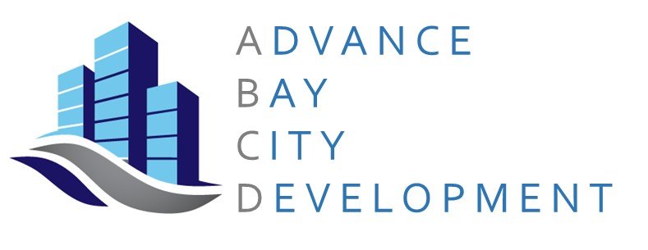

The Honorable Mayor of Bay City

Dear Mayor Smith,

I am writing to propose a partnership between Bay City and my organization on the implementation of Integrated Urban Water Management. As became clear in the recent briefing we received from your staff, the City has great ideas on how to address the pressing challenges of our water systems. It is also very clear that your financial resources are limited. Your staff has already indicated that the preferred solutions are likely not to be feasible because of budgetary constraints. As you know, ABCD is committed to improving and strengthening our Bay City communities and would therefore express our explicit willingness to invest in a more resilient Bay City.

Not only do we commit to achieving the highest resiliency and sustainability standards on our existing and future real estate developments, but also do we want to contribute to your investment programs. We would contribute $3,000,000 to Alternative 3 of your investment program. Moreover, we would be willing to contribute $500,000 to your storm water program under Alternatives 1, 2 or 3, but only if option 2 would be implemented.

We sincerely hope that you are willing to accept our offer and look forward to further developing our great partnership in making Bay City the most resilient, sustainable and livable delta city.

Yours sincerely,

Mrs. Cromwell
President and Chairman
Advance Bay City Development, LLC

RESULTS ROUND 2

Project Alternatives | FNPV | eNPV | Additional considerations
Alternative 3
Alternative 1 + SWM1
Alternative 1 + SWM2
Alternative 2 + SWM1
Alternative 2 + SWM2
Alternative 3 + SWM1
Alternative 3 + SWM2

