Public Transport Capacity Analysis Procedures for Developing Cities
Case Study: Metro de Medellin Rail Transit System, Medellin, Colombia

Carlos Garcia and Jack Reilly, Rensselaer Polytechnic Institute
May, 2011

Supported by the Transport Research Support Program, TRS of the World Bank with financing from the U.K.’s Department for International Development, DFID.

Table of Contents
1. Introduction 4
1.1. Description of Metro de Medellin 4
1.1.1 Vehicles 6
1.1.2 Running Ways 7
1.1.3 Stations 8
1.1.4 Fare Structure and Fare Collection 10
1.1.5 Service Characteristics 11
1.1.6 Operation at Stations 11
2. Train System Capacity Assessment 12
2.1. Determining the Train Throughput Capacity 12
2.1.1 Mean Dwell Time 12
2.1.2 Safe Separation Time 12
2.1.3 Operating Margin 13
2.1.4 Computation of Throughput Train Capacity 13
2.2. Vehicle Capacity 14
2.2.1 Entrance Capacity – Ticket Vending Kiosk 15
2.2.2 Turnstile Capacity 15
2.2.3 Platform Capacity 18

List of Figures

Figure 1 – Metrocable Aerial Lifts 5
Figure 2 – Metro de Medellin System Map 6
Figure 3 – Metro de Medellin Train (3 car trains for Line B) 6
Figure 4 – Metro de Medellin Train (6 car trains for Line A) 7
Figure 5 – Metro de Medellin Running Way 7
Figure 6 – Access to El Poblado Station 8
Figure 7 – Access to Main Station of Metrocable from Metro de Medellin 9
Figure 8 – Loading Platforms 10
Figure 9 – Faregates 11
Figure 10 – Exit Faregates 17

List of Tables

Table 2-1 Components and Controlling Headway 13
Table 2-2 Trainset Capacity 14
Table 2-3 Line Capacity (passengers/hour/direction) 15
Table 2-4 Ticket Booth Capacity 15
Table 2-5 Turnstile Capacity 16
Table 2-6 Platform Capacity Analysis 18

Case Study
Transit Capacity Concepts for Developing Cities
Metro de Medellin Mass Transit System, Medellin, Colombia

Introduction

Two case studies were developed using the procedures described in the manual Public Transport Capacity Analysis Procedures for Developing Cities. One case study was for a bus rapid transit system and the other for a rail rapid transit system. The bus case study was developed from data from Bogota, Colombia, and the rail case study was developed from data from Medellin, Colombia.
The purpose of the case studies was to determine if the procedures in the manual were of sufficient detail to provide reasonable results with moderate analytical effort. In the case studies, agency electronic data, supplemented with some field data was used. The data from the case studies was also useful in determining default values for certain attributes of the transit system elements which can be used if no local data are easily available. Examples of these are headway and service time variance, two variables required to estimate the throughput capacity of a transit line.

Description of Metro de Medellin

The Metro de Medellin (Empresa de Transporte Masivo del Valle de Aburrá Limitada) is a rail rapid transit system in the metropolitan region of Medellin, Colombia.
Metro de Medellin has two lines:
- Line A is 23.2 kilometers (~14.4 miles) in length. The trains used in this line have 6 vehicles. The line traverses the Valle de Aburrá from the Niquía station (in the northern region of Bello) to the southern region of Itagüí. The majority of Line A runs parallel to the Medellin river, breaking away from the river so that it passes through the heart of the city.
- Line B is 5.6 kilometers (~3.5 miles) in length, including five elevated stations and one at ground level. The trains used in this line have 3 vehicles. The line operates from the central station of San Antonio to the San Javier region in the western part of the city.
In addition to these two rail rapid transit lines, Metro de Medellin also operates Metrocable, a “feeder/distributor” cable car system with three short routes which intersect the rail lines. A photograph of the cable cars is shown in Figure 1. A map of the network showing the rail and cable lines appears in Figure 2)

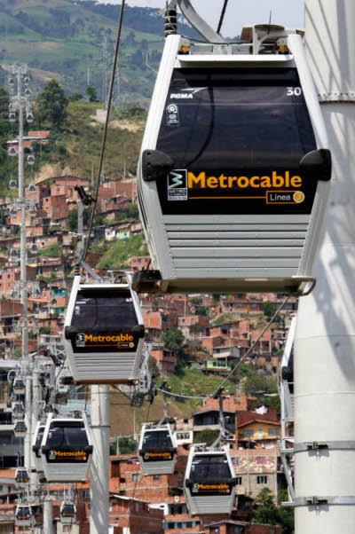
Figure 1 – Metrocable Aerial Lifts
Daily ridership on the Metro rail and cable network is about 480,000. The maximum number of passengers per direction per hour is about 22,000 along the busiest rail line and about 3,000 on the busiest Metrocable line. The hours of operation during the week are: 4:30AM to 11:00PM.

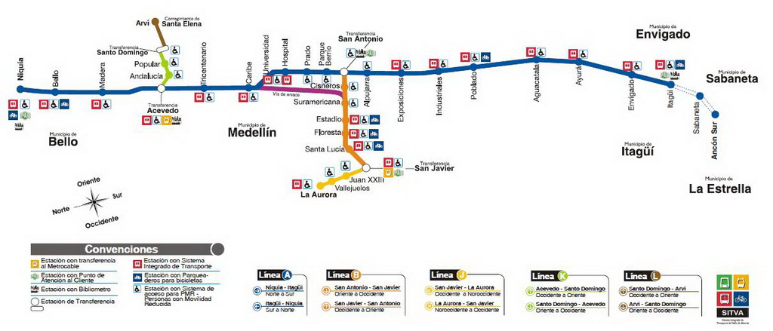
Figure 2 – Metro de Medellin System Map

- Vehicles
The Metro de Medellin rail fleet consists of 42 train sets: 34 trains of these have 6 cars, and 8 have 3 cars each. Each vehicle has a seat capacity of 48 and an overall capacity of 230. The implied standing density of this capacity is 5.5 persons per square meter. Each vehicle has four wide double doors which allow for two boarding or alighting streams. Illustrations of the vehicles are shown in Figure 3 to Figure 4

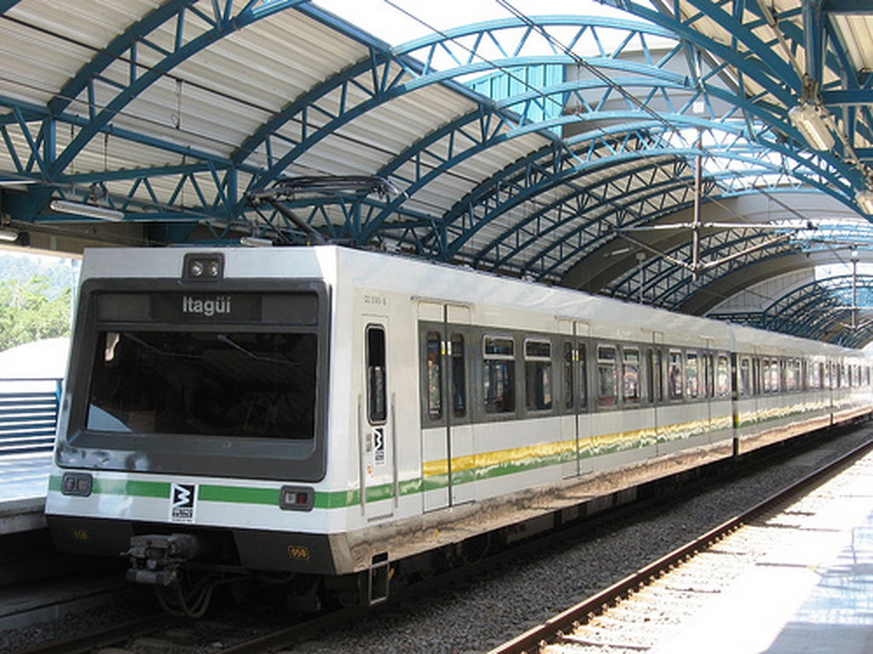
Figure 3 – Metro de Medellin Train (3 car trains for Line B)
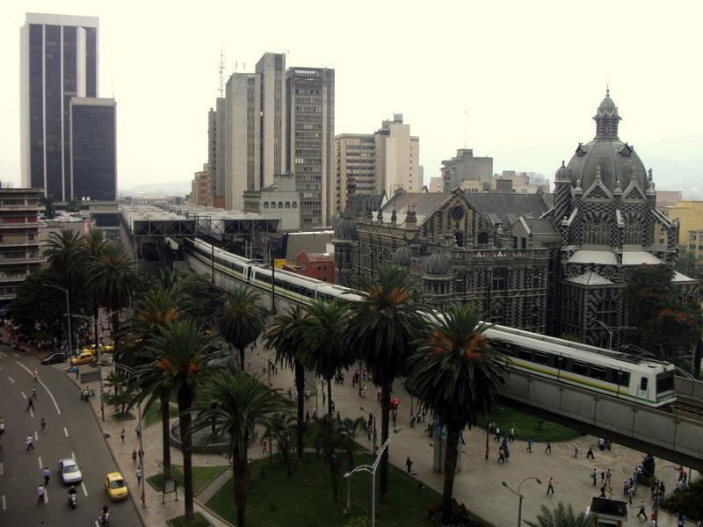
Figure 4 – Metro de Medellin Train (6 car trains for Line A)

- Running Ways
The railway of the Metro de Medellin has one track in each direction and there are no grade crossing with the streets. The running way is illustrated in Figure 5.
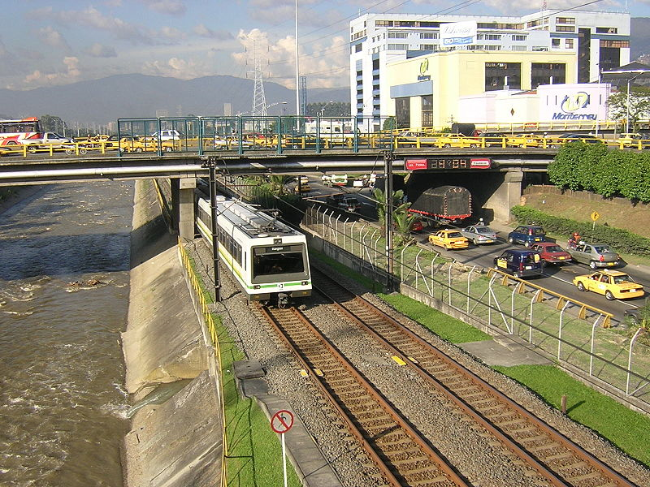
Figure 5 – Metro de Medellin Running Way

- Stations
There are 27 Metro de Medellin stations, 26 with center platforms. San Antonio station, where transfer between the heavy rail lines are enabled has side platforms. Along limited access highways, the stations are accessed by footbridges from either side of the roadway. Stations generally have a single point of entry for customers where customers can purchase tickets at a staffed kiosk. Platforms are between 4-8 meters wide. The access to some stations (including handicapped access) is show in Figure 6 to Figure 7.
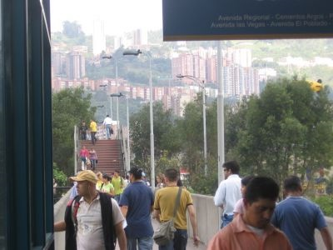
Figure 6 – Access to El Poblado Station

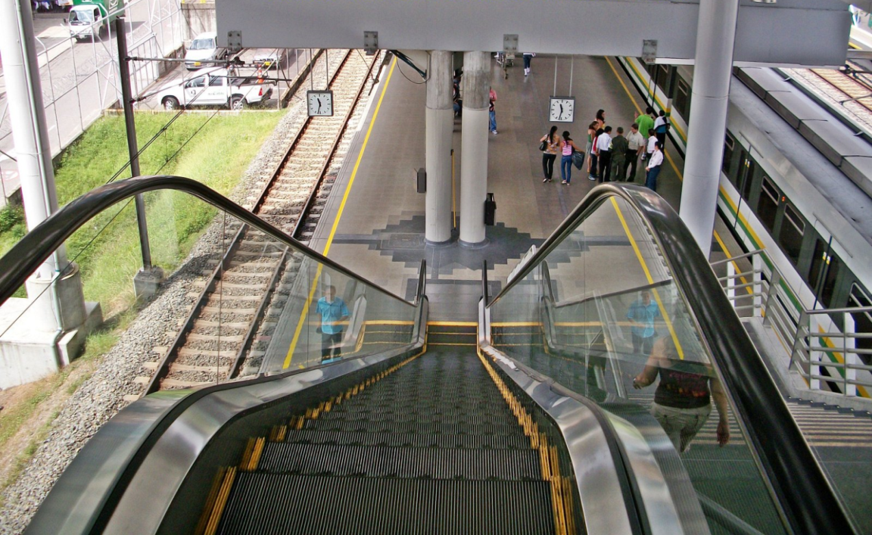
Figure 7 – Access to Main Station of Metrocable from Metro de Medellin

The stations do not have platform edge sliding doors aligned with the doors on the vehicles.
In addition to serving as a boarding location, the platforms act as a buffer space for waiting customers during peak periods when it is possible that passengers will not be able to board the first arriving train going to their destination due to either high levels of through passengers on arriving vehicle or high boarding levels at the station (see Figure 8).
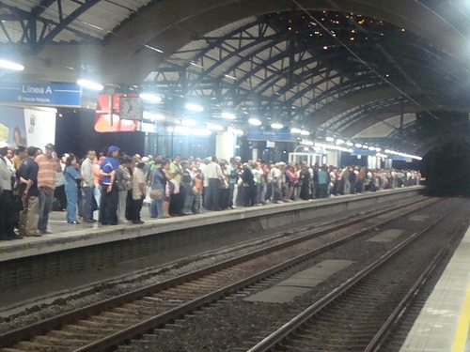
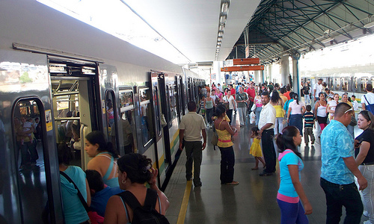
Figure 8 – Loading Platforms

- Fare Structure and Fare Collection
The fare for the service is 1,750 pesos per one way trip (1 dollar roughly). There are no zone or peak period surcharges but there are discounts for frequent use, students, elderly, and disabled travelers. All entering customers must use a wireless RFID card (Civica card) to enter through a turnstile. Exiting passengers must travel through a turnstile. An illustration of the fare gates appears in Figure 9. Given the large passenger volumes, fare gates often have an attendant to assist customers unfamiliar with the fare collection system and to assist customers with an occasional defective fare card.
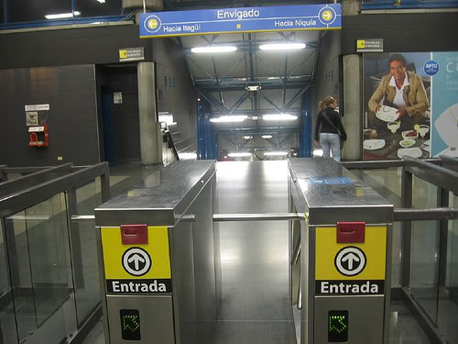
Figure 9 – Fare Gates

- Service Characteristics
The service scheme for the Metro de Medellin is fairly simple. During peak hours, both routes have headways on the order of 4.5 minutes. Since there is only a single track in each direction, there are no service variations such as express or skip-stop operation.

- Operations at Stations
A typical platform configuration for busy stations is a platform of about 142 meters for Line A with the 6 car train sets) and 80 meters for Line B (with the 3 car train sets.) There is automatic train control to assure a safe comfortable stop. Door operations are controlled by the train driver.

Train System Capacity Assessment

The procedures in the manual were used to estimate the capacity of the system at its critical links. The primary assessments were the determination of the maximum service frequency and the effective vehicle loading at the critical stop. Supplementary capacity assessments of other elements such as fare collection, station entrances and walkways were also undertaken. The data sources for these studies were primarily electronic records of the Metro de Medellin, supplemented by some field observation and interviews with the Metro de Medellin staff.
The procedures in the analysis followed the procedures in table Chapter 4 of the manual. Essentially, this task is one of determining the effective throughput capacity of the track and signal infrastructure measured in trains per hour and the effective vehicle capacity measured in passengers per train.
Based on conversations with the Metro de Medellin staff, the critical station on the network was determined to be the San Antonio station where the two rail lines intersect. As discussed previously, all trains follow the same service pattern at that station.

Determining Train Throughput Capacity
The maximum throughput in trains per hour is determined by the ability of the infrastructure and signal system to process arriving trains at the busiest station. The minimum interval between trains is a function of three factors – the dwell time of trains at the station, the safe separation time between successive trains and an operating margin to allow for randomness in the arrival pattern of trains and the dwell times at stations.
Mean Dwell Time
The mean dwell time at the San Antonio station was 30 seconds as reported by the Metro de Medellin staff. Dwell times at other stations were on the order of 20 seconds. Data on the variability of dwell time was not available.
Safe Separation Time
The safe separation time between successive trains is a function of the signal systems type and train length. This is because more advanced signal systems can more precisely determine the location of trains and longer trains require more time to clear the station. Table 4.2 in the accompanying manual has a chart showing safe separation distance. For the case of Medellin San Antonio station with 6 car train sets and a total length of 137m, the estimated safe separation time for a cab signal system is 45 seconds, and 22 seconds for a moving block signal system. For the busiest station of line B with three car train sets, the safer separation time is 35 seconds 18 seconds respectively.
Operating Margin
The operating margin is a buffer time which allows for random variation in system operation such as variability in dwell time and variability in the headway between vehicles. While a simulation model could be run to determine the failure rate (probability of train delay due to train occupancy at a station) of combinations of dwell and headway variability, a default value from practice elsewhere will usually suffice. A value of 35 seconds is frequently used for this. Lower values will increase the likelihood of headway interference between successive trains.

Computation of Throughput Train Capacity
The throughput train capacity can be estimated by applying the following formula:
h = t_{d} + t_{om} + t_{cs}

Where,
h = minimum headway
t_{d} = average dwell time at critical station
t_{om} = operating margin
t_{cs} = minimum train control separation

In the instant case, the controlling headway is shown in Table 2-1

Table 2-1 Components and Controlling Headway
Component | Source | Time (sec.)  Line A | Time (sec.)  Line B
Mean dwell time | field data | 30 | 30
Operating margin | Default value | 35 | 35
Safe separation time | Table 4.2 in manual | 45 | 35
Total |  | 110 | 100
The approximate theoretical maximum number of trains per hour at the minimum controlling headway is thus 32 and 36 respectively. In practical terms, fully grade separated metro systems rarely operate more than 30 trains per hour.

Vehicle Capacity
The second factor impacting system capacity is the maximum number of passengers that can be carried on board each vehicle. Classical capacity analysis assumes that sufficient train sets are assigned to each route so that a passenger has a reasonable expectation of being able to board the next arriving vehicle or train going to his or her destination. In the case of Metro de Medellin, however, particularly at the stations such as those being included in this case study, the system is fully saturated. Nearly all vehicles are departing from these stations at or above the stated capacity of 230 passengers per car. Randomness in the arrival rate of customers at the stations and the departure rate of passengers on trains causes variation in platform and station occupancy. Accordingly, it is necessary to make sure that station capacity and the access to and egress from station platforms via turnstiles and entrance walkways be scaled in such a way to assure safe transportation of passengers.
From visual observation, vehicles departing the station are loaded in the 6 passengers per square meter range, with a slightly higher value in the middle of the peak hour the higher values in the middle of the peak period.
The rated capacity of the train is 230 per vehicle or 1,840 for the 6-car train set at a rated density of 5.5 passengers per square meter. At a higher density, such as between 6 and 8 passengers per square meter, the capacity would be increased considerably as shown in Table 2-2
Table 2-2 Train Set Capacity
 | Allowable Standing Density (Pass./Sq. Mtr.)
 | 5.5 | 6 | 7 | 8
Standing capacity per car | 232.1 | 253.2 | 295.4 | 337.6
Seating capacity per car | 48 | 48 | 48 | 48
Total capacity per car | 280 | 301 | 343 | 386
Total for 3 car train (Line B) | 840 | 904 | 1,030 | 1,157
Total for 6 car train (Line A) | 1,681 | 1,807 | 2,060 | 2,314

Table 2-3 Line Capacity (passengers/hour/direction)
Line | Train capacity (trains/Hr.) | Train car capacity @5.5 persons per sq. m. | Train Set length (cars) | Capacity (pass/track/hour)
A | 32 | 230 | 6 | 44,000
B | 36 | 230 | 3 | 24,800

From Table 2-3 it can be inferred that the system is at 50% capacity and it can handle about 30 trains per hour.
Note that, as the standee density moves beyond 6 people per square meter, dwell times will go up because of the difficulty of people boarding and alighting through crowded aisles and door areas. This means that the actual throughput and hence capacity may well decrease at the increased standee densities, not increase.

- Entrance Capacity – Ticket Vending Kiosk
Each station entrance has a staffed ticket booth for selling tickets. The observed capacity of these attendant lanes was 400 transactions per hour per lane. Table 2-4 shows the ticket booth utilization and capacity at four key stations. Figure 10 shows the exit fare gates.
Table 2-4 Ticket Booth Capacity
Station | Line | Number Of Ticket Booths | Capacity (transactions/Hr.) | Peak Hour Percent of Capacity Used (2010)
Niquia | A | 8 | 3,200 | 42%
San Antonio | A | 3 | 1,200 | 69%
Itagui | A | 10 | 4,000 | 42%
San Javier | B | 3 | 1,200 | 104%

- Turnstile Capacity
Exiting and exiting customers must go through a turnstile. Entering passengers use an electronic card to enter. Passengers do not use their card on station exit. The observed capacity of each turnstile is 22 on entrance and 45 on exit. Medellin Metro periodically performs an assessment of the entrance and exit capacity of their system.
Table 2-5 presents the location, number of turnstiles, and the utilization for four key stations. A measure of the percent of capacity used based on 2010 peak hour boarding is also presented. The table suggests that the Poblado station is operating at about 70% of capacity. Additional entrance turnstiles may be required to improve capacity of at this station if growth continues.
 | Entrance Turnstiles |  |  |  | Exit Turnstiles
Station | Turnstiles | Capacity (Pass./Hr.) | 2010 Peak Hour Utilization (pass./Hr.) | Percent of Capacity Used | Turnstiles | Capacity (Pass./Hr.) | 2010 Peak Hour Utilization (Pass. /hr.) | Percent of Capacity Used
Niquia | 11 | 14,520 | 4,234 | 29% | 8 | 21,600 | 1,132 | 5%
Poblado | 5 | 6,600 | 4,690 | 71% | 4 | 10,800 | 4,639 | 43%
Itagui | 7 | 6,600 | 4,512 | 68% | 7 | 18,900 | 4,420 | 23%
San Javier | 5 | 6,600 | 641 | 10% |  | 8,100 | 3,584 | 44%

Table 2-5 Turnstile Capacity
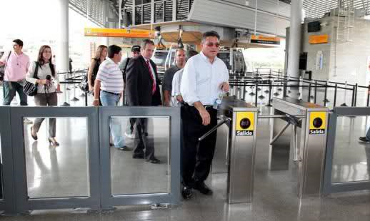
Figure 10 – Exit Fare Gates
- Platform Capacity
Metro de Medellin performs a periodic assessment of platform capacity at all of its stations. The procedure is to estimate the standing capacity of each platform assuming a standing density of 1.5 passengers per square meter. This measure is then multiplied by the service frequency in trains per hour to provide an estimate of the number of passengers who are able to board trains in an hour if there is sufficient capacity on trains to permit passengers to board the next arriving train. The actual peak hour boardings for each station, multiplied by 1.2 to allow for peaking within the peak hour is then compared to the computed hourly capacity. The result is an estimate of the proportion of capacity offered which is used by passengers.
The Metro de Medellin analysis for the three busiest stations on the busiest line (Line A) is replicated in Table 2-6 below. Two of the stations are the north (Niquia) and south (Itagui) terminal stations where a large number of boardings would be expected. This illustrate that under normal operating conditions, the platforms are operating well below capacity. Variation in headway would result in percent of capacity exceeding these numbers. At terminal stops, however, headway variability is not frequently an issue.
The extreme case where a train is removed from the normal headway due to breakdown, would result in operation in excess of 100% capacity at the terminal stations. However, since the design density (1.5 passengers per sq. meter) is low, occasional cases of a headway gap of twice the published headway could be accommodated. Operating procedures to prevent overcrowding platforms by restricting platform access would be required for safe operation in these unusual circumstances.

Table 2-6 Platform Capacity Analysis
Station | Niquia | San Antonio | Itagui
Station type | Terminal | En-route | Terminal
Platform Type | Side | Side | Center
Platform length (m) | 142 | 142 | 142
Platform width (m) | 4.0 | 5.0 | 6.5
Safety zone (m)* | 0.5 | 0.5 | 1.0
Effective Area (Sq. Mtrs.) | 497 | 639 | 781
Frequency (trains/Hr.) | 13.3 | 13.3 | 13.3
Design Passenger Density (pass./Sq.Mtrs.) | 1.5 | 1.5 | 1.5
Platform Capacity (Pass./Hr.) | 9,940 | 12,780 | 15,620
2010 Peak Hour Actual Boardings per peak hour | 5,174 | 1,962 | 9,563
2010 Peak Hour Percent of Capacity | 52% | 15% | 62%

* This is the area at the edge of the platform where passengers cannot wait safety. This space is included in the platform width.
This assessment is very suitable for terminal stations and when platforms are operating well under capacity. The assessment assumes that every customer can board the next incoming train. At en-route stations, this may not be true and a more sophisticated assessment, taking into account the effective capacity of incoming trains should be done.

The Metrocable is a continuous cable system with 90 passenger cars operating on a 12 second headway resulting in a theoretical capacity of 3,000 passengers per hour. This is the only discussion of Metrocable in this case study.

